Our stories

Annual Review
2015–16

Contents

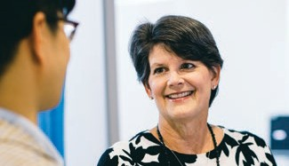Welcome to our hospital

02
Our people

03

Dr Fiona Fullarton
A mentor for the next generation

04

Scott Henderson
An integral presence in the hospital’s redevelopment

06

Dr Kristen Wells
Outstanding clinical leadership

08

Judy McCahon
Taking the lead in open communication

10

Our Senior Medical Staff

Eye and Ear Annual Review 2015–16 01

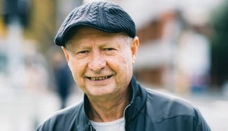

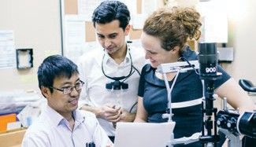Our patients

13

Adam
Hospital has eye safety in its sights with new campaign

14

Jemima Howe
Jemima’s journey at the Cochlear
Implant Clinic

16

Greg Bevan
Corneal transplant trial a first for Victoria

18

Jim McCalman
Sometimes a small procedure makes a big difference

20
Our teaching and research

23

Dr June Choi
Spreading our teaching worldwide

24

Tusker Patterson
New treatment prevents vision loss

26

Dr Jessica Vitkovic
Hearing important for balance

28

Marty O’Connell
Turning lives around

30

Our partners

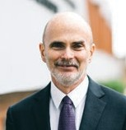Welcome to our hospital

On behalf of our Board of Management and dedicated staff, I am pleased to present the 2015–16 Annual Review.

I hope you enjoy reading about some of our patients, staff and research partners and their experiences. Each has a unique medical story, but all are joined by the common thread of high quality treatment at The Royal Victorian Eye and Ear Hospital (the Eye and Ear).

Reflecting on my first year as CEO of the Eye and Ear, it has been an exciting time and a privilege to work with the dedicated Executive and staff who strive to provide world-leading eye and ear care to the Victorian public. Our
new 24-hour Emergency Department opened its doors in May as one the first completed stages of the hospital’s redevelopment project and
has received overwhelmingly positive feedback so far.

Building a Better Future
During the redevelopment, we have maintained our high standards of clinical care. Patient welfare has not been compromised, even when services have been moved temporarily off-site. This is a significant achievement when the scale of our operations and the extensive building works is taken into account. The Eye and Ear
is the largest public provider of ophthalmology and ENT services in Victoria. We provide all of Victoria’s public cochlear implants and run more than 50 outpatient clinics, treating 200,000 outpatients per year.

The redevelopment project has created many logistical challenges, but the new facilities will
be well worth the disruption. Patients will benefit for years to come from the new and redeveloped hospital. The new Emergency Department is much larger and brighter, there are more consulting rooms and the patient flow is
now more streamlined.
Attracting the brightest and the best
The Eye and Ear has operated as a specialist tertiary teaching hospital since its foundation in
1863. Our reputation as a world-class learning facility attracts highly skilled medical and scientific professionals.

Our commitment to the highest standards of professionalism is backed by accreditation from the relevant colleges, including: The Royal Australian and New Zealand College of
Ophthalmologists (RANZCO), The Royal Australian College of Surgeons (RACS), The Royal Australian and New Zealand College of Anaesthetists (ANZCA) and The Royal Australasian College
of Emergency Medicine (ACEM).

Alongside teaching, the hospital fosters a
strong culture of clinical research and endorses approximately 80 new research projects a year with the Centre for Eye Research Australia (CERA), the University of Melbourne, Bionics Institute, Bionic Vision Australia, HEARing CRC and Monash University.

A clear focus on caring
The services of the Eye and Ear are provided to all Victorians across the state. Each year we deliver care that caters to around 250,000 patients. We actively seek feedback from our patients, families and the community to ensure we continue to deliver the best clinical care in all our facilities.

As you read this Annual Review, I hope you enjoy the stories illustrating the way we have provided care to the Victorian community over the past
12 months.

Mark Petty
Chief Executive Officer

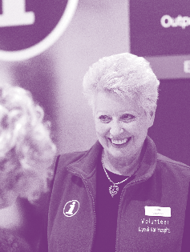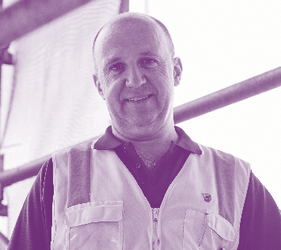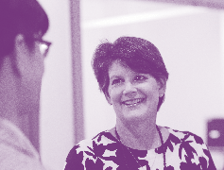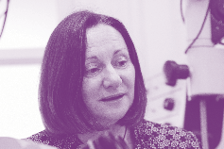

Eye and Ear Annual Review 2015–16 03

Our people

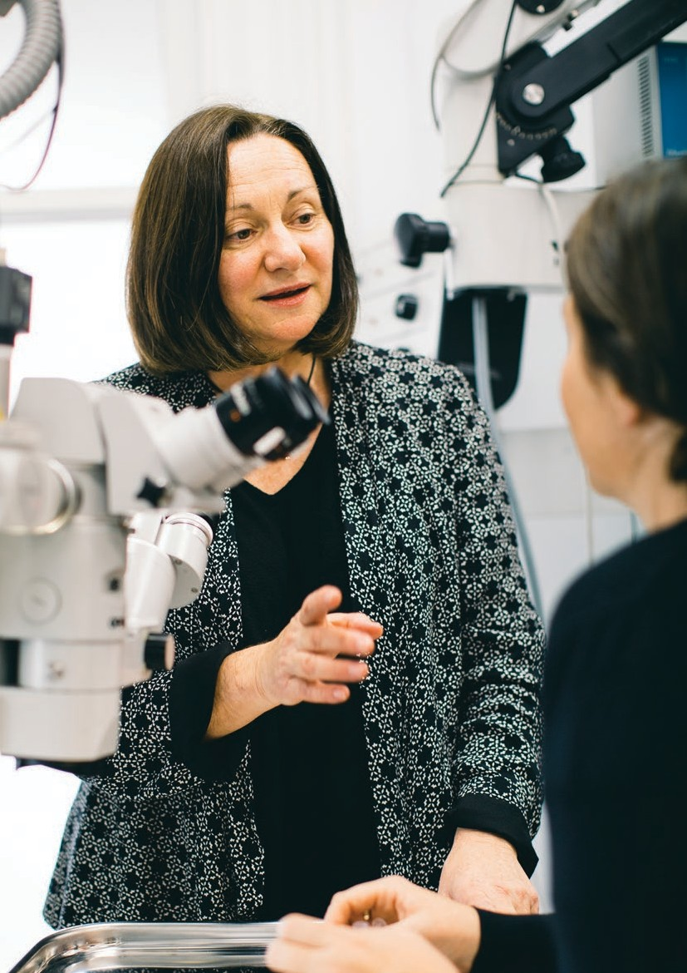Our people

04 Eye and Ear Annual Review 2015–16

Fiona

Eye and Ear Annual Review 2015–16 05

A mentor for the next generation

The Eye and Ear plays a significant national and international role in teaching and training.

As the Director of Ophthalmology Training, Dr Fiona Fullarton’s role was to support and coordinate the teaching of eye doctors until they progress to become fully trained specialists.

Dr Fullarton officially began her ophthalmology training in 1989.

“I actually started working in the Eye and Ear’s Emergency Department at the weekends, after passing the entrance examinations while working in geriatric medicine,” she recalls.

“I’m not sure what my title was
back then, but I was like the ‘Sunday helper’. The weekends were so busy back then (as they are now) and by the time I commenced official training the following year, I already had a lot of experience.”

After completing her training and Fellowship at the Eye and Ear, Dr Fullarton undertook further training overseas and returned to practice in Australia in a number of different regions, including Tasmania.

In 2007, Dr Fullarton returned to the Eye and Ear working as a consultant in the Outpatient Clinics and then in 2012 took on the role of Director of Ophthalmology Training.

“Interestingly when I came back to the Eye and Ear everything looked the same, not much had changed, so I am excited to see how things will progress and improve over the next few years with the redevelopment,” Dr Fullarton says.
As part of the hospital’s redevelopment project, there will be a dedicated education and training facility. The Education Precinct will include a multipurpose auditorium for seminars and lectures, a library, teaching rooms and a wet (microvascular training) and bone laboratory.

While also being trained at the hospital, the junior doctors perform an important service to the community.

“Fortunately the Eye and Ear is very pro-education and supports a high level of supervision for the trainees. In the wetlab, trainees practise and master surgical techniques before I assess their competency to be allowed to operate on people (under supervision) – patient safety is the main priority.”

The Eye and Ear’s training program is known for its subspecialty expertise. Being highly sought after, the Eye and Ear attracts the best doctors in the country and many overseas specialists also further their training on the subspecialty clinics.

Dr Fullarton handed on the role of Director of Ophthalmology Training to Dr Jacqueline Beltz in May 2016.

“I think Jacqui will be able to take the training of registrars to a whole new level, much is changing in the way we do things,” Dr Fullarton says.

“The trainees are all remarkable people. By the time they are qualified they are incredibly good at what they do and it is a privilege to have been part of their journey.”

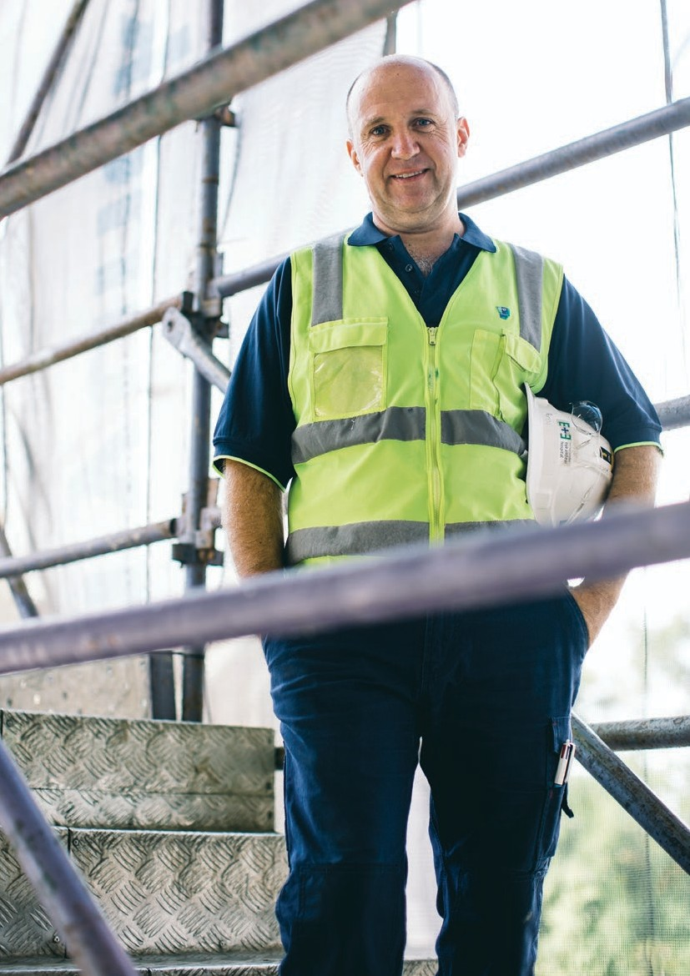Our people

06 Eye and Ear Annual Review 2015–16

Scott

In May 2016, the Minister for Health the Hon. Jill Hennessy MP, officially opened the hospital’s new Emergency Department, the first clinical area to be unveiled as part of the redevelopment.

It has fully reclining examination chairs which provide greater comfort for patients undergoing examinations and treatment. It also houses state-of- the-art equipment such as electronic visual acuity charts (to test vision) and ENT endoscopy towers (an all-in-one unit for specialised ear, nose
and throat procedures).

The waiting area is much larger and it is filled with natural light, creating a warm and calming atmosphere.

Eye and Ear Annual Review 2015–16 07

An integral presence in the hospital’s redevelopment

Scott Henderson knows the Eye and Ear building better than most.

Thanks to his uncle, Scott started his career as an apprentice electrician at the hospital in 1985.

Now, 31 years on and Scott’s role has changed significantly – from apprentice electrician, senior electrician, engineering supervisor to his current role, Assistant Manager of Facilities.

“My role now is to provide support to the Facilities
Manager and ensure the day-to-day continuity
of the facilities services throughout the hospital,” Scott says.

“When I started electricians just did electrical work, plumbers did plumbing work, painters etc. but over the years that mentality has changed, everyone helps each other and you have to know
a bit about everything. This is especially important now because most of my time is taken up with
the redevelopment project.”

The Eye and Ear is currently undergoing a $201 million redevelopment project. As part of the construction works, Scott manages a process called RISC (request to interfere with services or safety conditions) applications.

The Construction Manager, Hansen Yuncken, submits RISC applications outlining what works they would like to carry out within the hospital. Scott goes through the application ensuring there is minimal impact to the hospital patients and staff, and then liaises with department managers and the Executive Team for appropriate sign-off.

“The process is to hold the builders accountable, making sure every possibility, contingency and flow-on effect is worked through and clearly documented.”

Scott says he enjoys the logistics and working collaboratively with the builders.
“At first, it really took me out of my comfort zone. All I had ever done was be a hospital electrician and then all of a sudden I was chairing meetings, having a voice and helping to make decisions.”

“I meet regularly with the builders, giving them advice and helping out where possible – because really my role is to support the redevelopment.”

In late August 2016, the Eye and Ear will temporarily relocate outpatient and some day surgical services to the old Peter MacCallum Cancer Centre site, allowing the builders to complete the internal redevelopment faster and in a less disruptive manner to our patients, consumers, staff, volunteers and tenants.

“From a facilities point of view it will be challenging because we’re going into a building we’re not familiar with. So we will learn the layout, where everything is powered, plumbed, air- conditioned and so on, but I’m confident that we can all work together and ensure both sites are run efficiently,” Scott says.

“Although it’ll be a bit tricky behind the scenes at times, the relocation to the new site will be much easier and better for patients and hopefully it’ll mean the redevelopment is finished sooner.”

The redevelopment project does come with some challenges; however, Scott says he is enjoying being pushed and embraces the change.

“The hospital is old; when I started in 1985 they were building the Smorgon Family Wing. It is really difficult trying to keep the hospital running while redeveloping it at the same time, but I do really enjoy it.”

When complete in 2018, Scott says: “I’m looking forward to a new hospital, a new working environment and getting some sleep!”

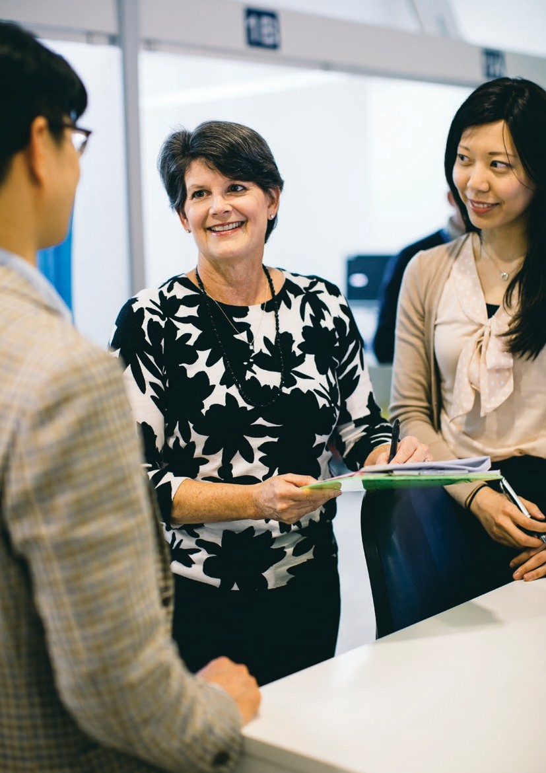Our people

08 Eye and Ear Annual Review 2015–16

Kristen

Following on from the work implemented by the Trauma Reference Group, an audit of trauma patients admitted to the Ward between December 2014 and November 2015 found a significant improvement from previous audits. The findings included the implementation of a dedicated review team which has optimised continuity of care, a decrease in the average time from presentation to theatre, very few patients operated on overnight, and an increase in compliance with the preferred antibiotic selection.

Eye and Ear Annual Review 2015–16 09

Outstanding clinical leadership

Dr Kristen Wells thanks her grade 8 biology teacher, Mrs Martin, for her interest in science, which then led to her passion for medicine.

It was when completing a rotation at
Southwestern Medical School in Dallas that
Dr Wells says she fell in love with ophthalmology
– the branch of medicine concerned with the study and treatment of the eye.

“I liked the medical side and the technical aspect of the surgery, and ever since I was a kid, I always liked doing things with my hands, tiny crafty sorts
of things, so the eye really appealed to me,” Dr Wells says.

While in medical school, Dr Wells met her husband Doug who was from Melbourne.

Forging a relationship with Melbourne, Dr Wells made contact with a well-known name to the Eye and Ear, Professor Gerard Crock AO. Professor Crock was appointed Australia’s first professor of ophthalmology, when the University of Melbourne established the Department of Ophthalmology
at the Eye and Ear in 1963.

In 1983, while still a medical student, Dr Wells came to the Eye and Ear and completed a
mini-observership under Professor Crock. An observership is when a clinician joins a medical team at a teaching hospital to observe the style of patient care.

“Professor Crock was an amazing doctor and my mentor for many years.”

Dr Wells moved to Melbourne in 1997 and took
up the role of Senior Registrar at the Eye and Ear.

“I had been a private consultant, so to come to Australia and take up the Senior Registrar role was a great way to orient myself with Australian ophthalmology – because the medicines, the
surgical equipment was all a bit different to what I was used to.”

Almost 20 years on, and Dr Wells is an integral part of the Eye and Ear, especially in the Emergency Department, as a Clinical Lead in the Acute Ophthalmology Service and as a mentor to junior doctors.

“Over the last few years, in addition to my clinical work, I have been involved in an increasing number of non-clinical projects or management processes, including the trauma audit,” Dr Wells says.

“Over a year and a half ago we identified the lack of a standardised treatment for our trauma patients, we didn’t have a consistent process for getting them from the Emergency Department to the Theatre and then to the Ward with continuity of care.”

Led by Dr Wells, the Eye and Ear implemented a Trauma Reference Group, which developed procedures for eye trauma management, two new clinical practice guidelines, standardised audit processes and an Emergency Department
trauma checklist.

As a result of this work, trauma patients at the Eye and Ear now have an efficient and enhanced care plan.

“What is unique about our current trauma management and something which the Eye
and Ear is doing more of, is that we are not just treating a clinical diagnosis – we are looking at the patient journey from the time they come through the front door, streamlining their trip through the hospital, minimising complications, optimising their clinical care and educating them with fact sheets relating to their specific condition.”

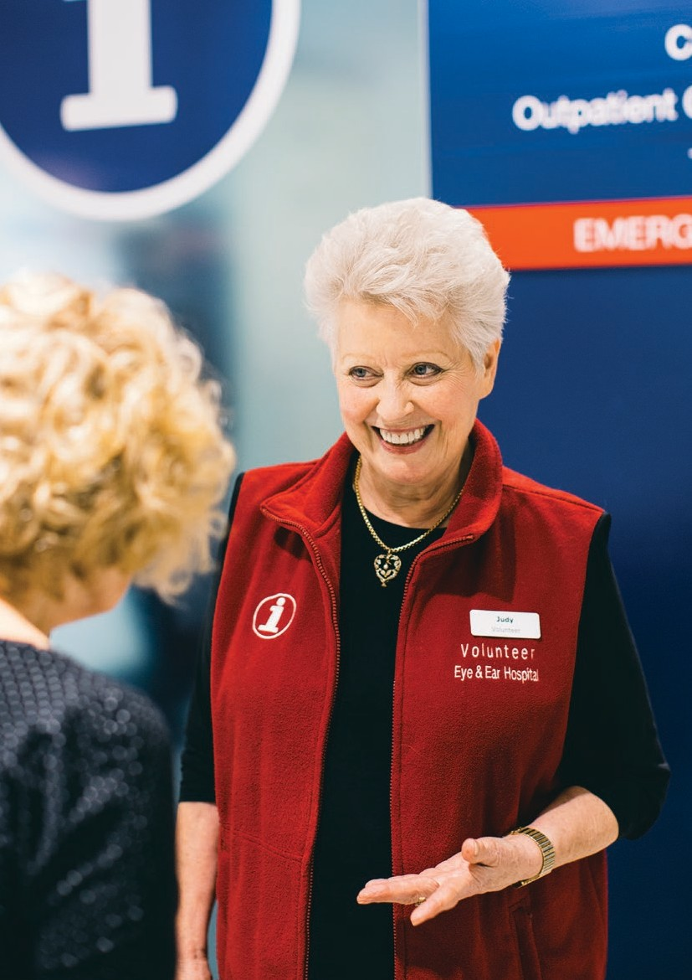Our people

10 Eye and Ear Annual Review 2015–16

Judy

The Eye and Ear received funding from the Nelken Trust which enabled the hospital to purchase the badge printing machine and produce a promotional video, which was launched at the Community Board Meeting in May.

Volunteers have dedicated their time to printing and assembling over 800 badges for Eye and Ear staff and volunteers across all disciplines within the hospital. The badges were first rolled out to clinical and patient facing areas and then also distributed amongst administrative departments.
The hospital has received positive feedback highlighting the value of the campaign.

Eye and Ear Annual Review 2015–16 11

Taking the lead in open communication

If you’re looking for directions or being treated in the Eye and Ear’s Emergency Department, Judy McCahon’s warm nature and pleasant smile will help ease any concern you may have.

Attending the Boroondara Volunteer Expo six years ago, Judy knew she had found the perfect organisation to become involved with.

“I met Coral and Joan [volunteers] and I thought
‘I think I can fit in there’ because I had a lot of transferrable skills that I could bring with me –
I didn’t know a great deal about hospitals but you learn these things pretty quickly, and I certainly did learn,” Judy says.

As well as volunteering two days a week, Judy is a member of the Consumer Advisory Committee. The committee ensures the consumer voice and opinion is heard when reporting on the hospital’s safety, quality and risk management.

“The two roles are so complimentary, because the knowledge I gain from the Consumer Advisory Committee and from reviewing patient information make me better at my job on the concierge desk, and my job on the concierge desk gives me a true understanding of the hospital which enables me to contribute to the Consumer Advisory Committee.”

The Consumer Advisory Committee is where Judy floated the idea of implementing the Hello My Name Is… campaign, which originated in 2013 when an English doctor who was being treated in hospital, realised that very few staff looking after her introduced themselves before delivering care.

The initiative encourages everyone to wear a name badge and provide a personal introduction at the first point of care.

“I first came across the concept when doing some committee work at Peter MacCallum Cancer Centre,” Judy says.
“I thought ‘yes, that’s it, that is what we need’ because it frustrated me that very few people seemed to be introducing themselves effectively to each other, as in staff and volunteers, and particularly when they interfaced with patients.

“I could see from my own observation that when I was wearing a name badge, people would read it and they would
use my name and it was the beginning of open communication between the patient and the volunteer.”

Betty Tellis, the Coordinator Community Engagement and Participation, has been instrumental in coordinating the name badges and rolling them out across the hospital.

“As well as continuing to encourage staff to introduce themselves, name badges assist patients and staff to know who they are speaking to which promotes an environment where we are all working together to improve the patient experience.”

Passionate about communication and helping others, Judy is thrilled that she has made a difference – especially for the patients.

“I’m proud to be able to provide a service in a wonderful organisation like the Eye and Ear; I get enormous satisfaction always doing whatever I do, to the best of my ability.”

12 Eye and Ear Annual Review 2015–16

Our Senior Medical Staff*
Directors
Dr Caroline Clarke Executive Director, Medical Services, Chief Medical Officer
Dr Jason Goh
Director, Medical Services Assoc. Professor Robert Briggs Clinical Director, Otolaryngology
and Head, Otology, Cochlear
and Ear Nose and Throat Dr Mark McCombe Clinical Director,
Ophthalmology Services
Dr David Ware
Director of Anaesthesia
Heads of Clinic
Assoc. Professor Anne Brooks Clinical Lead, Acute Ophthalmology Service and Head, Special Eye Clinic 3
Dr William Campbell Head, Vitreoretinal Unit Ms Anne Cass
Head, Head and Neck
Dr Carmel Crock Director, Emergency Department
Assoc. Professor Mark Daniell
Head, Cornea
Mr Michael Dobson
Chair, Senior Medical Staff
Dr Catherine Green
Head, Glaucoma
Dr Alex Harper
Head, Medical Retina
Dr Lionel Kowal
Head, Ocular Motility
Assoc. Professor Lyndell Lim
Head, Ocular Immunology Dr John Manolopoulos Clinical Lead, Surgical
Ophthalmology Services OP 2
Mr David Marty
Head, Rhinology
Dr John McKenzie
Head, Ocular Oncology
Assoc. Professor Alan McNab Head, Orbital Plastic and Lacrimal Clinic
Mr Halil Ozdemir
Chair, Senior Medical Staff
ENT Section
Ms Elizabeth Rose Head, Paediatric ENT Dr Marc Sarossy
Head, Ocular Diagnostics
Dr Neil Shuey
Head, Neuro-Ophthalmology
Dr David Szmulewicz
Head, Balance Disorders and
Ataxia Service
Dr Christine Tangas Clinical Lead, Surgical Ophthalmology Services 4
Dr Susan Carden
Head, Education Vision
Assessment Clinic
Dr Robyn Troutbeck
Head, Acute Ophthalmology
Service
Dr Anton van Heerden Clinical Lead, Surgical Ophthalmology Services 5
Dr Faye Walker
Chair, Senior Medical Staff
Eye Section
Assoc. Professor Diane Webster Clinical Lead, Surgical Ophthalmology Services 1
Dr Kristen Wells Clinical Lead, Acute Ophthalmology Service
Ophthalmologists Dr Suheb Ahmed Dr Penelope Allen Dr Alex Amini
Dr Brian Ang
Dr Maged Atalla
Dr Alicia Wai Pheng Au
Dr Renuka Bathija Dr Jacqueline Beltz Dr Roland Bunting Dr Benjamin Burt
Dr Robert Buttery Dr Dermot Cassidy Dr Elsie Chan
Dr Daniel Chiu
Dr Au Chun Ch’ng
Dr Elaine Wei-Tinn Chong
Dr Li Ping Chow
Dr J Ben Clark
Dr Georgia Cleary
Dr Amy Cohn
Dr Benjamin Connell
Assoc. Professor Michael Coote
Dr Joan Cosgrove
Professor Jonathan Crowston
Dr Rodger Davies Dr Rosie Dawkins Dr Fio De Vincentis Dr Joanne Dondey
Assoc. Professor Rohan Essex
Dr David Fabinyi
Dr Xavier Fagan
Dr Jennifer Fan Gaskin
Dr Lisa Farber
Dr Kevin Foo
Dr David Francis Dr Justin Friebel Dr Brent Gaskin Dr Trevor Gin
Dr Padmini Gnanaharan Dr Edward B Greenrod Dr Nishant Gupta
Professor Robyn Guymer
Dr Thomas Hardy
Dr Oded Hauptman
Dr Alex Hewitt
Dr Jwu Jin Khong
Dr Gary Leber
Dr Troy Lim Joon Dr Ming-Lee Lin Dr Cecilia Ling
Dr Lance Liu
Dr Damien Louis
Dr Ross MacIntyre
Dr John Manolopoulos
Dr Nicolaos Mantzioros
Dr Wendy Marshman Dr Bryan Matthews Dr Peter Meagher
Dr Ching Hui Ng
Dr Thanh T Nguyen
Dr Terrence Ong
Dr Pathmanathan Pathmaraj
Dr Zelda Pick
Dr Dustin Pomerleau
Dr Alexander Poon
Dr Dania Qatarneh
Assoc. Professor Salmaan al-Qureshi
Dr Robert Ramsay Dr Edward Roufail Dr Jonathan Ruddle Dr Julian Sack
Dr Joseph San Laureano
Dr Sukhpal Singh Sandhu
Dr Khami Satchithananthan
Dr Hakki Semirli
Dr Andrew D Shaw Dr Simon Skalicky Dr Grant Snibson
Dr Richard J Stawell
Dr Helene Steiner Dr Mark Steiner Dr Charles Su
Dr Laurence Sullivan
Dr Tu Anh Tran
Professor Rasik Vajpayee
Dr Mark Walland Dr Harry Wenas Dr Mark Whiting
Dr Sanjeewa Wickremasinghe
Dr Elaine Wong
Dr Heathcote Wright
Dr Jonathan Yeoh
Dr Ehud Zamir
Otolaryngologists
Ms Vasuki Anpalahan Dr Simone Boardman Mr Simon Braham
Mr Christopher Brown
Ms June Choo
Mr Markus Dahm
Mr Simon Ellul
Mr Mark Guirguis
Dr Claire Iseli
Mr David James
Mr Richard Kennedy
Mr Randal Leung Mr Philip Michael Professor Stephen O’Leary Mr Luke B Reid
Mr Theo Sdralis
Mr Craig Semple
Mr Michael Tykocinski
Mr Robert Webb
Mr Benjamin Wei
Mr Sarin Wongprasartsuk
Anaesthetists
Dr Matthew Acheson
Dr Ju Pin Ang
Dr Peter Ashton Dr Glenn Bakyew Dr Jacob Boon
Dr Michael Boykett
Dr Andrew Braun
Dr Linda Cass
Dr Jun Keat Chan
Dr Anne Chenoweth Dr Stephen Chester Dr Melinda Chouman Dr Elizabeth Coates
Dr Iresha Dissanayake
Dr Gavin Doolan
Dr Duncan Forbes
Dr Natalie Anne Gattuso Dr Alexander Gershenzon Dr Grace Gunasegaram
Dr Gaylene Heard
Dr Sean Hearn
Dr William Hurley
Dr Joseph Isac
Dr Simon Jones
Dr Zoe Keon-Cohen
Dr Jennifer King
Dr Sarah Kondogiannis
Dr Daniel Lane Dr Joshua Lau Dr Ei Leen Lee Dr Ana Licina Dr Lisa Lin
Dr John Lioufas
Dr Vaishali Londhe
Dr Ji Yan (David) Long
Dr Adele Grace MacMillan
Dr Kameel Marcus Dr James Mitchell Dr Craig Morgan
Dr Al Motavalli
Dr Shailesh Murty
Dr Michelle Natividad
Dr Ian Nguyen
Dr Igor Oleinikov
Dr Irene Palgan
Dr Dayalan Ramasamy
Dr Peter Read
Dr John Riseborough Dr Mhousci Scanlan Dr Peter Seal
Dr Nicole Sheridan
Dr Peter Snider
Dr Mark Suss
Dr Michael Tsiripillis
Dr Andrew Tymms Dr Andrew Walpole Dr Crispin Wan
Dr Margaret Watson Dr William Watson Dr Daniel Wong
Dr Andrew Wyss
Physicians
Dr Julian Bosco
Dr Timothy Godfrey
Dr Caroline Jung
Dr Michael Tan
Dr Anneke van der Walt
Dr Christine Wools
GP Liaison
Dr Lina Nido
Emeritus Consultants
Dist. Professor Graeme Clark, AC Dr Julian Heinze
Assoc. Professor Justin O’Day, AM Professor Hugh Taylor, AC
Dr John Thomson
Dr Brian Pyman

*As at 27 July 2016

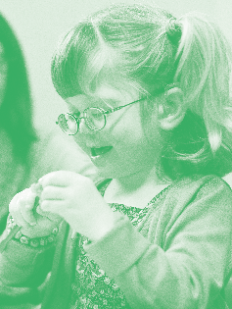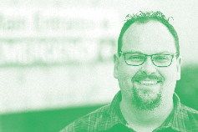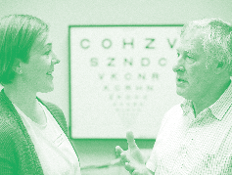

Eye and Ear Annual Review 2015–16 13

Our patients

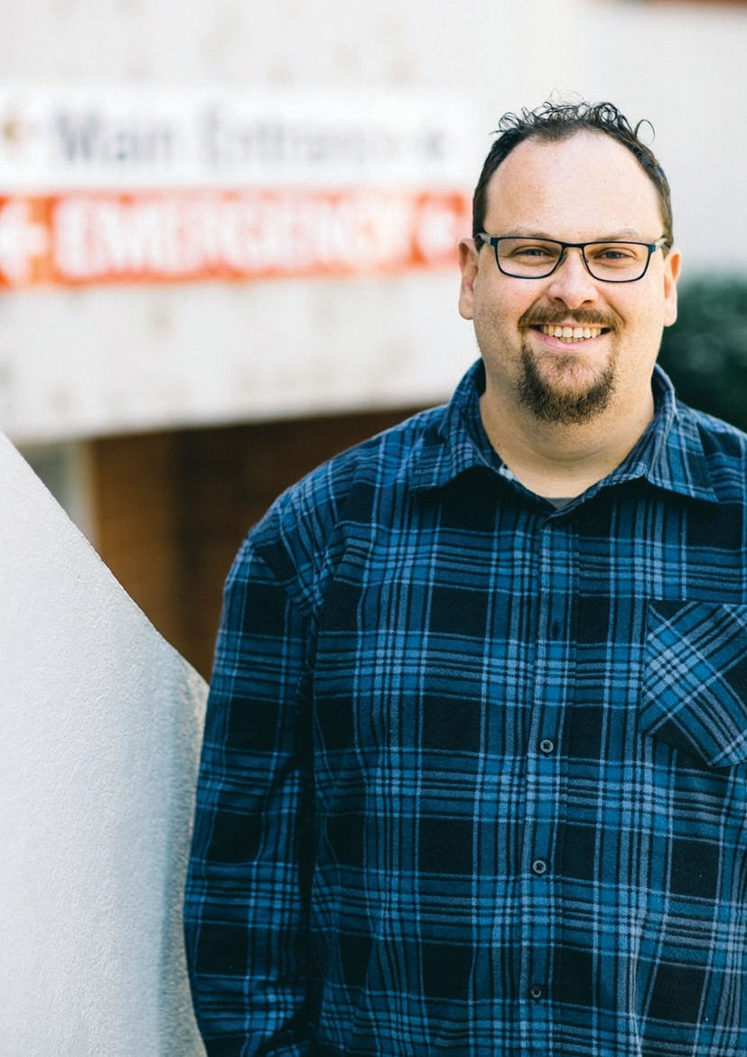Our patients

14 Eye and Ear Annual Review 2015–16

Adam

The Eye and Ear launched an Eye Safety Campaign in February this year to educate the public about the importance of eye safety. The campaign aims to prevent injury by reinforcing safety messages to the general public.

Last year the Eye and Ear Emergency Department saw more than 5,000 patients with eye injuries, which equates to about 14 patients a day.
Up to 90 per cent of these accidents could have been prevented with appropriate eye protection.

Eye and Ear Annual Review 2015–16 15

Hospital has eye safety in its sights with new campaign

The time that it took a sliver of metal to penetrate Adam’s eye was merely fractions of a second, but the impact will stay with him for the rest of his life.

Adam is a father of three and a small business owner-operator specialising in racing motor parts. Last August he was using a metal working lathe, when he noticed that his safety visor was fogging up.

What happened next was a combination of bad luck and the wrong decision.

“At the precise moment that I lifted my visor to clean it, the stationary drill bit shattered into three parts, one of which became embedded in my left iris,” Adam says.

After presenting to the Emergency Department he underwent surgery to remove the metal. The doctors also put a special oil inside the eye to help the retina heal.

Adam has since undergone two more surgeries, and although extremely grateful to the hospital for restoring much of his sight, says that the price he has paid for a momentary safety lapse has been considerable.

“One of the hardest consequences is a blind spot on my immediate left side, which cannot be fixed. This has made me much clumsier, especially in crowds.”

During the four months between surgeries Adam had to make substantial changes to his home life and business. He struggled with his vision and depth perception, making him accident-prone and reliant on others. Being driven by his wife
for weekly check-ups from Skye, in South East Melbourne, also impacted on his family life. He describes these struggles as ‘collateral damage’ to the main injury.

Adam says the staff at the hospital were brilliant, and he had an absolute trust in their care throughout his recovery.
Shockingly, Adam’s injury is one of 125,000 that occur every year in Australia – many of which don’t have such positive outcomes.

Eye and Ear Emergency Department Director Dr Carmel Crock says that many eye injuries could be avoided if correct eye protection is worn when handling chemicals or materials that can break and fly into your eye.

“Not only is eye protection essential, but the type chosen must be suitable. For example, safety glasses will not protect you from bits of flying material coming in from the side. If there are chemicals involved, well-fitting safety goggles
can be worn.

“The purpose of the safety campaign is to remind the public that our eyes are delicate and precious organs that must be protected. It is vital for this message to be taught – even to children and young adults – before they enter the workforce. We could prevent many cases of blindness and severe vision loss just with these simple eye safety messages.”

Adam is a strong supporter of the campaign and attended the launch in February 2016.

“Clearly, there are serious problems with the way people are choosing and wearing eye protection,” Adam says.

He believes the safety campaign underlines the need for people to automatically protect their eyes when conducting any work that puts eyes at risk.

“There is a lot of safety gear on the streets that is not meeting Australian standards,” warns Adam.

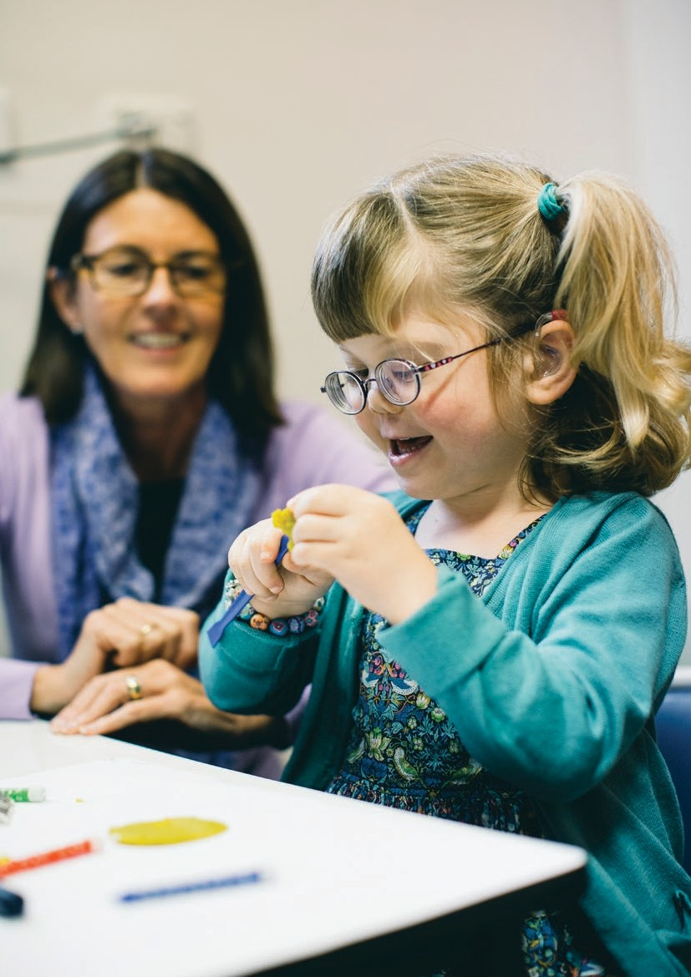Our patients

16 Eye and Ear Annual Review 2015–16

Jemima

Professor Graeme Clark AC performed the world’s first cochlear implant
(or ‘bionic ear’) operation at the Eye and Ear in 1978. Since then, around
3,500 patients have received implants through the hospital.

A cochlear implant consists of two parts, the internal cochlear implant and an external sound processor. These transfer sounds from the environment into electrical signals, which are then presented to the inner ear (cochlea). The hearing nerve fibres in the cochlea pick up the signals and send them to the brain and the brain then perceives these signals as sound. It is an ideal device for people who have a significant hearing loss and receive reduced or no benefit from a hearing aid.

Because the cochlear implant assessment process is complex, the clinic assigns a case manager to every patient to maintain a ‘patient-focused’ approach to care.

Eye and Ear Annual Review 2015–16 17

Jemima’s Journey at the Cochlear
Implant Clinic

Every year about 350 patients pass through the doors of the Eye and Ear’s Cochlear Implant Clinic on a journey to better hearing. They span all ages from seven months to 92.

Jemima Howe is one such patient. Now five,
she has had hearing loss in both ears all her life, due to a group of genetic disorders known as Stickler syndrome.

Stickler affects the tissues of the body especially the ears, face and joints.

Jemima was fitted with hearing aids at four months and this greatly assisted her with speech and language development. Last October she was referred by her audiologist to the Cochlear Implant Clinic to investigate a cochlear implant for her right ear, which has severe to profound hearing loss. Her left ear is less affected with moderate to severe hearing loss.

As part of the hospital’s dedication to patient centred care, Jemima was immediately assigned case manager Denise Courtenay. Denise is a speech pathologist and works as part of the clinic’s team of audiologists and surgeons to ensure a smooth and coordinated patient experience.

“We come from Baranduda (near the NSW border) but live in Melbourne during the week so that Jemima can attend the Furlong Park School
for Deaf Children, so having Denise as a case manager has been fantastic,” Jemima’s mother Louisa says.

Denise has worked in the clinic for seven years. She says it is important to build one-on-one relationships with patients and their families to help them through the complex assessment and testing process required for all cochlear implants.
“Jemima is extremely compliant with the testing. Her ability to give it a go is great for dealing with these challenges,” Denise says.

Jemima underwent the delicate three-hour surgery in March this year. After healing occurred, she was fitted with the sound processor. Jemima is now undergoing a weekly ‘sound mapping’ process with Denise and an audiologist to ensure that the implant is providing the right stimulation of sound.

‘Maps’ are a series of programs that are loaded into the processor, ranging from soft, then incrementally getting louder. A patient is gradually cycled through the maps until a stable program is reached in the processor.

At the moment Denise sees Jemima weekly, but this will stretch out as the initial mapping process draws to a close.

Louisa is very pleased with how well her daughter has adapted to the implant, in part due to the care and support of Denise.

“Jemima is really proud of her implant. As soon as she is out of her bath she wants it turned on!”

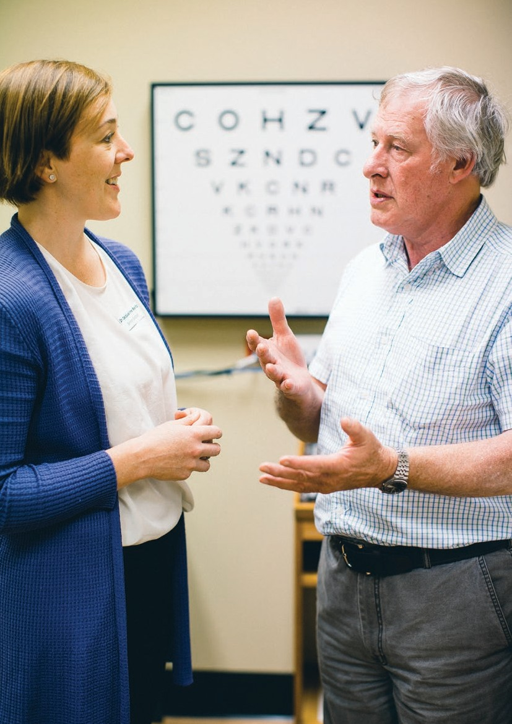Our patients

18 Eye and Ear Annual Review 2015–16

Greg

The Corneal Department has been conducting a clinical trial of a new transplantation technique known as Ultrathin DSAEK. The trial forms part of the Eye and Ear’s commitment to constantly improve and develop surgical services for patients.

For over 100 years, corneal transplantation has involved replacing a diseased or damaged cornea with an entire donor cornea. Medical science has recently refined this process with a partial transplantation technique that targets only the diseased corneal layers called Descemet’s Stripping Automated Endothelial Keratoplasty (DSAEK). Developed in 2009, Ultrathin DSAEK takes this technique one step further by using thinner donor tissue, resulting in better outcomes for patients.

Eye and Ear Annual Review 2015–16 19

Corneal transplant trial a first for Victoria

Greg Bevan loves using his hands for DIY around his home in Ferntree Gully, but knew something had to be done when deteriorating vision in his left eye made this increasingly difficult.

“I kept putting it off, until my wife insisted I see an optometrist,” he jokes.

The optometrist immediately identified a cataract and referred Greg to the Eye and Ear for further investigation.

Dr Jacqueline Beltz of the Corneal Department subsequently diagnosed a degenerative disease of the cornea called Fuchs’ Corneal Endothelial Dystrophy.

“The cornea is the clear window at the front of the eye. There is a single layer of cells on the inside of the cornea that keep it fresh and clean by constantly pumping out fluid. In Fuchs’ Dystrophy, these cells deteriorate and do not function properly,” Dr Beltz explains.

Greg was scheduled for cataract surgery and also agreed to take part in the Ultrathin DSAEK clinical trial for a transplant of the innermost layers of the cornea.

Ultrathin DSAEK is a further improvement on DSAEK surgery because it utilises less corneal tissue (less than 0.1 of a millimetre). This results in a faster recovery time, less chance of donor rejection and slightly better vision. Greg is one of
ten patients who have completed the clinical trial.

Dr Jacqueline Beltz is the first surgeon in Victoria to perform this particular technique and believes trials of this nature are important for both the advancement of surgeries and the community.

“We can only go so far with laboratory work. Eventually new techniques are ready to be performed on real people. Through these clinical trials, patients have access to newer and
hopefully better surgeries much earlier than would otherwise be available,” Dr Beltz says.

Before Greg’s surgery he was administered a local anaesthetic and a relaxant so that although conscious, he felt no pain.

Dr Beltz removed the dead cells from the back of his cornea. She then prepared the new cornea by dissecting an extremely thin layer of the healthy donor cornea. This was then inserted into Greg’s eye, unravelled, and attached onto the inside of his cornea. He had about five stitches, and stayed in hospital for two nights.

Greg was amazed at the experience, which went smoothly.

“I could actually see the doctors doing stuff to my eye! It was a bit like being in a car and seeing people through a windscreen.”

Greg has enjoyed excellent clear vision in the
eye ever since. However, his sight in the right eye is now rapidly degenerating and will also require a transplant.

Dr Beltz is also very happy with Greg’s surgical results.

“He has been a pleasure to look after, and I look forward to hopefully providing as good an outcome for his other eye later this year.”

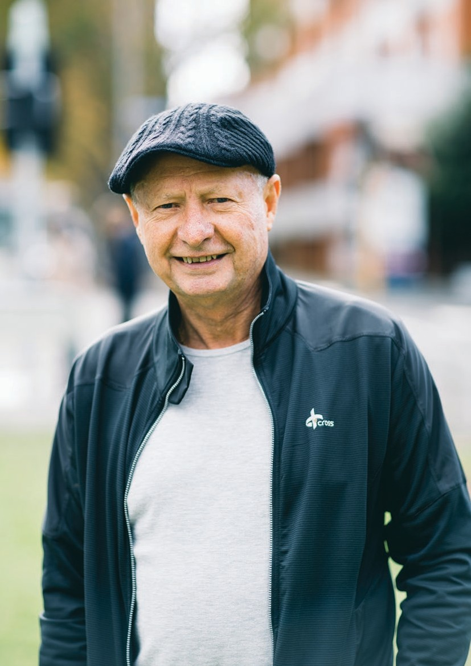Our patients

20 Eye and Ear Annual Review 2015–16

Jim

Eye and Ear Annual Review 2015–16 21

Sometimes a small procedure makes a big difference

Last year, Jim McCalman was enjoying his life. He was slowly winding down his importation business and was looking forward to spending more time on the golf course and socialising.

But in September he started to suffer from frequent nosebleeds. They were unpredictable, striking him every two or three days and requiring a lot of ice and towels to stem the flow.

“Even in the shower, I had to make sure it wasn’t too hot or the bleeding would start,” Jim explains.

Jim also has a heart condition requiring the blood thinning medication Warfarin. This was making the bleeding heavier.

In December, Jim had a procedure on his nose by an ear, nose and throat surgeon (ENT) under general anaesthetic with a hope of fixing the problem. However, in less than a week the bleeding started again.

“It was getting really bad. I went on a riverboat holiday with my wife Jo and I was bleeding every day and night. It was really frustrating. I couldn’t go out much in case it would start bleeding and,
if I did decide to go out, I would have to leave early if a bleed started.”

He realised something had to be done.

“I basically went through five months of nosebleeds, getting progressively more tired, headachy and frustrated.”

Upon their return he was referred to senior ENT
surgeon Halil Ozdemir by an emergency physician.

“Jim had a small reddish lesion on the right side of the nasal septum that was causing the bleeding. This kind of lesion would have caused nosebleeds in anybody, but because Jim is on Warfarin, this made the bleeding much worse,” Mr Ozdemir explains.
Mr Ozdemir attempted to cauterise the lesion,
but when this failed to stop the bleeds he decided surgery was the next step. The procedure was quick and conducted under local anaesthetic.

Mr Ozdemir has worked at the Eye and Ear for 22 years and has dealt with a wide range of medical conditions and people.

“Sometimes a small procedure can make a huge difference to someone’s life. Just imagine being in the car, playing golf, or eating out, and having a nosebleed? In Jim’s case this was really bad and I am happy that we were able to help him,”
Mr Ozdemir says.

Jim cannot speak highly enough of Mr Ozdemir and the staff.

“Mr Ozdemir has genius hands! He also had a genuine concern for me and understood what I was going through. All of the hospital staff were brilliant and made my experience as smooth as possible.”

Jim’s life has now returned to normal and he is back on the golf course, working on lowering his handicap.

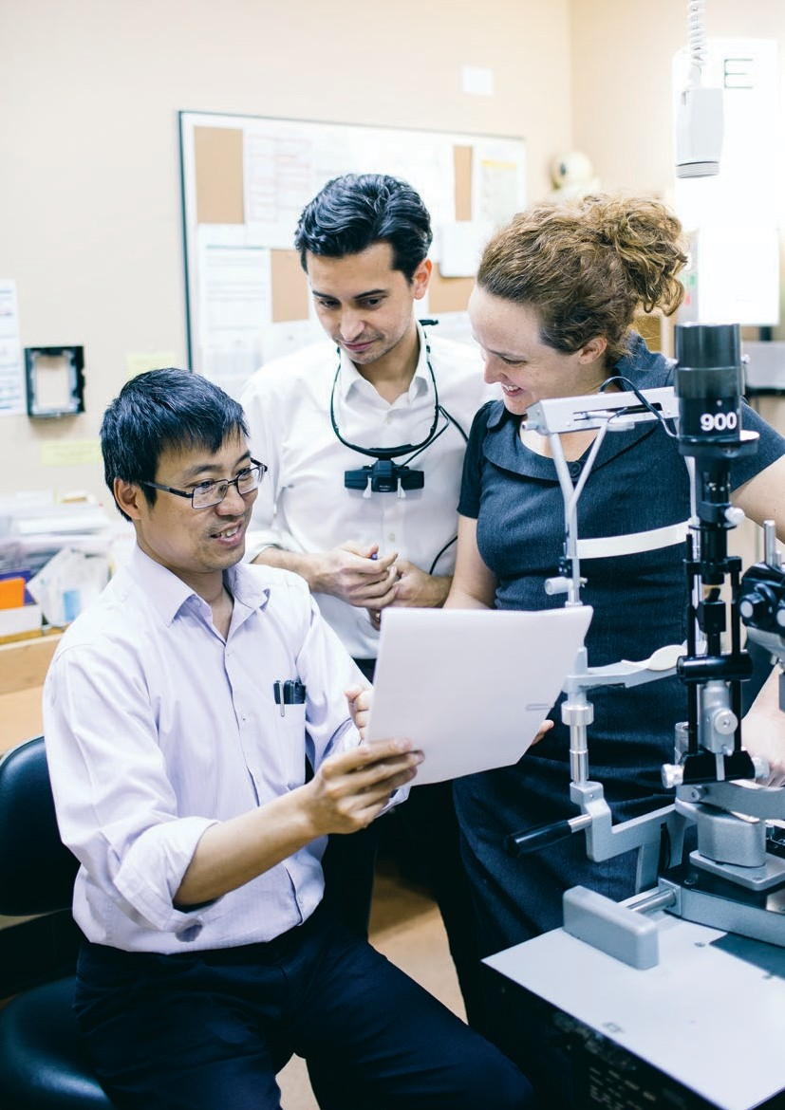

22 Eye and Ear Annual Review 2015–16

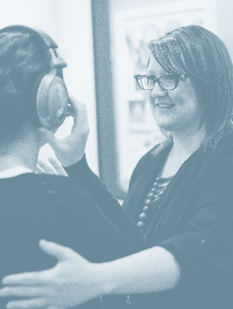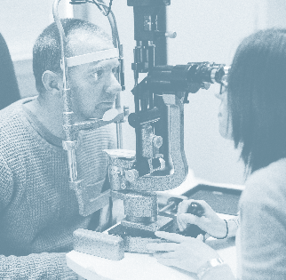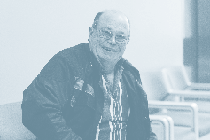

Eye and Ear Annual Review 2015–16 23

Our teaching
and research

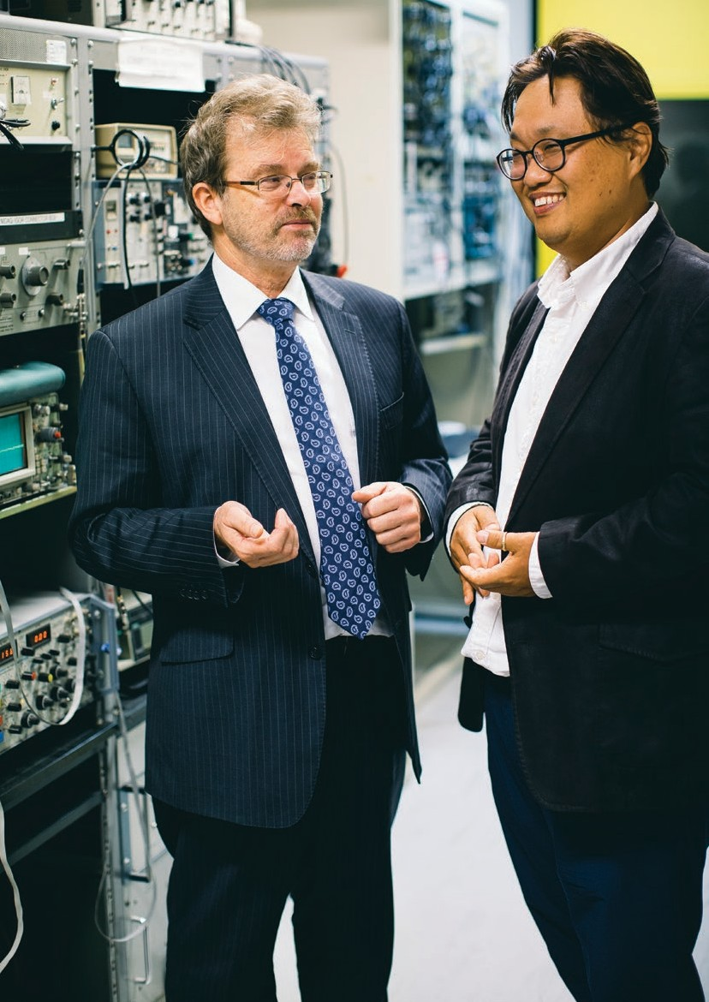Our teaching and research

24 Eye and Ear Annual Review 2015–16

Stephen and June

In 2015-16 the Eye and Ear hosted about 40 visiting medical staff from Australia and overseas who were keen to learn from our experts and take this knowledge back to their hospitals to improve treatment for their patients.

Visiting observers such as medical students or young doctors attend clinics for several weeks to observe. Academic visitors stay longer and often do research. They might see a problem in clinic and go to the laboratory to research an idea, resulting in better treatment for the next generation.

These visits also benefit the Eye and Ear staff and patients as they enable exchange of ideas, skills and information.

Eye and Ear Annual Review 2015–16 25

Spreading our teaching worldwide

Ear surgeon Dr June Choi performed a handful of cochlear implants in his home country South Korea but came to the Eye and Ear to hone his surgery
and research skills at a world class institute.

Dr Choi, an otologic surgeon at Ansan Hospital and an Associate Professor in Korea University’s Department of Otolaryngology, Seoul, is in the middle of a two year stint as a researcher and academic visitor in the Department of Otolaryngology at the Eye and Ear.

“I have always been interested in the recovery of hearing through cochlear (bionic ear) implantation. I wanted to join the studies of the world-class research group at the Eye and Ear during my sabbatical so I asked Professor Stephen O’Leary whether I could participate,” Dr Choi says.

Dr Choi joined an Eye and Ear research team studying why some patients experience dizziness after cochlear implants. He is also observing clinics and surgery including cochlear implantation and participates in collaborative discussions between researchers, doctors and students. Providing
input and contributions to collaborative discussions is one way he can give back.

“It’s a steep learning curve but it has been wonderful.”

The Korean surgeon says doctors in both countries have a passion for patients and for seeking the academic truth, but communication between researchers is freer in Australia as collaboration is an important part of our culture.

“In Korea, the professor talks and the students listen, few questions. In Australia, researchers and students discuss with professors and doctors. I would like to challenge the Korean system and introduce this,” Dr Choi says.

Professor O’Leary, a senior ENT surgeon at the Eye and Ear, and the William Gibson Chair of
Otolaryngology at the University of Melbourne, says the relationship between the university and the hospital means doctors and researchers can improve patient outcomes using clinical trials and basic research.

“The Eye and Ear is the premier hospital in Australia for clinical and research experience in ears and the only place in Victoria with academic links to otology,” Professor O’Leary says.

“It is internationally renowned for its focus on ear disease and the bionic ear.

“Medical students and young doctors come here at different times in their career such as for research and ENT training, but our international reputation means more senior doctors come to learn clinical work and research.

“June was an established ear surgeon who came to gain a greater nuanced understanding of ear disease, immerse himself in a world class institute, take home a different treatment philosophy and better appreciation of academic work. Patients worldwide will benefit from exchanges like this and people like him will
go home and in future run departments.

“It’s important in medicine to have broader views than local perspectives, hence my role as a mentor. Medicine is an international sharing of ideas for the benefit of patients.”

Dr Choi says: “Joining excellent research and having Professor O’Leary as my academic mentor is very rewarding and I am achieving my goals. When I return, memories of this hospital will make me smile.”

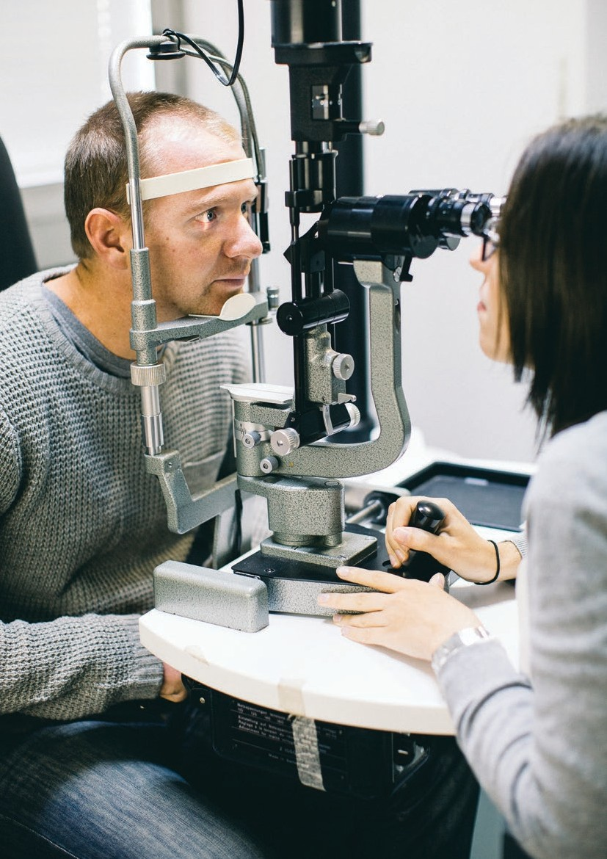Our teaching and research

26 Eye and Ear Annual Review 2015–16

Tusker

Uveitis is inflammation of the uveal tract, which lines the inside of the eye behind the cornea. It can produce swelling, destroy eye tissue and damage the structures in the eye, causing reduced vision or blindness.

In many cases the cause is unknown but known causes include autoimmune disease such as arthritis, sarcoidosis and ankylosing spondylitis, and infection such as herpes, syphilis and TB.

Types include infectious and the more common type in Australia, non-infectious (autoimmune).

Uveitis affects people of all ages but is more common in young and middle-aged people.

Eye and Ear Annual Review 2015–16 27

New treatment prevents vision loss

Tusker Patterson was just a boy when diagnosed with the sight-threatening condition uveitis, but
20 years of coming to the Eye and Ear for treatment have prevented him from going blind.

Medical management has meant that Tusker, from Maldon, near Bendigo has been able to continue working as a production planner with a smallgoods company. He is currently in a trial where he regularly self-injects a promising medication, Humira.

“The main symptom is blurry vision when I have flare-ups but medication generally controls flare- ups and blurriness. I also have black spots or
‘floaters’ in front of my eyes pretty consistently.” Tusker explains.

Tusker describes uveitis as his immune system attacking his eyes. As swelling in the back of the eye increases, vision goes blurry. With each flare-up is the risk of permanent damage and vision loss.

“I’ve tried different medications but Prednisolone was the most effective and the only one that consistently worked. Because it is a steroid it reduces the inflammation, but there can be nasty side effects such as osteoporosis if you are on it long term.”

His doctor recommended he apply for the trial through the Centre for Eye Research Australia (CERA) which is based at, and works collaboratively with, the Eye and Ear.

“It has been fantastic. Fairly quickly after going on Humira I noticed a big improvement in my vision and I have been able to completely come off the steroids.

“It’s the best treatment for me and controls the disease better than anything else.”

Head of the Eye and Ear’s Ocular Immunology Clinic, consultant ophthalmologist specialising in uveitis, Associate Professor Lyndell Lim, is head
of the clinical trials unit at CERA and a principal research fellow at the University of Melbourne.

“Industry knows we run the clinical trials unit at CERA to a very high standard and therefore asks us to run their trials,” she said.

“CERA’s collaboration with the Eye and Ear means we can offer these trials to Eye and Ear patients.”

Drug company, Abbvie asked CERA to take part in the global Visual Trial in 2008 for people with sight-threatening non-infectious non-anterior uveitis.

“All patients in our trial had active diseases and were taking high dose steroids but since the trial, many have been able to reduce or in many cases stop steroids and not relapse. For these patients, it’s been a better treatment,” Professor Lim says.

Humira is injected under the skin, initially by a physician, then patients self-inject fortnightly at home. It has been on the market for 10 years for rheumatoid arthritis, irritable bowel syndrome and juvenile idiopathic arthritis (which can
cause uveitis) but is being trialled for the new indication, uveitis.

Associate Professor Lim and Tusker are hoping the results will enable TGA approval and PBS listing so Humira is available for uveitis patients.

Tusker says: “Without the Eye and Ear and all the doctors over 20 years taking care of me and the fantastic researchers at CERA, I would be blind. They’ve saved my vision.”

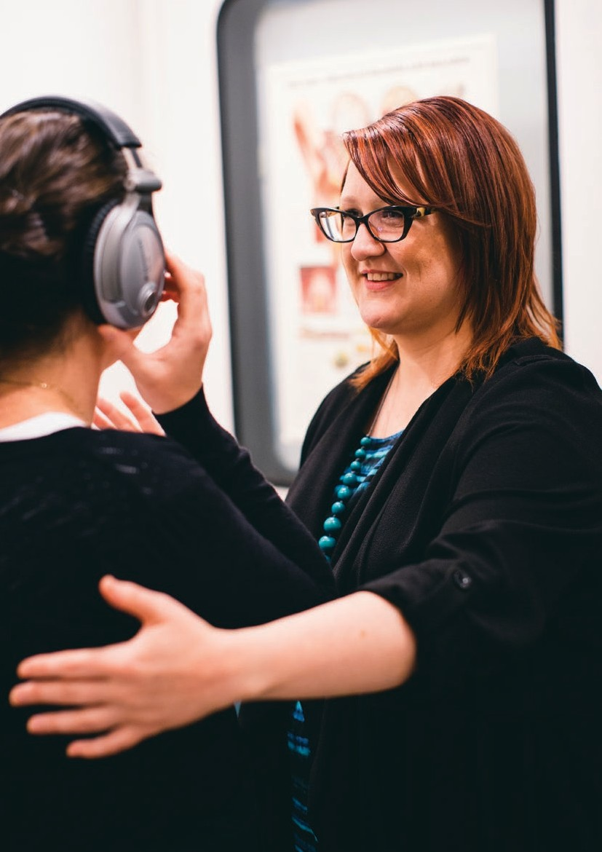Our teaching and research

28 Eye and Ear Annual Review 2015–16

Jessica

Peter Howson was the Deafness Foundation’s first president and held roles at the Eye and Ear. The foundation and the hospital worked together to establish The Peter Howson Deafness Fellowship and contribute equally to this two year research position.
Dr Vitkovic was the second recipient of the Fellowship, first awarded in 2011. The hospital’s research manager Jane King said the Fellowship supports
important, innovative research that directly benefits patients with
deafness and achieves the hospital and foundation’s aims of improving service delivery to hearing impaired people. It also provides opportunity to translate research findings to clinical practice and for patients to participate in research.

Eye and Ear Annual Review 2015–16 29

Hearing important for balance

Giving hearing aids to people with hearing loss improves their balance and may reduce their risk of falls and fractures, a new study shows.

Audiologist Dr Jessica Vitkovic from the University of Melbourne conducted the ground- breaking research which found that for people with hearing impairment, a significant additional benefit of wearing a hearing aid was that it helped aid their balance.

She said the finding was new as the impact of a hearing aid on balance had not been studied in hearing impaired people.

“Health professionals can now tell people with hearing loss that not only will a hearing aid help them hear better, but it has the added benefit of improving balance and potentially reducing falls risk,” Dr Vitkovic says.

“Falls in the elderly are a huge socioeconomic burden but wearing a hearing aid could reduce their chances of falling and fracturing a hip.

“It doesn’t have to be complete hearing loss. Even losing some hearing can affect your balance, and wearing a hearing aid can improve balance.”

Dr Vitkovic said people who recently lost hearing anecdotally reported that balance was often affected.

“Those in our hearing clinic often said that they felt a bit clumsy since their hearing loss,” Dr Vitkovic says.

This was the reason she applied for the Peter Howson Deafness Fellowship – to investigate the relationship between hearing loss and balance.

Dr Vitkovic studied people with and without hearing loss, and with and without balance problems and measured their sway in different sound environments while standing on a
Wii balance board. Sway is a measure of unsteadiness; if someone is unbalanced they will sway more.

Sway was measured in a soundproof room with participants wearing ear plugs to replicate no sound, then in a room with sound and speakers.

The trial confirmed hearing is used for balance control as people with and without balance problems swayed more when there was no sound compared with sound. Even people with normal hearing and no balance problems had poorer sway when sound was removed. For those with hearing loss, wearing a hearing aid improved balance and they swayed less.

“The effect of sound in the environment is that it keeps people steadier and they have more spatial awareness,” Dr Vitkovic says.

“People felt mildly disorientated without sound. Sound gives them something to focus on and they reported feeling more confident. Sound gives stability, helps people localise themselves within their environment and provides information which allows them to maintain their balance.

“Vision and touch are strong cues to help maintain balance, and while hearing is relatively minor compared to them, it is still significant.”

Dr Vitkovic, Senior Lecturer and Director of Teaching and Learning in the University of Melbourne’s Department of Audiology and Speech Pathology, is teaching the findings to her students. She will also spread the message worldwide when her study is published in Audiology and Neurotology and she speaks
at the 2016 World Congress of Audiology in
Vancouver in September.

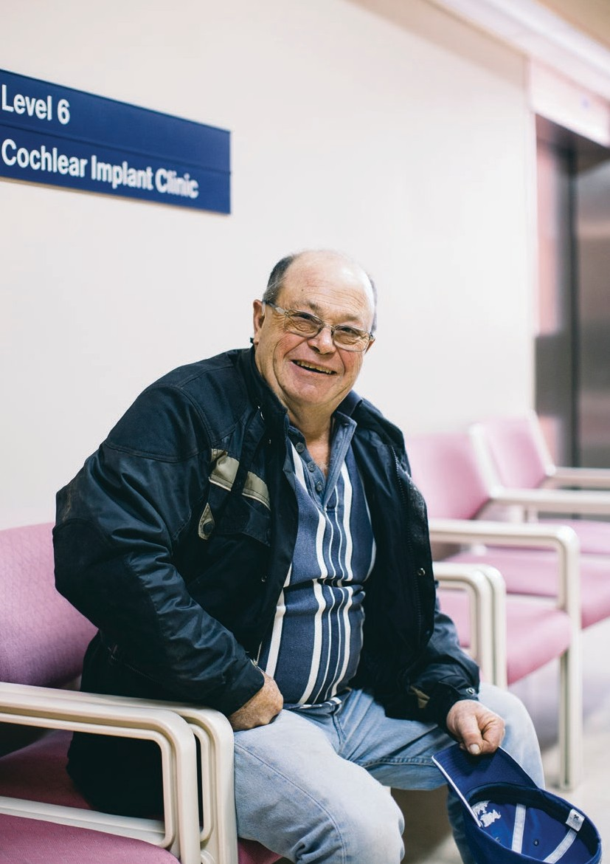Our teaching and research

30 Eye and Ear Annual Review 2015–16

Marty

This world first clinical trial has established the safety and feasibility of a combined drug-device approach, using the implanted electrode array as
a vehicle to deliver a therapeutic drug-load directly to the inner ear over an extended period of time post-surgery – leading to improved efficiency of the cochlear implant.

The HEARing CRC is a consortium of 23 universities, hospitals, early intervention agencies, government bodies and industry partners, Cochlear and Sivantos, funded by its members and the Australian Government’s Cooperative Research Centres Programme. It is dedicated to improving the prevention and remediation of hearing loss in Australia and world-wide.

Eye and Ear Annual Review 2015–16 31

Turning lives around

Marty O’Connell says receiving a cochlear implant did more than just change his life; it saved his life.

“I had earache issues as a boy and at 40 I was diagnosed with Meniere’s disease. My hearing reduced to about 12 per cent in my left ear and 46 per cent in my right ear. My life was very ordinary as it wasn’t easy to understand people and I also had to contend with tinnitus. It was extremely frustrating for myself and others, and the rudeness of some people pushed me into anxiety.”

Marty, 55, from Tylden near Kyneton in rural Victoria, had his first cochlear implant surgery in 2011 which provided 95 per cent hearing in his left ear.

“I consider it life-saving because being able to hear improved my mental health. There was a lot of psychological damage but I am in a safe place now and I am calmer. I can enjoy music again for the first time in ten years,” he says.

“The Eye and Ear has been a very positive experience, not just the surgeons and after care, but all the people at that hospital are so friendly, patient and understanding. I was in a fragile place
but the staff were phenomenal. It turned my life around.”

Marty was so appreciative he volunteered to trial an experimental electrode array for his second cochlear implant.

Developed by the HEARing Cooperative Research Centre at the University of Melbourne, and the Eye and Ear, the electrode array has been modified with tiny repositories of dexamethasone, an anti- inflammatory steroid, spaced along it. Following surgery, the drug leaches out directly into the cochlea for more than a month.

Marty received the experimental device in
February 2014. With two cochlear implants,
he is better able to judge the direction of sound, and also notices a reduction in his tinnitus and that his Meniere’s is more manageable.

“I’m happy and proud I was part of the research because, to me, the implants really were life- saving,” he says.

Led by ENT Associate Professor Rob Briggs and audiologist/researcher Professor Bob Cowan, the study evaluated whether releasing a drug directly into the cochlea post-surgery would reduce the degree of inflammation and potentially improve the electrical interface of the implant with the auditory nerve. This could lead to lower power requirements, meaning future batteries could
be smaller and last longer.

The researchers spent six years conducting extensive safety studies before starting the trial with eight patients from the Eye and Ear, and two from the Sydney Cochlear Implant Clinic.

Trial results confirmed the experimental implant didn’t compromise speech perception outcomes, but happily, the electrical interface characteristics were significantly improved.

“Twelve months post-surgery, the improved electrical interface remains for all in the experimental group. It is likely a follow-on trial will evaluate benefits in preserving residual hearing, an important issue as more patients with hearing are having cochlear implants,” Professor Cowan says.

Results have been presented at international conferences and well-received by the medical community. The Eye and Ear’s contribution through the HEARing CRC is important in providing guidance to Cochlear’s design of future cochlear implant devices and improving patient outcomes.

32 Eye and Ear Annual Review 2015–16

Our Partners

Our Research Partners Bionic Vision Australia HEARing CRC
The Bionics Institute
The Centre for Eye Research Australia
The University of Melbourne

Our memberships
The World Association of Eye Hospitals
Members: Tun Hussein On National Eye Hospital, Kuala Lumpur, Malaysia; The Department of Ophthalmology of the University Hospital Leuven, Belgium; Singapore National Eye Centre, Singapore; Moorfields Eye Hospital, London, UK; The Royal Victorian Eye and Ear Hospital, Melbourne, Australia; Rutnin Eye Hospital, Bangkok, Thailand; St Eriks Eye Hospital, Stockholm, Sweden; The Rotterdam Eye Hospital, The Netherlands; The Royal Victoria Eye and Ear Hospital, Dublin, Ireland; Jakarta Eye Center, Jakarta, Indonesia; Tianjin Medical University Eye Centre, China; Sydney Eye Hospital, Sydney, Australia; Kim’s Eye Hospital, Seoul, South Korea; Aditya Jyot Eye Hospital, Maharashtra, India; St John Eye Hospital, Jerusalem, Israel; Kellogg Eye Center, Ann Arbor, USA; Fondation Asile des Aveugles, Lausanne, Switzerland; The Metta Eye Hospital (Mettapracharak (Wat Rai Khing) Hospital), Bangkok, Thailand; Ispahani Islamia Eye Institute and Hospital, Bangladesh; Bascom Palmer Eye Institute, USA; Massachusetts Eye and Ear Infirmary, USA; Phillips Eye Institute, USA; Wilmer Eye Institute at Johns Hopkins, USA; Emory Eye Center, USA; New York Eye and Ear Infirmary, USA; Wills Eye Hospital, USA; The
Eye Hospital, Turino, Italy; Hoftalon Eye Hospital, Brasil.

The American Association of Eye and Ear
Centers of Excellence
Members: Bascom Palmer Eye Institute, Florida, USA; Emory Eye Centre, Georgia, USA; Massachusetts Eye and Ear Infirmary, Massachusetts, USA; Moorfields Eye Hospital, London, UK; New York Eye and Ear Infirmary, New York, USA; Phillips Eye Institute, Minnesota, USA; The Royal Victorian Eye and Ear Hospital, Melbourne, Australia; Rutnin Eye Hospital, Bangkok, Thailand; Show Chwan Health Care System, Taiwan; Singapore National Eye Centre, Singapore; St Eriks Eye Hospital, Stockholm, Sweden; Wills Eye Hospital, Pennsylvania, USA; Wilmer Eye Institute, Maryland, USA; King Khaled Eye Specialist Hospital, Riyadh, Saudi Arabia

Victorian Healthcare Association

Disclaimer
While every effort has been made to ensure the accuracy of this document, The Royal Victorian Eye and Ear Hospital makes no warranties in relation
to the information contained herein. The Royal Victorian Eye and Ear Hospital, its employees and agents disclaim liability for any loss or damage which may arise as a consequence of any person inappropriately relying on the information contained in this document.

Produced by Marketing and Communications, The Royal Victorian Eye and Ear Hospital Photography by Leo Farrell
Designed by Viola Design

Environmental Profile
Both the printer and the paper used to
produce this document have Forest Stewardship Council® (FSC®) and ISO 14001 environmental certification. FSC® is a Chain of Custody (COC) process. IS0 14001 is the international standard of Environmental Management Systems (EMS) designed to ensure the continuous
measurement and reduction of environmental impacts. This publication is printed using vegetable based soy inks.

The Royal Victorian Eye and Ear Hospital

E info@eyeandear.org.au
T +61 3 9929 8666
F +61 3 9663 7203
TTY +61 3 9663 8052

Main Hospital
32 Gisborne Street East Melbourne Victoria 3002

Eye and Ear on the Park
St Andrews Place East Melbourne Victoria 3002

eyeandear.org.au

