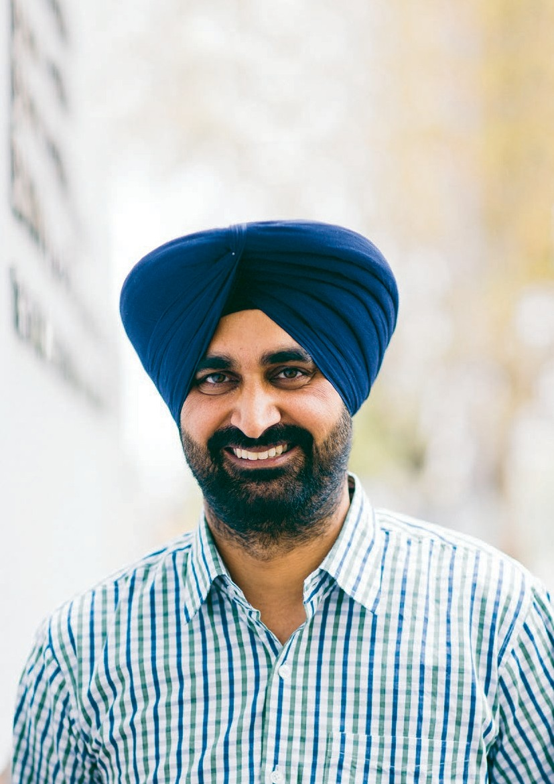

Our stories
Annual Review 2014–15

Contents

01

Welcome to our hospital 02
ANNUAL REVIEW 2014–15

Our people 03
Ileana Guizzo Representing the community 04
Dr Richard Stawell Sharing expertise through international volunteer work 06
Sinead Cucanic A passionate mentor 08
Jagdeep Singh Thind Outstanding administrative and problem solving skills 10
Our Senior Medical Staff 12

Our patients 13
Lorraine Lack Helping the dizzy back on their feet 14
Patricia Goddard Ground breaking model of service delivery 16
Steven and Elizabeth Success in working collaboratively 18
Janet Holt Improving access to regional patients 20

Our teaching and research 23
Dr Al Motavalli Investing in education 24
Dr Dean Cugley Teaching the next generation 26
Dr Sharan Sidhu Kick-starting careers 28
Ian Jack World-first research 30

Our partners 32

Welcome to our hospital
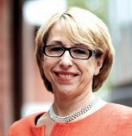02
THE ROYAL VICTORIAN EYE AND EAR HOSPITAL

The past 12 months at The Royal Victorian Eye and Ear Hospital (the Eye and Ear) have been busy and exciting.

As Australia’s leading provider of specialist eye, ear, nose and throat care services; the Eye and Ear continued its proud tradition of excellence in clinical care, teaching and research. We also
embraced many changes at the hospital as we look to the future through our redevelopment project.

Excellence in research and education
For more than a century, the Eye and Ear has been a world-leader in research and education. Our dedication to improving the lives of patients is
made stronger through collaboration with research partners that share our values and commitment
to service. We currently have 217 active research projects being undertaken in conjunction with
our partners such as the Centre for Eye Research
Australia (CERA), the University of Melbourne, the Bionics Institute, Bionic Vision Australia and HEARing CRC. We also remain committed to educating future health care professionals by providing students with competitive training programs and opportunities to learn in hands-on clinical settings.

Leaders in eye and ear health
Our commitment to excellence in training, research and patient centred care has attracted the best and brightest medical and scientific minds to the Eye and Ear. Our multi-disciplinary team of eye and ear surgeons, anaesthetists, nurses, emergency and specialist medical staff, allied health professionals and support staff all work together to provide the highest level of professionalism and care. To ensure we continue to attract professionals that share our passion for innovation, the hospital is accredited
by relevant colleges, including The Royal Australian and New Zealand College of Ophthalmologists (RANZCO), The Royal Australian College of Surgeons (RACS), The Royal Australian and New Zealand College of Anaesthetists (ANZCA) and the Royal Australasian College of Emergency Medicine (ACEM).
Caring for our community
Each year, the Eye and Ear helps to improve the quality of life for over 250,000 patients and their families. Our constant focus is on providing the highest possible standards of patient centred care. We’re always looking for new ways to improve patient access and clinical service standards by working with patients and their families. We also continue to build our relationships with local GPs and our network of metropolitan, regional and rural health partners.

Cementing our vision for the future The hospital’s redevelopment project progressed significantly last year. It is exciting and rewarding to see the hard work and planning coming to fruition.
The redevelopment will make access to the building
much easier for patients and allow the hospital to better meet the demand for eye, ear, nose and throat services. To coincide with the redevelopment project we also launched our new brand. The new branding and visual identity of the hospital reflects our innovative culture and long history as a specialist tertiary hospital.

I hope you enjoy reading more about how we have provided care for the Victorian community over the past 12 months.

Ann Clark
Chief Executive Officer

03

Our people
ANNUAL REVIEW 2014–15

A dedicated
multi-disciplinary team

Our people

04
THE ROYAL VICTORIAN EYE AND EAR HOSPITAL

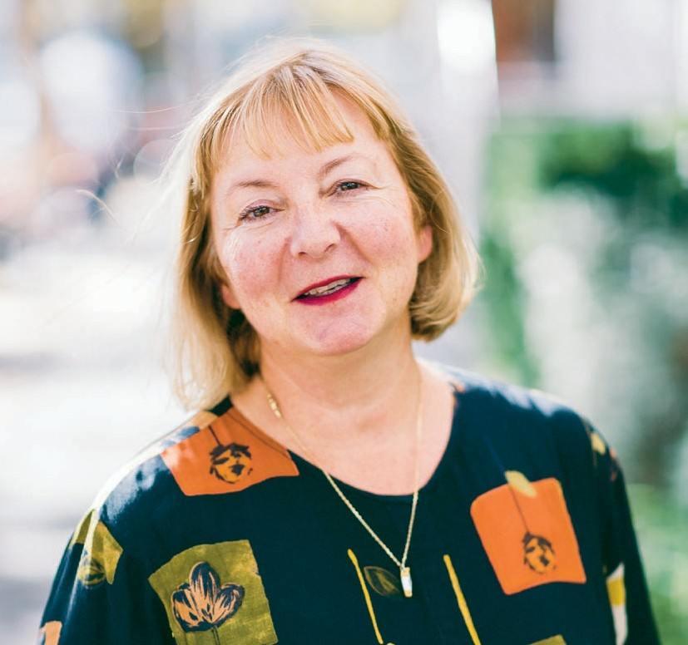

Ileana Guizzo

“I see my role as a consumer as being
a reminder, being a voice, particularly for those people who are not able to pick up the phone and make a complaint, are not computer literate and for
those who may have difficulty in communicating.”
The Eye and Ear adheres to the
National Safety and Quality
Health Service Standards (National Standards), a Federal Government initiative aimed to improve safety and quality systems in Australia’s health care.

In December 2014, the Eye and
Ear underwent an accreditation
on the 10 National Standards. The
Eye and Ear satisfactorily met all
209 core and 43 developmental actions, and staff and consumers were awarded 23 Met with Merit ratings. The hospital coordinates an organisational wide approach to continually meet all of the National Standards.

Representing the community
05
ANNUAL REVIEW 2014–15

Growing up in country Victoria, Ileana Guizzo understands how important it is for everyone to have a voice, especially in health care.

As well as being on the Eye and Ear’s Consumer Register, Ileana is a member of the hospital’s Clinical Quality Committee and Consumer Advisory Committee. Both committees ensure the consumer voice and opinions are heard when reporting on the hospital’s safety, quality and risk management.

“I see my role as a consumer as being a reminder, being a voice, particularly for those people who are not able to pick up the phone and make a complaint, are not computer literate and for those who may have difficulty in communicating,” Ileana says.

“I also remind people that our focus should not always be Melbourne centric, even though Victoria is not a big state, it can still be remote.”

The Eye and Ear’s Risk and Quality Manager, Linda Miln says the hospital is very grateful for Ileana’s contributions.

“We are so fortunate to have consumers like Ileana who volunteer their time and contribute to the hospital’s governance. Essentially, Ileana is part of the quality team that ensures we strive for constant improvement,” Linda says.

“Ileana takes her role seriously, she is well informed and not afraid to challenge decision-making, which can sometimes be intimidating in a room full of clinicians, and yet Ileana raises matters sensitively so all aspects of patient care are considered.”

Ileana says she is always kept up-to-date
of proposed changes in service delivery, the redevelopment, closing or setting up of services and proposed new partnerships. She says being informed is important, but it is also important
to be actively involved.
“I think if you agree to be a consumer representative you also bring with it a responsibility, you should be involved, you should read your papers, you should go to the meetings—if you do that, then you are fulfilling your part
of the bargain,” Ileana says.

As part of the National Safety and Quality Health
Service Standards accreditation process in late
2014, Ileana gave an opening address to the surveyors.

“I reminded the surveyors that the hospital’s focus was about the patients and the people who receive the treatment. But also that I believe that the National Standards are important, because we as consumers don’t have the clinical background to say if something is up to scratch or not, whether it is the best practice or if the right research is being done.”

The culture of the Eye and Ear was an important factor when Ileana decided she would become involved with the hospital.

“Another thing that persuaded me to become involved as a community member was whenever I’ve walked through the hospital door, a concierge volunteer has come up to me and said ‘Are you ok, do you need some help?’ They are just an amazing group of people.”

Our people

06
THE ROYAL VICTORIAN EYE AND EAR HOSPITAL

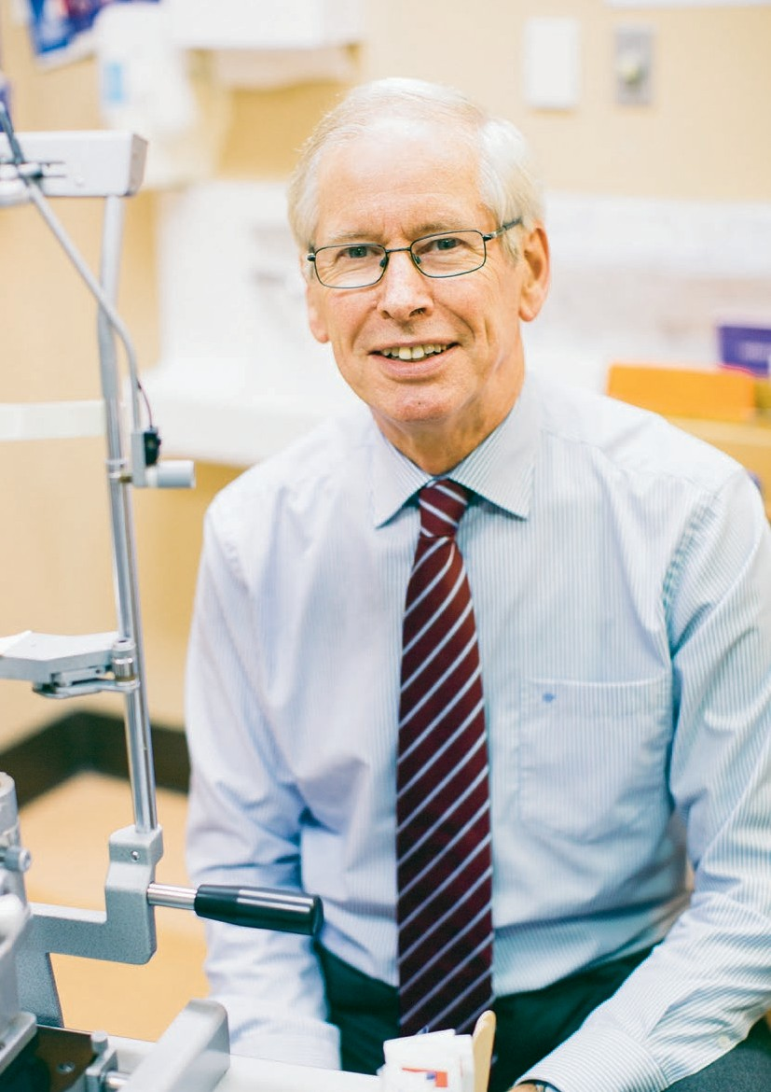

Dr Richard Stawell
Ocular Immunology is a specialised branch of ophthalmology that diagnoses and treats patients with a range of inflammatory eye diseases known generally as uveitis. The causes of uveitis are numerous but cannot always be determined in
an individual. Some known causes include systemic autoimmune diseases such as sarcoidosis, rheumatoid arthritis and Behcet’s syndrome. Uveitis can cause vision loss, pain and sensitivity to light. Once diagnosed ophthalmologists can treat uveitis using medication. Early detection is important as the prognosis for patients varies greatly. If left untreated, uveitis can result in permanent vision loss.

Sharing expertise through international volunteer work 07
ANNUAL REVIEW 2014–15

Dr Richard Stawell, a highly regarded ophthalmologist who specialises in Ocular Immunology, has been involved at the Eye and Ear for over 30 years.

Dr Stawell developed his passion for Ocular Immunology in the early 1990s while treating patients with eye conditions associated with HIV/AIDS.

“HIV causes all kinds of inflammatory and infectious complications in eyes,” Dr Stawell says.

“I got heavily involved (in Ocular Immunology) and did some extra training overseas—I thought it was a really interesting area to specialise in.”

Over the years, Dr Stawell’s expertise and leadership has seen him take on roles such as Chairman of the Senior Medical Staff and he was Head of the Eye and Ear’s Ocular Immunology Unit for 22 years.

“Working at the Eye and Ear has been a really interesting time. Developing this clinic and seeing it grow has been a really stimulating environment in which to work,” Dr Stawell says.

Last year, Dr Stawell stepped down as Head of the Ocular Immunology Clinic, but is continuing his work at the hospital while also volunteering his time to international development projects.

In October, he travelled to China to work with Lifeline Express, an international development agency aimed at improving eye health in China, particularly for rural communities.

“Sadly a lot of these people (in rural communities), particularly farmers, don’t have disposable money to pay for things like cataract surgery and that was tragic to see,” Dr Stawell says.
During the trip Dr Stawell attended outpatient clinics, gave a series of lectures and ran training sessions about patient management with local ophthalmologists.

“I was involved in a program that gets teams of ophthalmologists from every specialty area to
go and teach and update rural ophthalmologists in China.”

“It was challenging because few people spoke English and they needed a lot of help. We ended up teaching not just within our sub-specialty but also across the board, because I think they had been struggling to have access to good updated training sessions for a long time,” Dr Stawell says.

Dr Stawell says the program is making a difference and he will be returning this year to offer his expertise in a different region.

“I think they were really appreciative and also very keen that we should come back,” Dr Stawell says.

“I’m going back in October this year but to a different area because I think the hospital that I visited last year would really benefit from having another team going and talking about another specialty area.”

Dr Stawell’s dedication to ophthalmology and to the Eye and Ear was honoured last year when he received the hospital’s highest award, the Board Chair’s Medal.

Our people

08
THE ROYAL VICTORIAN EYE AND EAR HOSPITAL

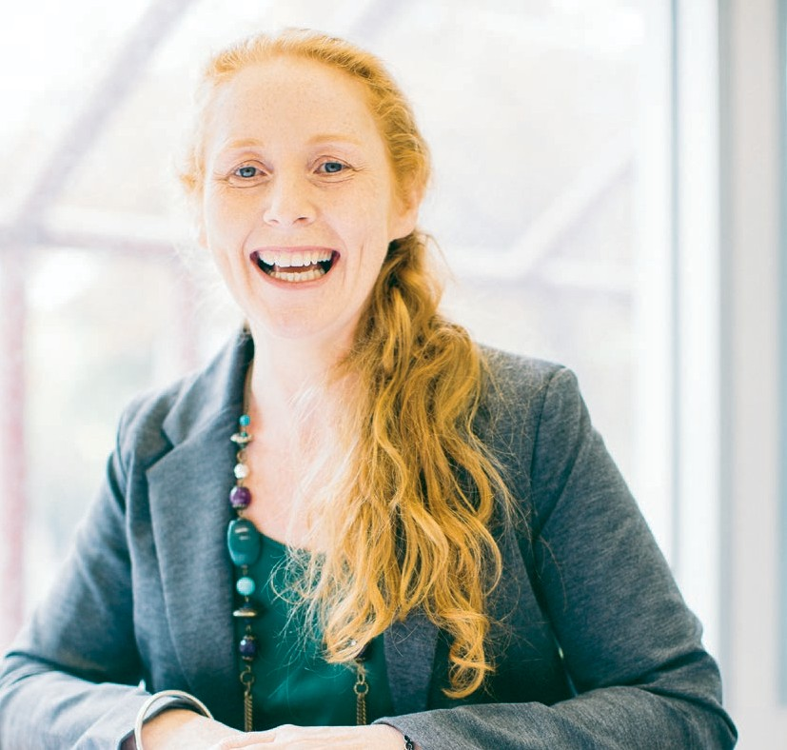

Sinead Cucanic

“This is where we are heading, to a paperless system. We have known it for many years and it’s about how we transition in to that, and this is the first step for us.”
The Digital Health Record (DHR) is the hospital’s new clinical system providing access to patient results in a digital format.

All patients will have their results and documentation stored on
the DHR, with security in place to protect patient information.

The DHR will improve accessibility and visibility of all patient records for hospital and research staff
and forms part of the hospital’s overarching Electronic Medical Record strategy.

A passionate mentor
09
ANNUAL REVIEW 2014–15

Qualifying as a nurse in Ireland in 1993, Sinead Cucanic moved to Australia the following year as a backpacker. Over twenty years on and Sinead is the Eye and Ear’s Elective Surgery Access Manager, a role she has held since December 2012.

As the Elective Surgery Access Manager, Sinead has direct oversight over all Perioperative and Inpatient Departments within the Surgical and Inpatient Services Division. In addition, Sinead oversees the management of the Surgical Bookings Department, Preadmission Clinics and has accountability for the Elective Surgery Wait List. The after-hours coordinators also report to Sinead.

“I enjoy the complexity and diversity of my role, I’m never bored as there
is always something going on—and I
thrive on a bit of stress,” Sinead says.

Sinead recalls the moment she realised clinical nursing was not her chosen career path.

“In 1998 I transitioned into an ANUM (Associate Nurse Unit Manager) role at Mercy Private and opportunities were becoming available for Acting NUM positions, I was also performing in the role
of relieving after-hours coordinator. I determined at that time that this was where my real passion was, in managing people and managing departments.”

“I mentor a lot of managers who all have different styles. I really enjoy being able to work collaboratively with those different styles and help and mentor the managers to adapt their style to suit different situations, because it is not always a one size fits all.”
Heavily involved in a number of initiatives across the hospital, Sinead says it is an exciting time for the Eye and Ear.

“With the redevelopment, the National Standards and the Digital Health Record (DHR) it is a great time to be involved and work at the Eye and Ear.”

The DHR was introduced at the Eye and Ear to enable the hospital to transition towards a ‘paper- lite’ system, and as a mentor Sinead is enthusiastic about the streamlined approach it will bring to managing patient information.

The DHR is an online version of the paper medical record and its documents. It improves the accessibility and visibility of patient records
by allowing more than one person to access the record at a time.

Sinead says the DHR is being implemented at an appropriate time.

“Because of the redevelopment we have less and less space and all of our Medical Records are going to be stored off site anyhow. Having the DHR means we are going to have the core information, the information we require, available at that time and not rely on Health Information Services to pull records and move around huge volumes of paper.”

“This is where we are heading, to a paperless system. We have known it for many years and it’s about how we transition in to that, and this is the first step for us. There’s an expectation that eventually we’re not going to have any paper record, it is certainly going to take a long time to get there, but we will, and this
is a good first step in achieving that.”

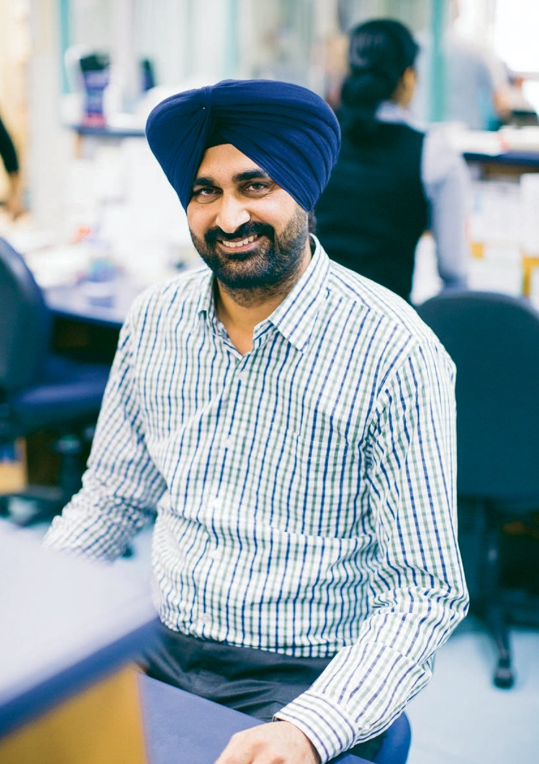Our people

10
THE ROYAL VICTORIAN EYE AND EAR HOSPITAL

Jagdeep Singh Thind

Outstanding administrative
and problem solving skills 11
ANNUAL REVIEW 2014–15

Jagdeep Singh Thind (Jag) has been a ward clerk at the Eye and Ear since 2012; however he began working at the hospital in 2010 as a patient service assistant with contractor, Medirest.

As a ward clerk for the Short Stay Care Centre (Ward 4), Jag is responsible for keeping track of patient files and also acts as a receptionist.

“I am one of the first people the patient has contact with on Ward 4,” Jag says.

“Once I see the patient, I check their identification and check that their medical history has all the documents ready for admission. I always try to prepare the histories as much as possible the day before.”

Patient care is Jag’s priority.

“I always try and make the patient feel comfortable and confident with their surgery, I often say ‘Don’t worry you are in good hands’ to try and relax them,” Jag says.

A valued member of Ward 4, Jag says he enjoys working as part of a team that is organised and efficient.

“I really like working with the other Ward 4 staff because of our team work and work flow. We always work according to schedules so it is very organised, and everyone is very friendly and helpful.”

Last year, Jag won the hospital’s Administrative Excellence Award. The award recognises the important role of administrative support staff who provide a professional, and often personal, supportive function that results in positive outcomes for our patients and improved working environments or improved hospital systems.
Executive Director of Corporate Services, Peter Gould, says Jag was a very worthy recipient of the award.

“Jag worked his way up to his current role in only
a short space of time, demonstrating outstanding administration and relationship skills,” Peter says.

“Jag ensures Ward 4’s operations are efficient and run smoothly. With excellent communications and problem solving skills, he goes above and beyond to help his colleagues and always ensures that patients are his first priority.”

The award and recognition came as a surprise to Jag.

“For me, it was such a big moment. It was the best feeling, to know that the hospital appreciates the work that I have done and will continue to do as
a clerk.”

Jag is an active and well respected member of the hospital. In March the Eye and Ear embraced Cultural Diversity Week, and as part of the celebrations hosted a cooking competition called
A Taste of Harmony. Jag was awarded second place with Aloo-gobi (cauliflower and potato curry) and Roti Bread.

“It is nice to get involved in the hospital’s activities, because you get to meet people from across the organisation.”

Jag says his journey and experience at the Eye and Ear, both as a clerk and as a patient service assistant, has been positive and joyful.

“If you love your job, the job will be easy for you.”

Our people

Our Senior Medical
Staff Directors*
Dr Christine Bessell
Executive Director, Medical
12 Services, Chief Medical Officer
Assoc. Professor Robert Briggs Clinical Director, Otolaryngology and Head, Otology, Cochlear and Ear Nose and Throat
THE ROYAL VICTORIAN EYE AND EAR HOSPITAL
Dr Caroline Clarke Executive Director, Performance and Improvement
Dr Mark McCombe Clinical Director, Ophthalmology Services
Dr David Ware
Director of Anaesthesia
Heads of Clinic
Assoc. Professor Anne Brooks Clinical Lead, Acute Ophthalmology Service and Head, Special Eye Clinic 3 and Chair of Senior Medical Staff
Dr William Campbell Head, Vitreoretinal Unit Ms Anne Cass
Head, Head and Neck
Dr Carmel Crock Director, Emergency Department
Assoc. Professor Mark Daniell
Head, Cornea
Dr Catherine Green
Head, Glaucoma
Dr Alex Harper
Head, Medical Retina
Dr Lionel Kowal Head, Ocular Motility Dr Lyndell Lim
Head, Ocular Immunology
Dr John Manolopoulos Clinical Lead, Surgical Ophthalmology Services Clinic 2
Mr David Marty Head, Rhinology Dr John McKenzie
Head, Ocular Oncology
Assoc. Professor Alan McNab Head, Orbital Plastic and Lacrimal Clinic
Mr Halil Ozdemir
Chair, Senior Medical Staff
ENT Section
Ms Elizabeth Rose Head, Paediatric ENT Dr Marc Sarossy
Head, Ocular Diagnostics
Dr Neil Shuey
Head, Neuro-Ophthalmology
Dr David Szmulewicz
Head, Balance Disorders and
Ataxia Service
Dr Christine Tangas Clinical Lead, Surgical Opthalmology Services Clinic 4
Dr Robyn Troutbeck
Head, Acute Ophthalmology
Services
Dr Anton van Heerden Clinical Lead, Surgical Ophthalmology Services Clinic 5
Dr Faye Walker
Chair, Senior Medical Staff
Eye Section
Assoc. Professor Diane Webster Acting Clinical Lead, Surgical Ophathalmology Services 1
Dr Kristen Wells Clinical Lead, Acute Ophthalmology Services
Ophthalmologists Dr Penelope Allen Dr Alex Amini
Dr Brian Ang
Dr Maged Atalla
Dr Alicia Wai Pheng Au
Dr Renuka Bathija Dr Jacqueline Beltz Dr Roland Bunting Dr Benjamin Burt
Dr Robert Buttery Dr Susan Carden Dr Dermot Cassidy Dr Elsie Chan
Dr Daniel Chiu
Dr Au Chun Ch’ng Dr Li Ping Chow Dr J Ben Clark
Dr Benjamin Connell
Assoc. Professor Michael Coote
Dr Joan Cosgrove
Professor Jonathan Crowston
Dr Rodger Davies Dr Fio De Vincentis Dr Joanne Dondey Dr Rohan Essex
Dr David Fabinyi Dr Xavier Fagan Dr Lisa Farber
Dr Kevin Foo
Dr David Francis Dr Justin Friebel Dr Fiona Fullarton Dr Brent Gaskin
Dr Jennifer Fan Gaskin
Dr Trevor Gin
Dr Padmini Gnanaharan Professor Robyn Guymer Dr Thomas Hardy
Dr Oded Hauptman
Dr Alex Hewitt
Dr Jwu Jin Khong
Dr Gary Leber
Dr Andrew Jones Dr Troy Lim Joon Dr Ming-Lee Lin Dr Cecilia Ling
Dr Lance Liu
Dr Damien Louis Dr Ross MacIntyre Professor David Mackey Dr Nicolaos Mantzioros Dr Wendy Marshman
Dr Peter Meagher
Dr Ching Hui Ng
Dr Terrence Ong
Dr Pathmanathan Pathmaraj
Dr Dustin Pomerleau
Dr Alexander Poon
Assoc. Professor Salmaan al-Qureshi
Dr Robert Ramsay Dr Edward Roufail Dr Jonathan Ruddle Dr Julian Sack
Dr Joseph San Laureano
Dr Sukhpal Singh Sandhu
Dr Khami Satchithananthan
Dr Hakki Semirli
Dr Michael Shiu
Dr Simon Skalicky Dr Grant Snibson Dr Helene Steiner Dr Mark Steiner
Dr Charles Su
Dr Laurence Sullivan
Dr Tu Anh Tran
Professor Rasik Vajpayee
Dr Mark Walland Dr Harry Wenas Dr Mark Whiting
Dr Sanjeewa Wickremasinghe
Dr Elaine Wong
Dr Heathcote Wright Professor Tien Wong Dr Jonathan Yeoh
Dr Ehud Zamir
Otolaryngologists
Ms Vasuki Anpalahan Dr Simone Boardman Mr Simon Braham
Mr Christopher Brown
Ms June Choo
Mr Markus Dahm Mr Michael Dobson Mr Simon Ellul
Mr Mark Guirguis
Dr Claire Iseli
Mr David James
Mr Richard Kennedy
Mr Randal Leung Mr Philip Michael Professor Stephen O’Leary Mr Theo Sdralis
Mr Craig Semple
Mr Michael Tykocinski
Mr Robert Webb
Mr Benjamin Wei
Mr Sarin Wongprasartsuk
Anaesthetists
Dr Matthew Acheson
Dr Ju Pin Ang
Dr Peter Ashton Dr Glenn Bakyew Dr Jacob Boon
Dr Michael Boykett
Dr Andrew Braun
Dr Linda Cass
Dr Jun Keat Chan
Dr Anne Chenoweth Dr Stephen Chester Dr Melinda Chouman Dr Elizabeth Coates
Dr Iresha Dissanayake
Dr Gavin Doolan
Dr Duncan Forbes
Dr Natalie Anne Gattuso Dr Alexander Gershenzon Dr Grace Gunasegaram
Dr Gaylene Heard
Dr Sean Hearn
Dr William Hurley
Dr Simon Jones
Dr Zoe Keon-Cohen
Dr Jennifer King
Dr Sarah Kondogiannis
Dr James Koziol Dr Joshua Lau Dr Ei Leen Lee Dr Ana Licina
Dr Lisa Lin
Dr John Lioufas
Dr Daniel Liu
Dr Vaishali Londhe Dr Kameel Marcus Dr James Mitchell Dr Craig Morgan
Dr Al Motavalli
Dr Michelle Natividad
Dr Bruce Newman
Dr Ian Nguyen
Dr Igor Oleinikov
Dr Mark Chong Seng Ong
Dr Irene Palgan
Dr Dayalan Ramasamy
Dr Peter Read
Dr John Riseborough Dr Mhousci Scanlan Dr Peter Seal
Dr Nicole Sheridan
Dr Andy Sisnata Siswojo
Dr Peter Snider Dr Mark Suss Dr Wai Yin Tam Dr Alan Tse
Dr Michael Tsiripillis
Dr Andrew Tymms Dr Andrew Walpole Dr Crispin Wan
Dr Margaret Watson Dr William Watson Dr Daniel Wong
Dr Andrew Wyss
Physicians
Dr Julian Bosco
Dr Luke Chen
Dr Timothy Godfrey
Dr Caroline Jung
Dr Michael Tan
Dr Anneke van der Walt
GP Liaison
Dr Lina Nido
Emeritus Consultants
Dist. Professor Graeme Clark, AC Dr Julian Heinze
Assoc. Professor Justin
O’Day, AM
Professor Hugh Taylor, AC Dr John Thomson

*As at 19 June 2015

13

Our patients
ANNUAL REVIEW 2014–15

Committed to patient centred care

Our patients

14
THE ROYAL VICTORIAN EYE AND EAR HOSPITAL

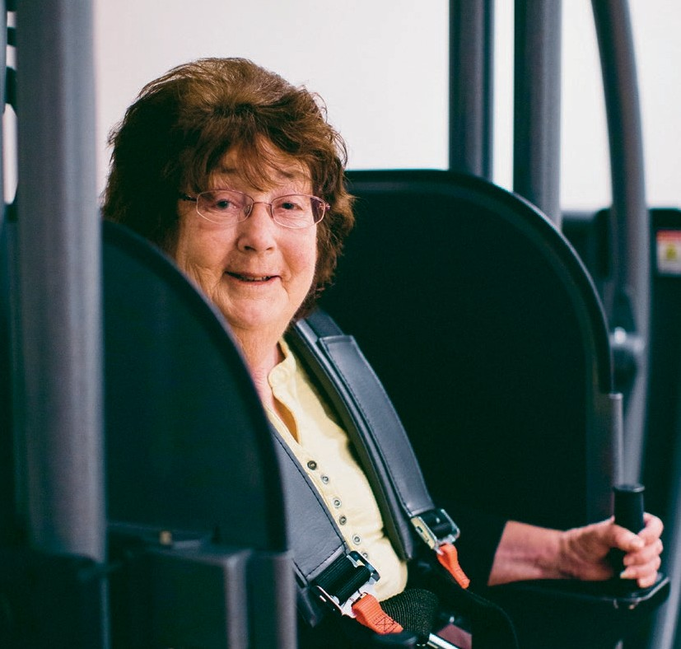

Lorraine Lack

“I’m glad I was able to come in here to the Eye and Ear and not have to travel to Sydney. Everybody here at the Eye and Ear have been so friendly, very nice and helpful.”
Thanks to generous funding from
a Gandel Philanthropy Community Build Grant, the Eye and Ear opened the Gandel Philanthropy Balance Disorders Diagnostics—an area dedicated to a new balance disorder diagnostic and management system.

Housed in this area is the state-
of-the-art $225,000 Epley Omniax System, one of only 34 in the world and only the second in Australia. It increases diagnostic accuracy for sufferers of balance disorders, meaning shorter hospital stays
and a rapid return to daily activities and productivity for the patient. The cutting-edge technology will enable the Eye and Ear to explore new treatment techniques and ensure the hospital is at the forefront of balance disorder research and diagnosis.

Helping the dizzy back
on their feet 15
ANNUAL REVIEW 2014–15

“Even though I was laying down it felt as though I had
to hold on to something because everything was moving, but really it wasn’t, it was all in the head—or the ears!”

Lorraine Lack was diagnosed with Benign Paroxysmal Positional Vertigo (BPPV), the most common cause of vertigo, in early 2014.

“I felt as though I was going to fall over, the whole room including the ceiling spun around, then all of a sudden it would just stop,” Lorraine recalls.

Dr David Szmulewicz, Head of the Balance Disorders and Ataxia Services at the Eye and Ear says balance disorders are widespread and debilitating conditions.

“80% of people aged over 65 years have experienced dizziness, and BPPV is the cause of approximately
50% of dizziness in older people,” Dr Szmulewicz says.

Lorraine suffers from rheumatoid arthritis, which excludes her from undergoing traditional treatments of BPPV. She was referred to the Eye and Ear’s Balance Disorders and Ataxia Services where she saw Dr Szmulewicz.

In October 2014, the Eye and Ear launched the Gandel Philanthropy Balance Disorders Diagnostics, the room that houses the Epley Omniax System.

“Lorraine was suitable for the Epley Omniax System because some other methods of treatment had failed in the past, while others were inappropriate given her rheumatoid arthritis,” Dr Szmulewicz said.

Lorraine admits the machine was quite overwhelming.

“I was a bit sceptical at first, when I saw the machine I thought ‘Oh my God, what is that?’”
“It was a funny feeling being in the machine. After some movements I would experience vertigo, then David would bring me back up right and it would go back to normal.”

Lorraine’s vertigo has not returned after three sessions in the Epley Omniax System.

“Life is so good now, it’s lovely to be able to get out of bed, not feel dizzy and not have to be sick,” Lorraine says.

Dr Szmulewicz says thanks to the new system, patients will have an improved quality of life.

“The Epley Omniax System is an opportunity for faster diagnosis of BPPV, and it will also significantly improve treatment options available for patients, who are often forced to live with chronic untreated dizziness,” Dr Szmulewicz says.

Being the first machine of its kind in Victoria
and only second in Australia means patients like
Lorraine won’t have to travel interstate or overseas.

“I’m glad I was able to come in here to the Eye and Ear and not have to travel to Sydney. Everybody here at the Eye and Ear have been so friendly, very nice and helpful.”

Lorraine’s story was featured on Channel 9 news, and generated much interest in the Gandel Philanthropy Balance Disorders Diagnostics. Successful stories like Lorraine’s are thanks to the generosity of Gandel Philanthropy.

“I’m very pleased with what has happened and very fortunate and grateful to be able to have used and benefited from the machine.”

Our patients

16
THE ROYAL VICTORIAN EYE AND EAR HOSPITAL

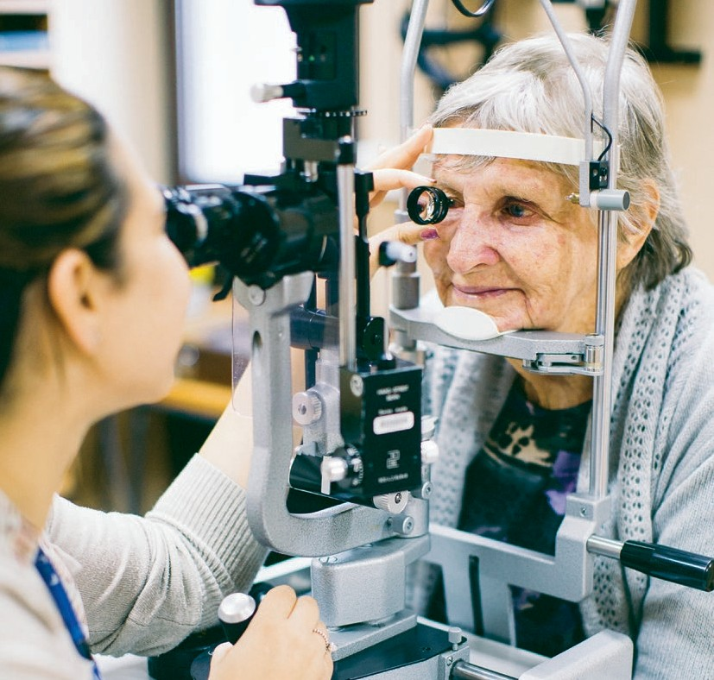

Patricia Goddard

“Patients are able to be seen by the same clinician throughout their visit which really makes them feel more comfortable. But we’re also ensuring a level of care with an ophthalmologist overseeing the clinic.” – Catherine Mancuso
The Eye and Ear’s Orthoptic Department has been participating in an initiative to up-skill clinicians and improve care for glaucoma patients. The alternate model of care, which has been successful
in the Glaucoma Monitoring Clinic, has also been adopted within the Tuesday Glaucoma Clinic.

Members of the orthoptic team have developed their clinical knowledge and skills around glaucoma under the expert guidance of Dr Cathy Green and Dr Brian Ang. In the first
12 months, changes to the model of care have improved service delivery and lead to an additional 800 patients being seen in the clinic.

Ground breaking model
of service delivery 17
ANNUAL REVIEW 2014–15

Patricia Goddard first noticed a problem with her vision while playing for the Melbourne University Squash Team back in the 1970s.

“One night I didn’t play very well and another girl in our team, who was a medical student, asked
if I’d ever had my eyes tested,” Patricia says.

“She said to me ‘You seem to see the ball and then not see it and then see it again’—she suggested
I go across to the optical department to get tested. It was discovered that I had glaucoma.”

Patricia has been a patient at the Eye and Ear
ever since and is currently being seen twice a year at the hospital’s multi-disciplinary Glaucoma Monitoring Clinic.

The alternate model of care used in the clinic aims to streamline the assessment of patients with stable glaucoma and improve patient centred care.

In 2013, the model was also rolled out into the Tuesday Glaucoma Clinic to improve patient access to scheduled review appointments.

The initiative saw orthoptists undertake significant up-skilling to improve their clinical knowledge and skills around glaucoma.

Catherine Mancuso is the Manager of Diagnostic
Eye Services at the Eye and Ear.

She says the alternate model allows patients to form a rapport with their clinician while guaranteeing an excellent level of care.

“Patients are able to be seen by the same clinician throughout their visit which really makes them feel more comfortable. But we’re also ensuring a level of care with an ophthalmologist overseeing the clinic.”

Patricia says she is very happy being seen in the
Glaucoma Monitoring Clinic.
“Previously, you would just see who ever was on duty, you were never sure who it was going to be and I would go at all different times. I’m a lot happier now,” Patricia says.

“They do all the tests thoroughly and I have been able to have my eyes tested for my driver’s licence at the same time.”

Patricia is 80 this year and lives in Rosebud on the Mornington Peninsula. She says the clinic has also made it easier for her to secure her preferred appointment times.

“I can usually be seen in late morning which is good because I am able to get home not too late.”

Catherine says staff have also benefitted from the program.

“It’s been really well received by the clinicians involved. They have really enjoyed the opportunity to increase their clinical knowledge and skills. They are relishing the learning and thinking more critically,” Catherine says.

“It would be great to see similar programs put in place in other clinics at the hospital.”

The streamlining of the assessment of glaucoma patients has also lead to an increase in the number of patients being seen and decreased waiting times for review appointments.

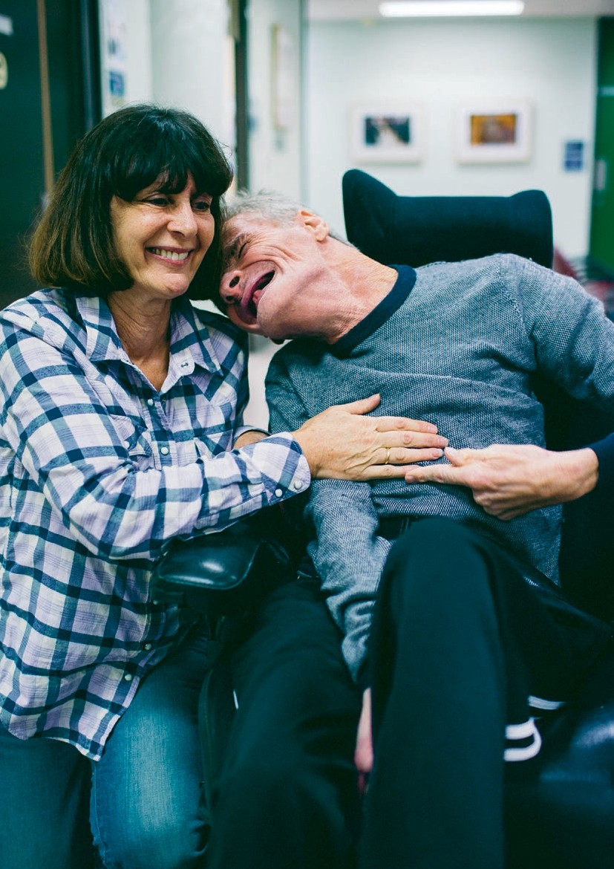Our patients

18
THE ROYAL VICTORIAN EYE AND EAR HOSPITAL

Steven and Elizabeth

Success in working
collaboratively 19
ANNUAL REVIEW 2014–15

Steven was born with cerebral palsy and a significant hearing impairment. For the past nine years, he has been supported by his carer Elizabeth Nicholas from Scope.

Steven has always accessed the community independently, however in recent years Steven’s sight started to deteriorate, which impacted his independence and daily living.

Elizabeth says although Steven did not complain about his sight, it was picked up by his support workers.

“Steven went to an optometrist for a vision test where he was diagnosed with cataracts,” Elizabeth says.

“One eye was so bad that Steven had no functional sight and the cataract in the other eye was advancing.”

Steven was referred to the Eye and Ear, where he saw ophthalmologist Dr Sukhpal Singh Sandhu who performed his cataract surgery.

To gain Steven’s confidence, Dr Sandhu says it was important to have a ‘whole team’ approach.

“Elizabeth explained at the first visit, that Steven’s engagement in hospital based care was dependent on trust,” Dr Sandhu says.

“It was important for Steven to see the same team at each visit, developing a consistency for Steven, which enabled him to gain confidence in the hospital. Seeing different people could have had a detrimental effect on the good rapport that had been developed.”

Elizabeth agreed, saying working collaboratively between the Eye and Ear and Steven’s support network allowed for an honest relationship.

“Dr Sandhu and the many other doctors, nurses and the social worker from the Eye and Ear created an informative and inclusive environment for Steven, which gained Steven’s trust in the procedures prior to surgery,” Elizabeth says.
“Steven communicates with finger spelling and with the assistance of his speech therapist, Kaye
Mackay. Kaye’s involvement was invaluable for Steven’s understanding of the ongoing visits to the hospital and the cataract surgery.

“The collaboration between Steven’s support workers and the specialists at the hospital enabled a positive, uncomplicated outcome for Steven.”

A small stitch was used to stabilise Steven’s eye that was successfully operated on, which had to be removed shortly after the operation.

“Steven had such a good rapport and trust with Dr Sandhu, that the stitch was easily removed, without pain and without another general anaesthetic.”

Dr Sandhu’s style and approach really stood out with Steven.

“He (Dr Sandhu) makes me laugh and he is always happy to see me, he smiles a lot and talks to me,” Steven says.

“I had my speech therapist Kaye and support workers with me and together with Dr Sandhu, they all explained what was going to happen.”

Now that Steven can see again, he has resumed his independent life.

“I can go out, go to the pokies, play pokies, win money and see people I know there.”

Our patients

20
THE ROYAL VICTORIAN EYE AND EAR HOSPITAL

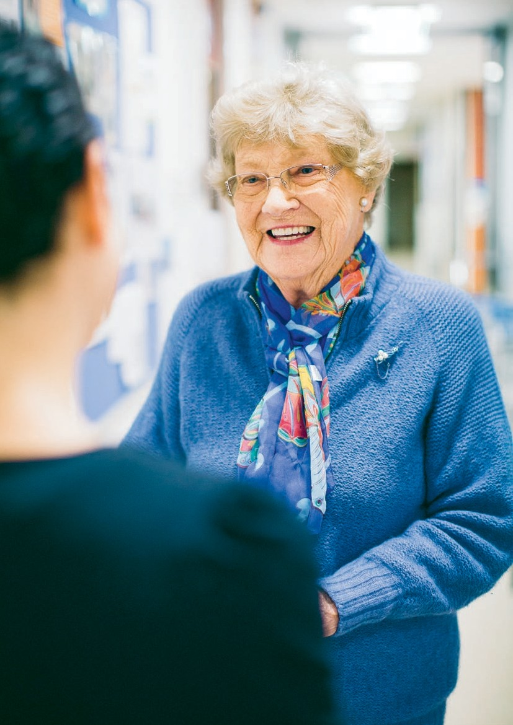

Janet Holt
The Eye and Ear’s Cochlear Implant Clinic partnered with Australian Hearing to run a 14-week pilot project to test the feasibility of offering cochlear implant services in a regional centre. The project in Geelong cut travel time for patients in the area.

A survey found 72% of patients reported a travel time of less than
30 minutes to the Geelong clinic compared to a travel time of up to
120 minutes to East Melbourne. It also found that all (100%) patients at the Geelong clinic were happy with the clinical care they received and would like to see the program continue.

Improving access for
regional patients 21
ANNUAL REVIEW 2014–15

Janet Holt has worn a hearing aid for almost thirty years but she was referred to the Eye and Ear for a cochlear implant in 2013 when her hearing started deteriorating significantly.

Janet was 80 at the time and had reservations about getting the implant at her age but decided to go ahead with the surgery.

“I was very worried about the operation but it was a very pleasant surprise, it wasn’t bad at all,” Janet says.

The surgery went well and Janet says she is thrilled with the results.

“I have 12 grandchildren and 12 great- grandchildren and I wasn’t really able to talk to the children before because I couldn’t hear what they were saying,” Janet says.

“Now I can hear those little ones and talk to them. It’s certainly the best thing that could have happened for me.”

While Janet is extremely happy with the results of her implant, living in Elliminyt East near Colac in Western Victoria, required her to make long trips into the Eye and Ear and rely on the assistance of family members to attend appointments.

This changed last year when the Eye and Ear’s Cochlear Implant Clinic partnered with Australian Hearing to run a trial that offered services to patients in Geelong and nearby regional areas.

Janet was able to have several follow-up appointments in Geelong, as part of the pilot service, which significantly reduced her travel time.

Eye and Ear Audiologist Michelle Moran assisted in setting up and running the Geelong clinic.
She says the program was highly successful in improving access to services for patients in the area.

“For a lot of people the thought of driving into Melbourne is a big barrier so it was great to be able to provide
a local service,” Michelle says.

“We saw new patients who previously hadn’t thought they could travel and we also saw patients who hadn’t been into the Cochlear Implant Clinic
at the Eye and Ear for almost 10 years because of the distance.”

Janet agrees saying the Geelong clinic was excellent for patients like her, as it saved time and money on getting in to the clinic.

“Geelong was great. When you live in the country, Melbourne can be a bit difficult with parking and other things. It would be a great help to country people if clinics like the one in Geelong were to go ahead,” Janet says.

The success of the project is currently being examined to explore the possibility of a long-term service in Geelong and other regional centres.

Michelle says the pilot program was well received by patients and she would like to see it continue.

“It would be fantastic if we had regional outreach centres, not just in Geelong but also in other places—just to make access that much easier.”

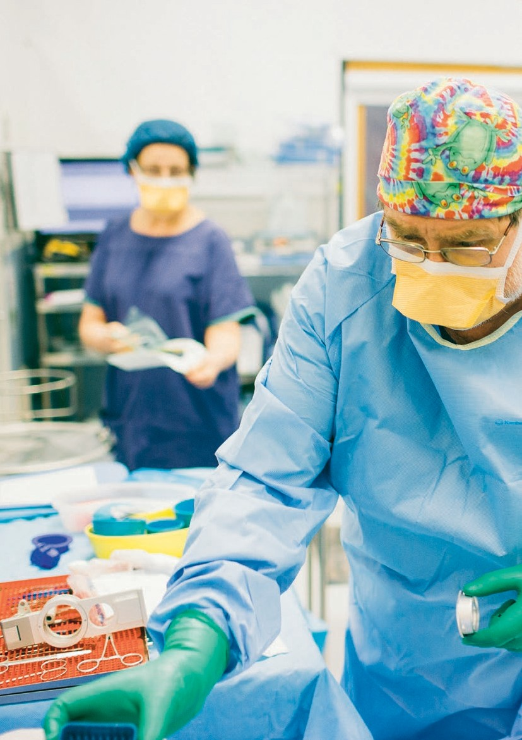

RESEARCH PHOTO

22
THE ROYAL VICTORIAN EYE AND EAR HOSPITAL

23

Our teaching
ANNUAL REVIEW 2014–15
and research

Excelling in innovative research and teaching

Our teaching and research

24
THE ROYAL VICTORIAN EYE AND EAR HOSPITAL

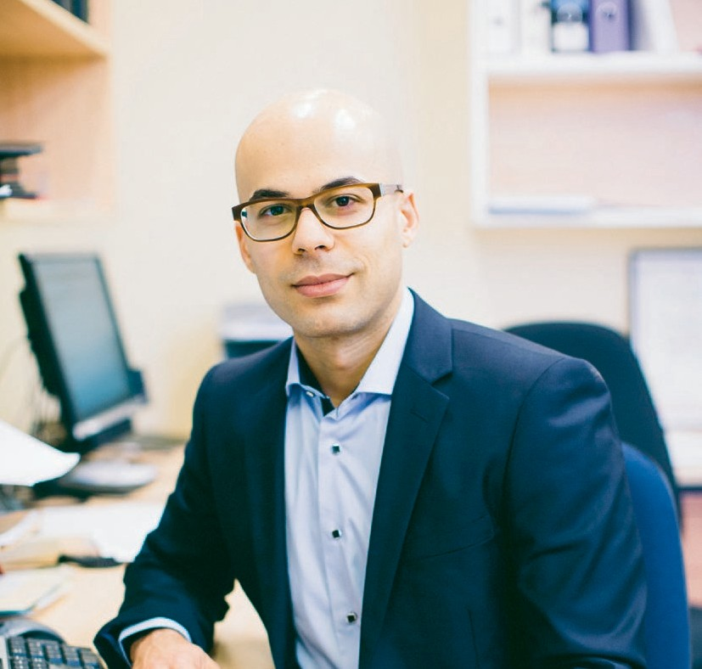

Dr Al Motavalli

“This is a huge expansion and will keep us up there as one of the leading eye and ear services in Australia and around the world.” – Kylie Young
Staff and patients will have access to a dedicated new education
and training facility as part of the Eye and Ear redevelopment. The Education Precinct will include a simulation centre, a multi-purpose auditorium for seminars and lectures, a library, teaching rooms and wet and bone labs.

The world-class precinct will foster the ongoing education and training of Eye and Ear medical staff to improve patient care. It will also provide opportunities for
the community to learn about new research and treatments.

Managing the day-to-day care of patients may be second nature to medical staff, but dealing with unexpected situations and emergencies can require additional hands-on training.
ANNUAL REVIEW 2014–15

Specialist anaesthetist Dr Al Motavalli has helped design the Eye and Ear’s first purpose-built simulation centre, which will form part of the hospital’s new Education Precinct. The simulation centre will allow staff to take part in simulation education, which includes managing clinical scenarios using mannequins in replicas of operating theatres and wards.

“Maintaining expert skills for routine patient care is relatively easy because this is what staff do almost every day,” Dr Motavalli says.

“But if a patient suddenly develops an uncommon condition such as a life-threatening drug reaction, this requires the activation of a whole different set of individual and team skills to manage the situation promptly and effectively.

“Simulation education allows staff to develop and practice these skills regularly on mannequins in a safe environment, so that if the situation arises in real life they will be well prepared.”

Dr Motavalli, who has a special interest and qualifications in clinical education and safety management, has been a strong advocate for education and training at the Eye and Ear since coming to the hospital in 2010.

“I find it immensely rewarding helping staff improve their knowledge and skills. I enjoy seeing how this enables them to feel empowered to confidently fulfil their professional roles.”
Dr Motavalli says the Education Precinct will provide better teaching and learning opportunities, helping to improve patient care.

“The precinct will have the necessary infrastructure for delivering high quality education and training experiences.

“It’s a commitment by the hospital to ensure staff have the facilities and training opportunities to provide the very highest standards of patient care, and this will give patients a lot of confidence in our health service.”

Redevelopment Project Coordinator Kylie Young says the Education Precinct will also provide learning opportunities for patients and the wider community.

“It gives us a nice space to run patient forums and involve the community in our work,” Kylie says.

“They can learn about new research, treatments and preventative measures. It’s important because we have an ageing population and eye and ear diseases are going to become more prevalent in the future.”

Kylie says the Education Precinct is a key part of the hospital’s redevelopment and will ensure staff and patients have access to world-class education facilities.

“We don’t have anything like this at the moment. This is a huge expansion and will keep us up there as one of the leading eye and ear services in Australia and around the world. Our patients will end up benefiting.”

The Education Precinct will be built within the main hospital and is expected to be completed by the end of 2017.

Our teaching and research

26
THE ROYAL VICTORIAN EYE AND EAR HOSPITAL

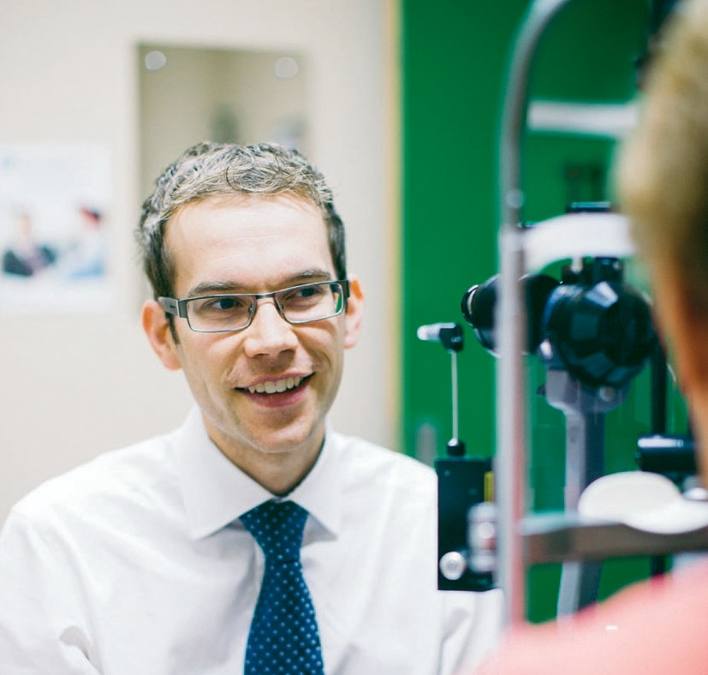

Dr Dean Cugley

“Having the opportunity to examine very complex patients in an exam situation is invaluable. You get used to seeing all those conditions and building your clinical expertise.”
With a strong focus on teaching, the Eye and Ear holds a range of tutorials, seminars and clinics for junior medical staff and students, helping them to prepare for their exams and for further clinical training.

The 3 Special Clinic is one of the longest-standing teaching clinics at the Eye and Ear, having successfully supported trainee eye doctors
since the 1960s. Each year, the clinic teaches more than a hundred medical officers, registrars, medical students and overseas trained eye doctors.

Learning from senior eye doctors has been invaluable for second year ophthalmology registrar Dr Dean Cugley.
ANNUAL REVIEW 2014–15

Dr Cugley transferred to the Eye and Ear from St Vincent’s Hospital in 2014 to specialise in ophthalmology, following a long-held interest in eyes.

“My great uncle worked on a dairy farm in the country and had cataracts to the point where he couldn’t work anymore,” Dr Cugley says.

“He had a cataract surgery and was able to go back to work. I thought that was quite powerful and it stuck with me from when I was young.”

As part of his training, Dr Cugley attends the
3 Special Clinic on Wednesday afternoons alongside other registrars and medical students. Ophthalmology trainees examine patients with eye conditions such as corneal, eye movement and retinal problems. They present their findings to senior doctors Associate Professor Anne Brooks and Dr Alex Hewitt, as well as to their peers in
a clinical forum.

“The patients have interesting and complex conditions,” Dr Cugley says.

“Often there are conditions that you haven’t seen before and have only read about, so it gives you the opportunity to see what it actually looks like.

“While we examine patients and discuss findings with senior doctors during our day-to-day work, it’s usually very busy. The clinic provides a unique opportunity to ask questions and assess your progress, but also benefits patients
by providing ongoing management.”

Dr Cugley says the clinic also holds practice exams to allow students to assess patients under tough exam conditions. Junior doctors training to be ophthalmologists in Australia must pass clinical
exams at the end of their first and fourth years to gain their specialist qualifications.

“Having the opportunity to examine very complex patients in an exam situation is invaluable. You get used to seeing all those conditions and building your clinical expertise. It gives you the confidence you need to be able to one day function independently as a specialist.”

Associate Professor Anne Brooks has run the
3 Special Clinic since 1989 and says it is an important part of the hospital’s teaching role.

“The registrars and medical students attending the clinic improve their clinical skills to be able to examine patients accurately,” Associate Professor Brooks says.

“They receive immediate feedback about what they’ve found so it’s an invaluable learning experience for them.

“I think it’s important that we are able to get our junior doctors trained to the highest possible standards, with good clinical diagnosis and decision-making skills. They are our future and it’s good to pass on knowledge.”

While Dr Cugley is yet to pick his ophthalmology sub-speciality, he says teaching clinics like the
3 Special Clinic give students exposure to all areas in the field.

“Teaching is a very high priority in the hospital, alongside delivering patient care. Many of the senior clinicians volunteer their time to run teaching clinics because they care about your development and learning.”

Our teaching and research

28
THE ROYAL VICTORIAN EYE AND EAR HOSPITAL

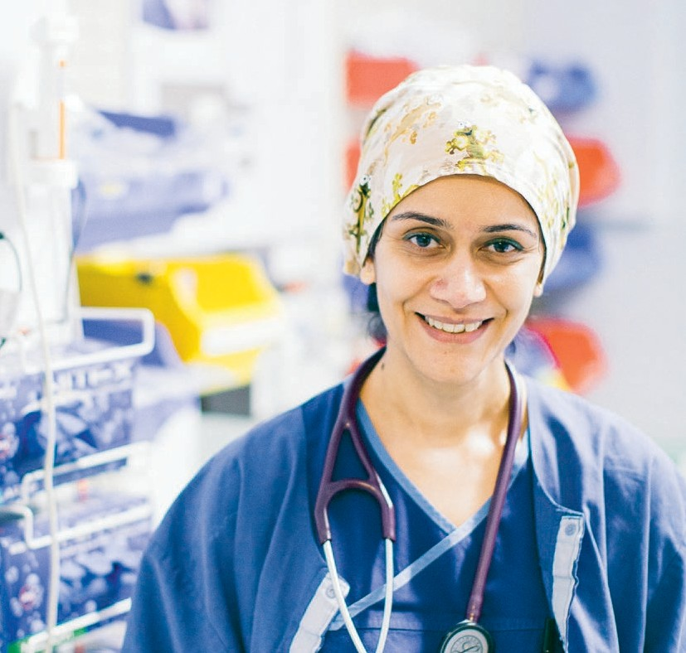

Dr Sharan Sidhu

“The Eye and Ear is really world-class in terms of ENT and eye surgery and the people who work at the hospital are some of the best in their profession.”
The Eye and Ear offers fellowships
to registrars nearing the end of their training. Fellows gain exposure
to a special area of interest and undertake both clinical work and research. They also have an important role in educating and supervising junior registrars.

Each year, the hospital offers 15 fellowships across ophthalmology, ear, nose and throat and anaesthesia. The fellowships are offered on a six or 12 month basis and are open to applicants both
in Australia and overseas.

An interest in research prompted Dr Sharan Sidhu to apply for one of three anaesthesia fellowships at the Eye and
ANNUAL REVIEW 2014–15
Ear in 2015.

“It’s a useful experience because research is something I will be heavily involved with for the rest of my career,” Dr Sidhu says.

As part of the 12-month fellowship, Dr Sidhu is involved in a study, known as the Pain-T Study, looking at pain management for children who have their tonsils removed. The study was started by fellows in 2014 in collaboration with the University of Melbourne.

While a tonsillectomy is one of the most common ear, nose and throat (ENT) surgical procedures among children, there are no standard protocols around the type or amount of pain relief given to children after the operation.

In 2013–14 the Eye and Ear performed 522 tonsillectomy/adenoidectomy surgeries and 347 of these were in the 0-17 age group.

Dr Sidhu says most children are currently sent home with paracetamol or anti-inflammatory medication such as Nurofen.

“We’re looking at whether these pain medications are adequate. If we find children are going home without adequate pain medication, we will roll out another study to see which combination of medications might work best.

“The outcome of this study might change anaesthetic practice in terms of how we treat patients in the operating theatre and also once they go home.”
Dr Sidhu completed most of her training at the Austin Hospital. She says the Eye and Ear was an obvious choice for her fellowship and final year of training given its exposure to some of the country’s leading ENT experts.

“I’ve always been interested in ENT surgeries because they are more complex than other surgeries. Some patients present with tumours in the throat and vocal cords. This can make it difficult to control their breathing during operations, which makes giving anaesthetics more challenging.

“I have to make sure I have complete control over breathing and not impair the surgeon’s ability to do the operation.”

Dr Sidhu says the hospital offers a supportive learning environment for fellows.

“The Eye and Ear is really world-class in terms of
ENT and eye surgery and the people who work at
the hospital are some of the best in their profession.

“Fellowship positions give trainees invaluable experience to work with some of the best professionals and enhance our skills to a very high level.”

Nicky Efron, who manages the Eye and Ear’s fellowships program, says fellowships attract both local and overseas applicants.

“We are the only sub-speciality hospital of its type in Australia so they get exposure here to cases they wouldn’t get anywhere else,” Nicky says.

Our teaching and research

30
THE ROYAL VICTORIAN EYE AND EAR HOSPITAL

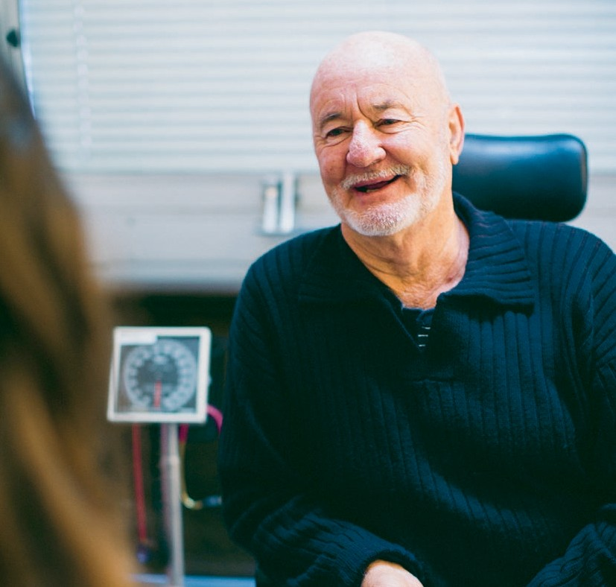

Ian Jack

“As a clinician you can maybe help a few hundred patients a week by going to clinic, but in research, you have the potential of benefitting millions of people.” – Dr Lyndell Lim
The Eye and Ear approves approximately 80 new research projects each year, with an aim to better understand disease
and improve patient treatments. Research projects that involve patients and volunteers are called clinical trials. These trials help establish the safest and most effective way to treat a disease, often by comparing two or more treatments or interventions.

The Eye and Ear is undertaking a number of clinical trials in collaboration with its research partners, such as the Centre for Eye Research Australia, with whom we are conducting a world-first trial to improve treatment for patients with diabetic eye disease.

Ian Jack knew something was wrong when he suddenly lost vision in his right eye eight years ago.
ANNUAL REVIEW 2014–15

“I came home early from work one afternoon and said to my wife, ‘I’ve got a problem, I can’t see out of my right eye’,” Ian says. “It just happened as quickly as that. It frightened the life out of me.”

Ian was diagnosed with diabetic retinopathy, a diabetes-related eye condition that damages blood vessels inside the retina, leading to vision loss.
He subsequently developed cataracts in both eyes, requiring surgery.

While cataract surgery helps improve vision for many patients, for those with diabetic eye disease like Ian, the operation can lead to severe vision loss. This is due to the worsening of diabetic retinopathy as a result of the surgery. One aspect of this is the increased risk of swelling in the central retina (diabetic macular oedema) after surgery.

Ian is taking part in a ground-breaking clinical trial by the Eye and Ear and Centre for Eye Research Australia to improve outcomes for at-risk patients through the use of two injected medicines during cataract surgery.

Principal Investigator Dr Lyndell Lim says that these medicines, which are injected into the eye, are already used in the treatment of diabetic retinopathy—but their use during cataract surgery has not been fully investigated.

“Patients with both diabetic retinopathy and a cataract are often denied cataract surgery due to concerns that their vision will be worsened, rather than improved, by the operation,” Dr Lim says.
“If we can show that patients do very well with either of these medications after cataract surgery, than this would translate into better vision for the diabetic community as a whole. The trial has the potential to change current medical practice.”

Participants are given injections during their cataract operation and receive follow-up injections either monthly or quarterly for up to a year. The three-year trial, which is funded by the Eye and Ear and Diabetes Australia, is recruiting 100 patients, with initial results expected to be published by the end of the year.

Dr Lim says clinical trials rely on participants like Ian to help uncover new treatments that can benefit the wider community.

“As a clinician you can maybe help a few hundred patients a week by going to clinic, but in research, you have the potential of benefiting millions of people.”

Ian says he was happy to join the trial after receiving treatment for diabetic retinopathy at the hospital. He had cataract surgery on his right eye in early 2015 as part of the trial and attends the hospital regularly
for eye injections.

“The treatment has been good and it seems to have stabilised the condition. They explain what they’re doing and I’ve learned an awful lot about eyes.
I think if I’ve got something to contribute that’s going to help someone else, I should do it.”

Our partners
32

Our Research Partners Bionic Vision Australia HEARing CRC
THE ROYAL VICTORIAN EYE AND EAR HOSPITAL
The Bionics Institute
The Centre for Eye Research Australia
The University of Melbourne

Our Memberships
The World Association of Eye Hospitals
Members: Tun Hussein On National Eye Hospital, Kuala Lumpur, Malaysia; The Department of Ophthalmology of the University Hospital Leuven, Belgium; Singapore National Eye Centre, Singapore; Moorfields Eye Hospital, London, UK; The Royal Victorian Eye and Ear Hospital, Melbourne, Australia; Rutnin Eye Hospital, Bangkok, Thailand; St Eriks Eye Hospital, Stockholm, Sweden; The Rotterdam Eye Hospital, The Netherlands; The
Royal Victoria Eye and Ear Hospital, Dublin, Ireland; Jakarta Eye Center, Jakarta, Indonesia; Tianjin Medical University Eye Centre, China; Sydney Eye Hospital, Sydney, Australia; Kim’s Eye Hospital, Seoul, South Korea; Aditya Jyot Eye Hospital, Maharashtra, India; St John Eye Hospital, Jerusalem, Israel; Kellogg Eye Center, Ann Arbor, USA; Fondation Asile des Aveugles, Lausanne, Switzerland; The Metta Eye Hospital (Mettapracharak (Wat Rai Khing) Hospital), Bangkok, Thailand.

The American Association of Eye and Ear Centers of Excellence
Members: Bascom Palmer Eye Institute, Florida, USA; Emory Eye Centre, Georgia, USA; Massachusetts Eye and Ear Infirmary,
Massachusetts, USA; Moorfields Eye Hospital, London, UK; New York Eye and Ear Infirmary, New York, USA; Phillips Eye Institute, Minnesota, USA; The Royal Victorian Eye and Ear Hospital,
Melbourne, Australia; Rutnin Eye Hospital, Bangkok, Thailand; Show Chwan Health Care System, Taiwan; Singapore National Eye Centre, Singapore; St Eriks Eye Hospital, Stockholm, Sweden; Wills Eye
Hospital, Pennsylvania, USA; Wilmer Eye Institute, Maryland, USA; King Khaled Eye Specialist Hospital, Riyadh, Saudi Arabia.
Disclaimer
While every effort has been made to ensure the accuracy of this document, The Royal Victorian Eye and Ear Hospital makes no warranties in relation
to the information contained herein. The Royal Victorian Eye and Ear Hospital, its employees and agents disclaim liability for any loss or damage which may arise as a consequence of any person inappropriately relying on the information contained in this document.

Produced by Marketing and Communications, The Royal Victorian Eye and Ear Hospital

Photography by Leo Farrell

Designed by Viola Design

Environmental Profile
Both the printer and the paper used to produce this document have Forest Stewardship Council® (FSC®) and ISO 14001 environmental certification. FSC®
is a Chain of Custody (COC) process. IS0 14001 is the international standard of Environmental Management Systems (EMS) designed to ensure the continuous measurement and reduction of environmental impacts. This publication is printed using vegetable based soy inks.

The Royal Victorian Eye and Ear Hospital
32 Gisborne Street East Melbourne Victoria 3002
T +61 3 9929 8666
F +61 3 9663 7203
E info@eyeandear.org.au
eyeandear.org.au

