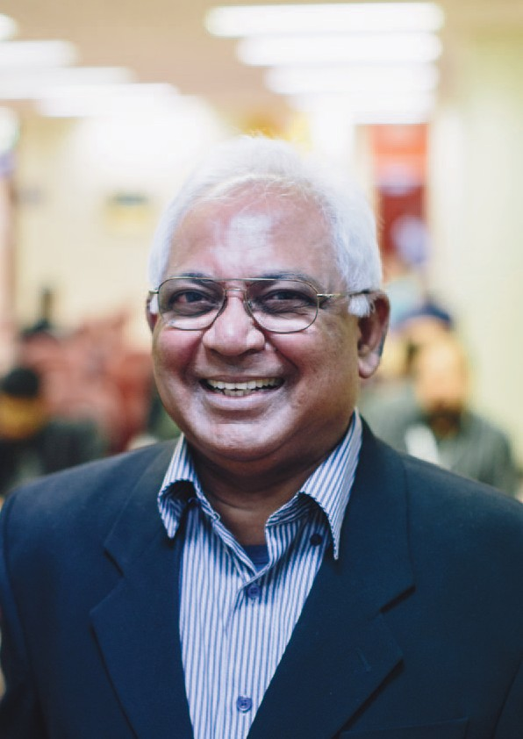

Our stories
Annual Review 2013–14

Contents

Welcome to our hospital 3

Our people 5

Dr Bob Wang, Helping improve patient safety 6

Marianna Charalambous, Extra special specialist care 8

Dr Mark McCombe, Passionate about the hospital’s future 10

Eden Zambara, Excited for what the future may hold 12

Our Senior Medical Staff 14

Our patients 15

Russell Short, Recognising excellence 16

Nora Refahi, Giving consumers a voice 18

Jodie Boyd, Switching on the sound 20

Jason Watts, Working together to achieve the best outcome 22

Our teaching & research 24

A world leader in teaching and research 25

Dr Alex Harper, Meeting of minds 26

Dr Zoe Gao, Striving for success 28

Charles Braganca, Thinking outside the box 30

2 Eye and Ear Annual Review 2013–14

Over 150 years of caring in every sense

our stories

Welcome to
our hospital

As Australia’s leading provider of eye, ear, nose and throat care services, The Royal Victorian Eye and Ear Hospital (the Eye and Ear) plays an important role in Victoria’s health care system. Last year was an exciting year for the hospital, as we celebrated our 150 year anniversary. This significant milestone was an excellent opportunity to reflect on our achievements in clinical care, teaching and research throughout our history and also reflect on the many changes to the hospital during this time.

Innovative research and teaching

The Eye and Ear has a long and proud history
of teaching and research. We currently have 205 active research projects, in conjunction with our partners, the Centre for Eye Research Australia (CERA), the University of Melbourne, Bionics Institute, Bionic Vision Australia, Monash University and HEARing CRC. Working collaboratively with our research partners, we continue to improve
the lives of our patients. As a training hospital, we are dedicated to educating the next generation of health professionals.

Dedicated to the Eye and Ear

Since our inception, the Eye and Ear has attracted the best and brightest, working
in an environment of excellence. We have a
multi-disciplinary team of eye and ear surgeons, anaesthetists, nurses, emergency and specialist medical staff, allied health professionals and support staff all providing the highest level of care and professionalism. Ensuring we continue to attract innovative professionals, the hospital
is accredited by the relevant colleges, including The Royal Australian and New Zealand College of Ophthalmologists (RANZCO), The Royal Australian College of Surgeons (RACS), The Royal Australian and New Zealand College of
Anaesthetists (ANZCA) and the Royal Australasian
College of Emergency Medicine (ACEM).
Care for the community

For 16 decades, the Eye and Ear has provided the highest possible standards of patient care to the Victorian community. In 1863 Dr Andrew Sexton Gray opened an infirmary for diseases of the eye and ear to all who needed care, today the Eye and Ear sees around 250,000 patients a year, helping improve their quality of life. Working collaboratively
with consumers, families and carers, the Eye and Ear continues to provide the best possible care to our patients. As a state-wide provider, the hospital also supports care for patients through our network of metropolitan, regional and rural health partners.

Planning for the future

The past 12 months have been particularly busy with construction works for the redevelopment project
well and truly underway. The redevelopment of the Eye and Ear will be carried out in stages, sequenced to enable the hospital to continue to provide high quality service delivery of care to its patients, as
well as the training, teaching and research functions that operate on-site. The work is expected to be complete in late 2017, and will provide a building with much easier access for patients and visitors and allow the Eye and Ear to better meet the future demand of eye, ear, nose and throat services.

Ann Clark
Chief Executive Officer

150 years of
•caring
In every sense.

- 9 ..
' 2 ....,.....

We attract
Eye and Ear Annual Review 2013–14 5

the best and brightest to the Eye and Ear

our people

Our people

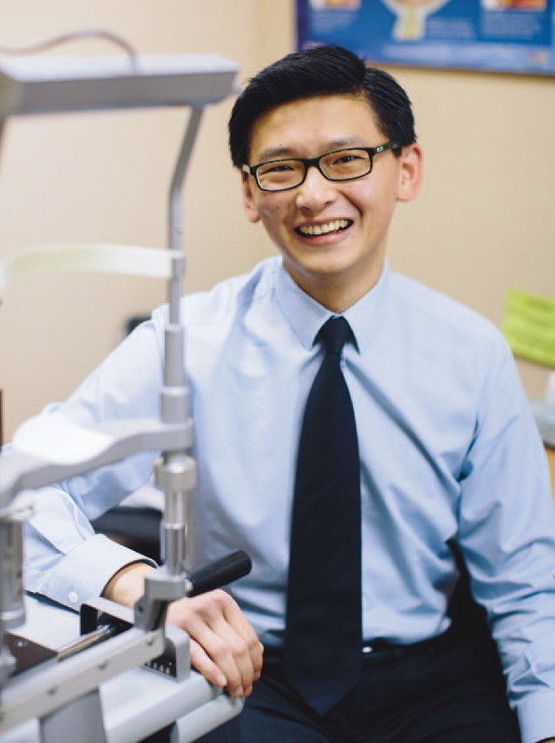

Dr Bob Wang
There are 10 different National Safety and Quality Health Service (NSQHS) Standards, which outline the level of care consumers should be able to expect from health services. They form the basis of the hospital accreditation and change the focus of accreditation to the point of care.

The Eye and Ear has working groups responsible for putting in place the actions required in each of the 10 standards. Each working group has a clinical lead that drives the activities and changes, it is important that
the changes reach all areas of the organisation.

Helping improve
patient safety

Dr Bob Wang has always had an interest in eyes. After working as an optometrist for four years,
Dr Wang returned to University to complete a post-graduate degree in medicine and has been a Hospital Medical Officer at the Eye and Ear for the past two years.

“One of the reasons I wanted to work at the
Eye and Ear was to further myself and gain more knowledge in ophthalmology and ENT, and the Eye and Ear is certainly the premier eye hospital in Victoria,” Dr Wang says.

“Having worked as an optometrist prior to studying medicine means I have been able to see ophthalmology from the allied health perspective, so I think you get a bigger picture of things, as you know what happens to patients before they get to you, and what happens to patients after they leave the ophthalmologist.”

In 2014, Dr Wang took on another role as the Clinical Risk Registrar at the Eye and Ear, meaning he assesses patient safety and outcomes within the hospital — a job he describes as satisfying.

“It’s a very rewarding job because not only are you looking after the individual patient, but you are also improving the models of care.”

The Eye and Ear adheres to the National Safety and Quality Health Service Standards (National Standards), an initiative by the Federal Government aimed to improve safety and quality systems in Australia’s health care.

As part of Dr Wang’s role as the Clinical Risk Registrar he is involved in implementing the National Standards, in particular standard six which focuses on clinical handover within the hospital and standard five which covers patient identification and procedure matching.
“The National Standards ensure hospitals are giving all patients safe and quality health care,”
Dr Wang says.

“I have been working on the patient identification and clinical handover standards, focusing on increasing doctors’ awareness of the standards and implementing strategies to ensure these standards are being followed.”

One of the strategies Dr Wang has been involved with was implementing a formal clinical handover called ISBAR (Identify, Situation, Background, Assessment and Recommendation), a process that outlines how and when clinical handover should occur.

“The clinical handover process is something that we do on an everyday basis, but it is important to do it well and to have a strategy formalised so everyone is on the same page and to make sure that everything is consistent.”

He is optimistic that the important message is being heard.

“I think we are making inroads. The clinical handover process has certainly improved. Just having people talking about it is increasing the awareness of the standard.”

Dr Wang stressed the National Standards are of great benefit.

“It’s all about making the process safer, which is what the clinical governance role has taught
me, and this ultimately means patients have better outcomes.”

Our people

Marianna
Charalambous

“BDAS is the only service of its type in Victoria, I believe the patients here receive the
best possible care because they can access a comprehensive range of services and state-of- the-art equipment within the same clinic.”

In December 2013 the Eye and Ear began the Balance Disorders and Ataxia Service, or BDAS. The service is a multidisciplinary team of sub- specialist neurologists, ENT doctors, trainees, rehabilitation specialists
and also houses the country’s largest group of vestibular audiologists, as well as vestibular physiotherapists and speech pathologists.

The clinic provides a complete range of services for the diagnosis, treatment and rehabilitation of patients with a variety of balance disorders. The BDAS team work together to manage dizziness, vertigo and imbalance covering all possible causes from the ear to the brain.

Extra special
specialist care

It was almost as though Marianna Charalambous was destined to work at the Eye and Ear’s Balance Disorders and Ataxia Service (BDAS) clinic.

Dual-disciplined, Marianna is an audiologist and physiotherapist.

After working as a physiotherapist for four years, in
2012 Marianna returned to university to undertake a Masters of Clinical Audiology.

“When I was studying I thought: ‘I would love to combine vestibular audiology and physiotherapy
so that I can investigate patients’ balance disorders and also help them through their rehabilitation – how amazing would that be?’ I never imagined
an opportunity would come up so quickly where
I could work in both disciplines,” Marianna says.

Currently a grade one audiologist, Marianna is
keen to learn more about vestibular audiology which deals with the balance system in the inner part of
the ear.

“When I began my master’s degree, I hadn’t considered vestibular audiology as a career path, but after I started learning about the vestibular system I really enjoyed it and I got hooked,”
she says.

“I was also fortunate enough to observe Arimbi Winoto, the senior Vestibular Physiotherapist working at the Eye and Ear and found the field of vestibular physiotherapy extremely interesting.

“Luckily for me, the BDAS clinic started the year that I graduated.”

Marianna’s background and knowledge in physiotherapy have given her a head-start with her audiology career.

“Although I’m just beginning to perform vestibular testing as an audiologist, my role as a physiotherapist allows me to put theory into practice, both disciplines really complement each other.”
It’s not only Marianna who benefits from being trained in two disciplines, her patients at the Eye and Ear appreciate it as well.

“On occasion, I may see a patient for a hearing or balance test and then again for their physio rehab and I hope to be able to do this more in the future. In terms of continuity of patient care, it’s really quite lovely to be able to see someone through their whole journey.”

“Dizziness and balance issues can be very frightening for patients and can cause anxiety, so it is important for patients to see the same clinician with whom they have built trust and rapport.”

Marianna says working collaboratively with other specialists will help her grow as a clinician.

“BDAS is the only service of its type in Victoria,
I believe the patients here receive the best possible care because they can access a comprehensive range of services and state-of-the-art equipment within the same clinic.”

“I love working within the BDAS team. I have a support network where I can bounce ideas off other people and where I’m always learning.”

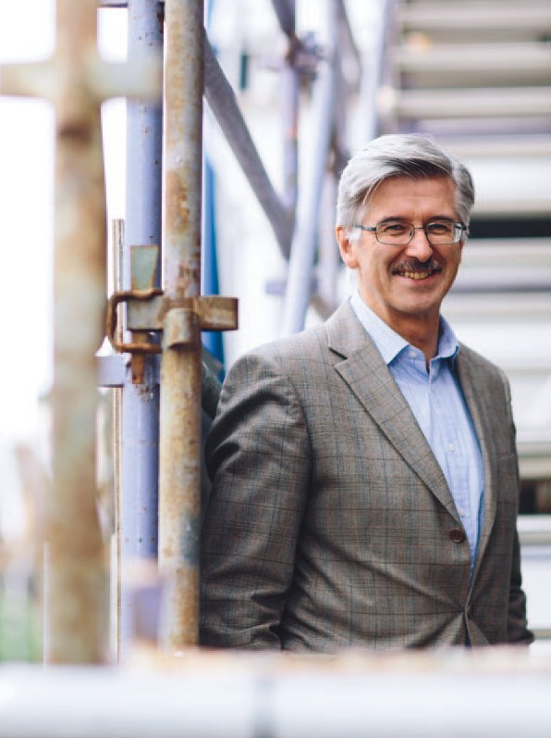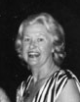Our people

Dr Mark
McCombe

Aline Darke OAM (1920 – 2014)

Mrs Aline Darke was a much loved supporter of the Eye and Ear for many decades and was instrumental in raising vital funds for the hospital. Aline was elected President of the hospital’s
Executive Council of Auxiliaries in 1980, after ten years of service. She was President from 1980 – 1992 and 1995 to December 2001 when the Auxiliaries were renamed ‘Friends of the Eye and Ear.’

During her time as President, the Auxiliaries raised more than $7 million for the hospital. In December 2011 Aline presented $3 million towards the hospital’s planned future redevelopment.

Sadly, Aline passed away in March 2014. Her hard work, dedication and commitment to the hospital will never be forgotten and the hospital is truly grateful for her enormous contribution over the decades.

Passionate about the
hospital’s future

A consultant ophthalmologist and retinal specialist in the surgical and medical retinal clinics at the Eye and Ear, Dr Mark McCombe has worked at the hospital since 1990.

Passionate about the Eye and Ear, Dr McCombe joined the hospital’s redevelopment team as the clinical lead across the user groups, to help manage the process of schematic design and design development.

As the clinical lead, Dr McCombe plays a pivotal role by feeding information from the user groups back to the senior clinical group and bringing their feedback to the redevelopment team and user groups.

“It’s a completely different role to what I normally do which is clinical medicine, so it’s really interesting and has taken me out of my comfort zone,” Dr McCombe explains.

Dr McCombe was an obvious choice for the role as he has been involved since the beginning; he was part of the committee which first put forward the business case for a redevelopment in 2006.

In May 2013, the State Government provided
funds of $135 million, with the hospital contributing
$30 million, taking the total redevelopment project to $165 million.

“I am passionate about the hospital surviving, and to survive we have
to develop and move forward and that’s why the redevelopment is so utterly important… and that’s why it was so exciting when the State Government did commit funds for the redevelopment.”

Once the redevelopment is completed in 2017,
Dr McCombe says the hospital will have a greater patient centric approach to how patients make their way around the hospital.
“What I am really looking forward to is a much more efficient environment and a hospital structure that will be an easier and more pleasant experience for patients,” Dr McCombe says.

“It is completely inefficient with the two towers, the Peter Howson Wing and the Smorgon Family Wing that are only connected on three levels; we have patients going up, down and across the towers, so
I am really looking forward to having a much more patient friendly hospital.

“A purpose built, state-of-the-art eye and ENT hospital will be just fantastic and having seen modern, recently built hospitals both here in Melbourne and overseas, I know the environment can be so much better.

“We want a hospital that will attract clinicians and researchers as part of our aim to be a world-leading facility in ophthalmology and ENT.”

With the redevelopment underway, the building phase provides a perfect opportunity for the Eye and Ear to develop a new education precinct.

“The education centre is something which is pretty exciting because for the first time the hospital will
have a proper auditorium rather than a hall that we’ve had since the 1920s, we will have a modern library facility and a state-of-the-art surgical simulation space,” Dr McCombe says.

“There is so much to look forward to and it is all very exciting.”

Our people

Eden Zambara A graduate nurse is someone who is in their first year of practise. The aim
of the graduate nurse program is to facilitate and support the development

“My graduate nursing experience has completely surpassed all
my expectations. The Eye and Ear is an excellent learning environment and has taught me more than I could have imagined. This journey has made me become a more confident and competent nurse and I can’t wait to see where this amazing year will lead me.”
of the graduate to become a competent nurse practitioner.
This involves exposing the graduate to comprehensive learning and development opportunities, including a structured study day each month where the graduate learns about new conditions and techniques.

The Eye and Ear has a long history of supporting new staff. When commencing their clinical practise, graduates are ‘buddied’ up with an experienced nurse familiar with the learning needs of the new graduate.

Excited for what the
future may hold

Nursing wasn’t always Eden Zambara’s chosen career path.

“All through high school I wanted to do prosthetics and orthotics, and then in Year 12 my grandmother got sick and was in ICU, and I saw what the
nurses did and how one-on-one they were with my grandmother, and that made me realise I wanted to do nursing,” Eden says.

Graduating from Victoria University with a Bachelor of Nursing in 2013, Eden is one of five graduate nurses at the Eye and Ear.

She says she learnt about the program at the ACN Nursing and Health Expo held at the Melbourne Convention and Exhibition Centre.

“I spoke to past Eye and Ear graduates at the expo and they couldn’t say anything bad about
the hospital or the grad program —
they absolutely loved it,” she says.

“The fact that we got to do Emergency and Theatre really got me interested because they were two areas I really wanted to work in and knowing that
we got to work with paediatrics was also a major draw card to work here at the Eye and Ear.”

During the graduate program, nurses complete five rotations throughout the hospital in the Short Stay Unit, Operating Theatre Suite and Day Surgery Facility, Emergency Department, Outpatient Department and the Inpatient Department. Eden says this diversity is what makes the graduate program stand out from other hospitals.

“I enjoy the variety of being able to work with different ages from elderly patients to young children and also learning the specifics about eyes, ears, noses and throats,” she says.
“You still come across other health issues such as heart problems and diabetes, so you don’t lose any skills but you do get to specialise and focus on areas that often people take for granted, such as their eyes and their ears and I think that’s really nice.”

Constantly learning, Eden is very appreciative of all the guidance she has received from her colleagues.

“The nurse educators, Karen and David are both really helpful — whenever I have a question they are always happy to answer it. Everyone has been really lovely in every department I have worked in; it’s a really friendly environment and it’s good for people who enjoy asking lots of questions and like to learn new things.”

She says working collaboratively with other health professionals has expanded her knowledge and skill set.

“It’s great when the more experienced nurses want to show you new techniques and the doctors don’t mind you sitting
in the room with them to watch what they are doing, which is an incredible experience.”

When asked what Eden will pass on to the next intake of graduate nurses, she said: “My graduate nursing experience has completely surpassed all my expectations. The Eye and Ear is an excellent learning environment and has taught me more
than I could have imagined. This journey has made me become a more confident and competent
nurse and I can’t wait to see where this amazing year will lead me.”

14 Eye and Ear Annual Review 2013–14

Our Senior Medical
Staff Directors
Assoc. Professor Robert Briggs Clinical Director, Otolaryngology and Head, Otology, Cochlear and Ear Nose and Throat

Dr Caroline Clarke
Executive Director, Ambulatory and Medical Services, Chief Medical Officer

Assoc. Professor Michael Coote Clinical Director, Ophthalmology Services

Dr Peter Read
Director of Anaesthesia

Heads of Clinic
Assoc. Professor Anne Brooks Head, Acute Ophthalmology Service and Special Eye
Clinic 3 and Chair of
Senior Medical Staff

Dr William Campbell
Head, Vitreoretinal Unit

Ms Anne Cass
Head, Head & Neck

Dr Carmel Crock Director, Emergency Department

Assoc. Professor Mark Daniell
Head, Cornea

Dr Catherine Green
Head, Glaucoma

Dr Alex Harper
Head, Medical Retina

Dr Lionel Kowal
Head, Ocular Motility

Dr John Manolopoulos
Head, Surgical Ophthalmology
Services Clinic 2

Mr David Marty
Head, Rhinology

Dr John McKenzie
Head, Ocular Oncology

Assoc. Professor Alan McNab Head, Orbital Plastic and Lacrimal Clinic

Dr Peter Meagher
Head, Surgical Ophthalmology
Services Clinic 1

Mr Halil Ozdemir
Chair, Senior Medical Staff
ENT Section

Ms Elizabeth Rose
Head, Paediatric ENT

Dr Marc Sarossy
Head, Ocular Diagnostics

Dr Neil Shuey
Acting Head, Neuro- Ophthalmology

Dr Richard Stawell
Head, Ocular Immunology
Dr David Szmulewicz
Head, Balance Disorders and
Ataxia Service

Dr Christine Tangas
Head, Surgical Opthalmology
Services Clinic 4

Dr Robyn Troutbeck
Head, Acute Ophthalmology
Services

Dr Anton Van Herrden
Head, Surgical Ophthalmology
Services Clinic 5

Dr Faye Walker
Chair, Senior Medical Staff
Eye Section

Assoc. Professor Diane Webster Acting Head, Surgical Ophathalmology Services 1

Dr Kristen Wells
Head, Acute Ophthalmology
Services
Ophthalmologists
Dr Penelope Allen
Dr Alex Amini
Dr Brian Ang
Dr Maged Atalla
Dr Alicia Wai Pheng Au
Dr Renuka Bathija Dr Jacqueline Beltz Dr Roland Bunting Dr Benjamin Burt
Dr Robert Buttery Dr Susan Carden Dr Dermot Cassidy
Dr Christopher Chan
Dr Elsie Chan
Dr Thomas Chia
Dr Daniel Chiu
Dr Au Chun Ch’ng
Dr Elaine Wei-Tinn Chong
Dr Li Ping Chow
Dr J Ben Clark
Dr Suzanne Cochrane Dr Benjamin Connell Dr Joan Cosgrove
Professor Jonathan Crowston
Dr Rodger Davies Dr Fio De Vincentis Dr Joanne Dondey Dr Thomas Edwards Dr Rohan Essex
Dr David Fabinyi Dr Xavier Fagan Dr Lisa Farber
Dr Kevin Foo
Dr David Francis Dr Justin Friebel Dr Fiona Fullarton Dr Trevor Gin
Dr Padmini Gnanaharan Professor Robyn Guymer Dr Thomas Hardy
Dr Oded Hauptman
Dr Alex Hewitt
Dr Farokh Irani
Dr Jwu Jin Khong Dr Kavita Khurana Dr Gary Leber
Dr Lyndell Lim
Dr Troy Lim Joon Dr Mark Lazarus Dr Ming-Lee Lin
Dr Cecilia Ling
Dr Lance Liu
Dr Michael Loughnan
Dr Damien Louis Dr Ross MacIntyre Professor David Mackey Dr Nicolaos Mantzioros Dr Wendy Marshman
Dr Mark McCombe
Dr Ching Hui Ng Dr Lorraine Ong Dr Terrence Ong
Dr Pathmanathan Pathmaraj
Dr Alexander Poon
Assoc. Professor Salmaan al-Qureshi
Dr Robert Ramsay
Dr Edward Roufail
Dr Jonathan Ruddle
Dr Julian Sack
Dr Joseph San Laureano Dr Sukhpal Singh Sandhu Dr Khami Satchithananthan Dr Hakki Semirli
Dr Michael Shiu
Dr Simon Skalicky Dr Grant Snibson Dr Helene Steiner Dr Mark Steiner
Dr Tony Stubbs
Dr Charles Su
Dr Laurence Sullivan
Dr John Sutton
Dr Tu Anh Tran
Professor Rasik Vajpayee
Dr Mark Walland Dr Harry Wenas Dr Mark Whiting
Dr Sanjeewa Wickremasinghe
Dr Elaine Wong
Dr Heathcote Wright Professor Tien Wong Dr Jonathan Yeoh
Dr Ehud Zamir

Otolaryngologists
Ms Vasuki Anpalahan
Mr Simon Braham
Mr Christopher Brown
Ms June Choo
Mr Benjamin Cook Mr Markus Dahm Mr Michael Dobson Mr Simon Ellul
Mr Mark Guirguis
Mr David James
Mr Richard Kennedy
Mr Randal Leung
Mr Philip Michael
Professor Stephen O’Leary
Mr Theo Sdralis
Mr Craig Semple
Mr Michael Tykocinski
Mr Langley Webb Mr Robert Webb Mr Benjamin Wei
Mr Sarin Wongprasartsuk

Anaesthetists
Dr Matthew Acheson
Dr Ju Pin Ang
Dr Peter Ashton Dr Glenn Bakyew Dr Jacob Boon
Dr Michael Boykett
Dr Andrew Braun
Dr Heather Butler
Dr Linda Cass
Dr Jun Keat Chan
Dr Anne Chenoweth
Dr Stephen Chester
Dr Lucia Nallamma Premilla
Chinnappa-Quinn
Dr Melinda Chouman
Dr Elizabeth Coates
Dr Iresha Dissanayake
Dr Gavin Doolan
Dr Duncan Forbes
Dr Natalie Anne Gattuso Dr Alexander Gershenzon Dr Grace Gunasegaram Dr Gaylene Heard
Dr Sean Hearn
Dr William Hurley
Dr Simon Jones
Dr Zoe Keon-Cohen
Dr Jennifer King
Dr Su May Koh
Dr Sarah Kondogiannis
Dr James Koziol Dr Joshua Lau Dr Ei Leen Lee Dr Ana Licina
Dr Lisa Lin
Dr John Lioufas
Dr Daniel Liu
Dr Vaishali Londhe Dr Kameel Marcus Dr James Mitchell Dr Craig Morgan Dr Al Motavalli
Dr Michelle Natividad
Dr Bruce Newman
Dr Ian Nguyen
Dr Igor Oleinikov
Dr Mark Chong Seng Ong
Dr Irene Palgan
Dr Dayalan Ramasamy Dr John Riseborough Dr Mhousci Scanlan
Dr Peter Seal
Dr Nicole Sheridan
Dr Andy Sisnata Siswojo
Dr Peter Snider Dr Mark Suss Dr Wai Yin Tam Dr Alan Tse
Dr Michael Tsiripillis Dr Andrew Tymms Dr Andrew Walpole Dr Crispin Wan
Dr Margaret Watson
Dr William Watson
Dr Daniel Wong
Dr Andrew Wyss

Physicians
Dr Julian Bosco
Dr Timothy Godfrey
Dr Caroline Jung
Dr Michael Tan
Dr Aneeke van der Walt

GP Liaison
Dr Lina Nido

Emeritus Consultants Dist. Professor Graeme Clark, AC Dr Julian Heinze
Assoc. Professor Justin O’Day, AM
Professor Hugh Taylor, AC Dr John Thomson

Working
together to
Eye and Ear Annual Review 2013–14 15

provide the best possible care

our patients

Our patients

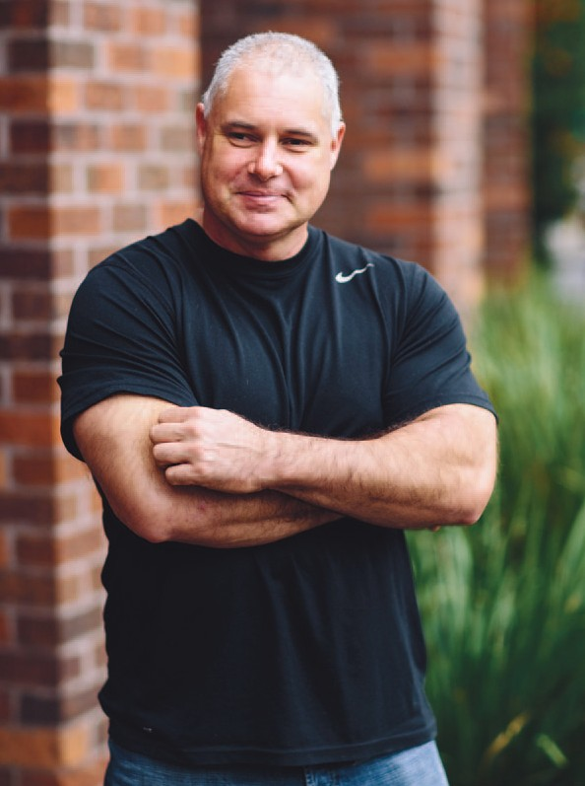

Russell Short
The Eye and Ear celebrated its
150th anniversary in 2013. Starting with five pounds and one bed as the Eye and Ear Infirmary in 1863, the hospital has grown to become Australia’s only specialist eye, ear, nose and throat hospital, caring
for more than 250,000 patients each year.

To mark this milestone, the Eye and Ear held a number of public events throughout 2013. A Staff Service Awards ceremony was held to recognise the dedication and
service of long serving staff members. Paralympian and Eye and Ear patient Russell Short was a guest speaker at this special event.

Recognising
excellence

Hand Russell Short OAM a shot put, discus or javelin, and he’ll throw further than most athletes. That may not seem extraordinary, until you learn that Russell is legally blind.

One of Australia’s most successful Paralympians, Russell has a rare genetic eye disease that also affects his wife Christine and two sons Jim, 8 and Will, 6.

In 2013, the Eye and Ear facilitated genetic testing for the family, which Russell hopes will “put a name” to the genetic cause of the mysterious disease.

“My wife and I are both legally blind and my boys also have sight problems,” Russell says.

“Doctors at the hospital were confused as to what was causing it, which is why genetic testing has been done.”

The Eye and Ear’s Ocular Diagnostic Clinic (ODC) is one of only two in the state that investigates and monitors rare eye conditions using specialist equipment.

Dr Marc Sarossy from the ODC says the hospital
is fortunate to have the specialised equipment and trained staff to be able to diagnose and characterise rare diseases of the retina by measuring the tiny signals that come from the eye.

“Being the main referral centre for such diseases for Victoria and Tasmania means that we have the opportunity to learn from patients like Russell
and his family to better diagnose and treat similar patients in the future,” Dr Sarossy says.

Russell spoke about his eye condition and experiences as a Paralympian at the hospital’s Staff Service Awards in 2013.

The event coincided with the Eye and Ear’s 150th anniversary.

“To hear the history of the hospital and to be involved in the Staff Service Awards was very personal for me because my boys might have to rely on these doctors in the future,” Russell says.
“It’s great to see how things have advanced, particularly with technology such as cochlear implants. In another 20 years, who knows what will be possible.”

“It’s not about me, but about my kids and their kids. It’s wonderful to see doctors at the Eye and Ear making a difference for the next generation.”

Despite being born vision impaired, Russell discovered a love of sport early, taking up shot put, discus and javelin.

“I was a good thrower in high school. I got the opportunity to go to the Australian Institute of Sport to see how athletes with disabilities would fit into an able-bodied regime. I did very well and they kept
me on a scholarship.”

Russell has gone on to win 12 Paralympic and 8
World Championship medals and, at the age of 45, is determined to make the 2016 Paralympic Games in Rio de Janeiro.

Russell says his disability has never deterred
him from reaching his goals. “I don’t think about it because I’ve had it all my life. I’ve achieved everything I set out to do. I won medals, I carried the flag for Australia at the Beijing Paralympics in
2008 and the World Championships team in 2002. I’ve earned the respect of other athletes.”

As for what the future holds, Russell says: “I think if
I make Rio that might just about do me.”

Our patients

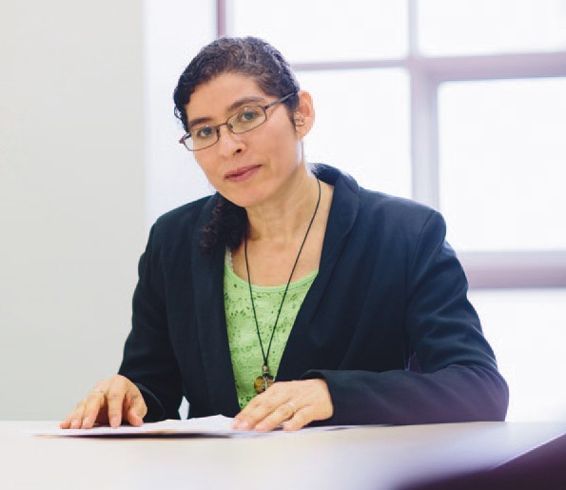Nora Refahi

“The views and experiences of patients, families, carers and community members are
important in improving care and safety at hospitals.”– Betty Tellis, Community Engagement and Participation Coordinator
A Consumer Register formed by the Eye and Ear in 2013 has given patients, carers and community members the opportunity to
provide input into hospital services. More than 60 people have already joined the register, getting involved in everything from reviewing
patient brochures to becoming members on hospital committees and working groups.

The Consumer Register provides the hospital with a valuable feedback tool to help improve services and meet the current and future needs of people who visit the hospital.

Giving consumers
a voice

When a rare medical condition in 2012 left Nora Refahi seeing only a large black dot with her left eye, doctors at the Eye and Ear came to her rescue.

“I could not see much at all and it was very dark,” Nora says. “It stemmed from an inflammation behind the optic nerve. I was so worried and the doctors did everything they could to help me —
I was really grateful.”

Two years on, with her sight almost back to normal thanks to treatment through the Ocular Immunology Clinic, Nora has made it her mission to give back
to the hospital by joining the Consumer Register.

“The doctors were so caring and I wanted to give something back,” she says. “I read a brochure about the Consumer Register and decided to call and find out how I could be involved. It is a way for me to say ‘thank you’ for all the generosity, care and support I received during the most vulnerable time of my life.”

The register gives patients, carers and community members the opportunity to provide feedback
on a range of hospital services and consumer- relevant issues.

For Nora, the role has involved reviewing patient brochures to ensure information is clear and relevant.

“Although hospital staff know what they mean, sometimes patients may not. The information may be unclear or even confusing to them. I look at it from a patient’s point of view,” she says.

“It’s very empowering because you can provide your insight and opinion and, a lot of the time, those opinions are taken on board.”
Having immigrated to Australia from El Salvador
26 years ago, Nora is passionate about issues affecting people from culturally diverse backgrounds and has also joined the hospital’s newly-integrated Diversity and DisAbility Working Group.

Eye and Ear Community Engagement and Participation Coordinator Betty Tellis says the Consumer Register aims to match consumers with their areas of interest. She says it helps the hospital gauge community views while giving patients like Nora the opportunity to contribute.

“We have many passionate and driven consumers who really want to give something back to the hospital, especially patients who have been very happy with the care they have received and want to be part of the bigger picture,” Betty says.

“The Consumer Register offers people the opportunity to be involved in many different areas including health service planning, delivery and evaluation of our services. It shows the Eye and Ear is committed to partnering with consumers to ensure that the consumer’s voice is heard.”

Nora says the Consumer Register has given her a strong connection to the hospital.

“I love the culture of the Eye and Ear hospital. Every time I visit the hospital, it’s like I’m going home because I feel so appreciated. That feeling has grown now that I’m part of the Consumer Register.”

Our patients

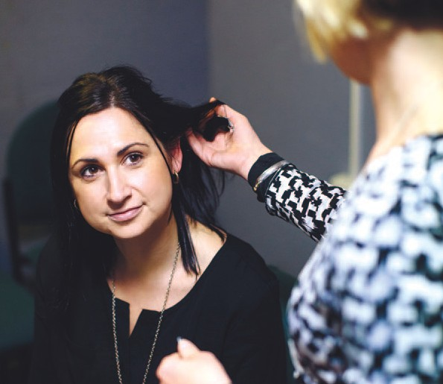Jodie Boyd

“Before, I was so scared of waking up deaf,” Jodie says. “I don’t have that fear anymore because the implants will be there forever.”
Patients with cochlear implants will receive long-term care at a dedicated new centre launched
as a partnership between the Eye and Ear and Cochlear Limited. Located next to the hospital on Victoria Parade, the Cochlear Care Centre™ will help cochlear implant recipients with programming their implant systems and aftercare.

With a quarter of all Australia’s cochlear implants conducted at the Eye and Ear and demand for services increasing, the new centre will not only enhance patient care, but also enable the hospital to see more patients and perform more cochlear implant surgeries.

Switching on
the sound

Jodie Boyd had experienced progressive hearing loss from the age of 13, but it wasn’t until she gave birth to her daughter Bethany in 2006 that her hearing took a sudden turn for the worse.

“I had lost quite a lot of hearing and couldn’t hear any high-pitched sounds,” Jodie says. “It was really hard because I couldn’t talk on the phone and I was worried I wouldn’t be able to hear Bethany.”

Hormonal changes during pregnancy are thought
to have caused the deterioration in Jodie’s hearing. After seeing several specialists, she was referred
to the Eye and Ear for treatment, under the care of
Audiologist Michelle Moran.

Jodie was assessed as a suitable candidate for
a cochlear implant, a devise invented in 1978 by Eye and Ear specialist Professor Graeme Clark AO, and received an implant in her right ear in 2009.

Michelle says: “In Jodie’s case, the main issue was that she had no hearing in the high pitch region. There was no way we could use a hearing aid to improve her detection of sound, whereas the cochlear implant could improve her hearing
by doing the job of the cells in the ear that weren’t functioning.”

Jodie still remembers the moment her implant was switched on.

“You know when you have a cold and you’re all blocked up and you want to pop your ears? That’s what it felt like before the implant. When they turned it on, everything was suddenly clearer and louder. It was amazing.”
The moment was also memorable for Michelle. “When we switch people on, we have all sorts of different responses. With Jodie, she seemed to hear the sound straight away and she was quite emotional that she could hear something. When you’ve worked with the person for so long, it’s gratifying to see that you have made a difference.”

Jodie’s hearing improved further when she received an implant in her left ear in 2011. “Two ears work better than one — I’ve now got surround sound,” she says. “It was kind of like a dream to be able
to hear with both ears again, to be able to live a normal life.”

Now mum to a second daughter, one-year-old Ruby, Jodie is enjoying doing “the normal things that people take for granted”. That includes speaking on the phone, which has allowed her to return to work as a bookkeeper.

“Before, I was so scared of waking up deaf,” Jodie says. “I don’t have that fear anymore because the implants will be there forever.

“The hospital and Michelle have been fantastic. They really care about you and they want you to get the best out of your implants. I’d love to meet Professor Clark one day to say thank you to him. He’s changed my life.”

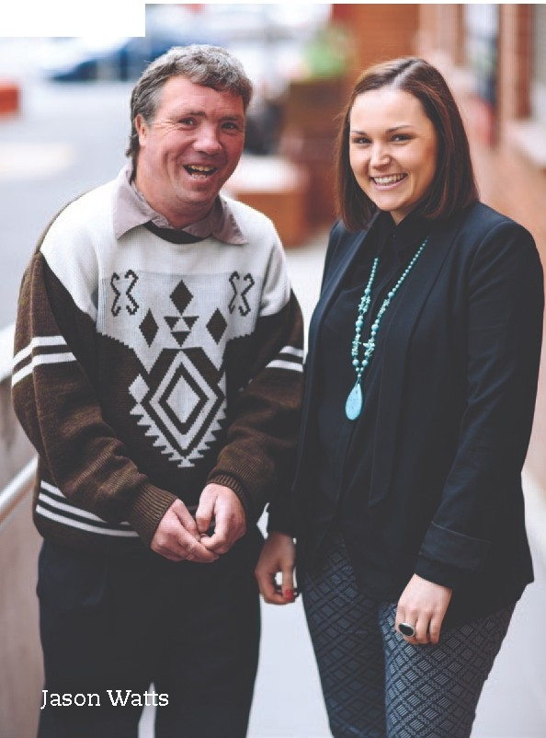Our patients

Working together to achieve
the best outcome

Jason Watts is very familiar with the Eye and Ear hospital; he has been a regular patient since 2004 and has been treated for a range of ENT issues.

Jason has an intellectual disability and is supported by his case manager Kelly Newsome from the Mental Illness Fellowship of Victoria.

“Kelly is like a sister to me, she is a role model,” Jason says.

Before Kelly became Jason’s case manager, it was noted that he was likely to cause disruptions to other patients and staff.

“I used to be really nervous about coming to the hospital, but not anymore.”

Kelly says that Jason would become agitated when he had to attend appointments at hospital.

“Jason often complained to me that he was not being heard or listened to and he felt uncomfortable asking questions or seeking clarification around
what was happening with his treatment,” Kelly says.

Collaboratively working with staff at the Eye and Ear, Jason now describes the experience as fun and is willing to attend his different appointments.

“I now like coming to the hospital because the people and doctors are really nice and now I ask
them [the clinicians] lots of questions,” Jason says.

Kelly explains that Jason’s confidence at the hospital is a result of patient centred care.

“Jason now feels comfortable and at ease when he presents to the Eye and Ear, largely due to the perception that his needs and values as a person are being recognised and met. I believe this is largely due to the collaboration and care
coordination that has taken place between Jason, clinicians, staff and me,” Kelly says.
“I have noticed that Jason is a lot more confident when seeing clinicians and is able to ask questions freely and seek clarification when needed without
me having to prompt him to ask. I also think that the active involvement to include Jason in the decision making process has allowed Jason to grow in confidence particularly around decisions regarding his own health care.”

Jason was recently treated by Dr Dan Gordon, an
ENT registrar.

“Jason had a nasal fracture sustained as an injury and came into the Eye and Ear concerned about his breathing and appearance,” Dr Gordon says.

Dr Gordon’s approach really stood out with Jason.

“I really liked Dr Gordon because he treats me good and he listened to me,” Jason says.

Dr Gordon: “When you are treating someone you
are not just treating the disease, you are treating the person and that is very true for someone like Jason, looking at why he came to the hospital but also his social support network.”

“I think patient centred care is very important because ultimately that is what we are here for — to provide a service
to the patients, listening to their needs and trying to match their needs with anything that we can do to help them.”

Jason will continue to be a regular patient at the Eye and Ear and says he is looking forward to the redevelopment.

“I like that they are rebuilding it [the hospital] the atmosphere will be good.”

24 Eye and Ear Annual Review 2013–14

Leadership
and innovation through
ground-breaking teaching and research

our teaching
& research

A world leader in
teaching and research

As a world leader of eye, ear, nose and throat research and a specialist tertiary teaching hospital, The Royal Victorian Eye and Ear Hospital is dedicated to improving patient outcomes through supporting pioneering research and innovative teaching.

Our research partners, the Centre for Eye Research Australia (CERA) and the University of Melbourne are housed on-site and have access to the latest clinical resources and world class clinicians and doctors. This means that we
can collaborate with our partners and translate research into clinical care more quickly and have a direct impact on our patients.

Each year, the Eye and Ear approves approximately 80 new research projects, ranging from large clinical trials to small retrospective record reviews. Collaborating with our research partners CERA, the University of Melbourne, the Bionics Institute, Bionic Vision Australia, HEARing CRC and Monash University these projects translate into meaningful eye, ear, nose and
throat health care outcomes.

The Eye and Ear, together with our research partners, is committed to conducting our research honestly and accurately and at
the highest professional standards. We are responsible for the governance of research undertaken at the hospital, to ensure accountability for the scientific quality, ethical acceptability and safety of our research. This ensures that all research conforms to national standards, including the National Statement on Ethical Conduct in Human Research (2007), the Australian Code for the Responsible Conduct
of Research (2007) and the Victorian Managed
Insurance Authority Guidelines.
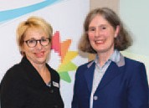
CEO Ann Clark with Associate Professor
Anne Brooks

The Human Research Ethics Committee considers and approves new applications for research projects and manage the existing projects. The hospital also allocates research grants, such as the Churches Bequest, the
Peter Howson Deafness Fellow and other annual research grants and philanthropic donations.

We couple our research with dedication to training the next generation of eye, ear, nose and throat specialists and on-going mentoring and development of our junior staff.

The Eye and Ear has a long history as a teaching hospital, with the John Colvin Saturday Morning Ophthalmology Lecture Series and the Brian Pyman Otolaryngology Lecture Series long running initiatives at the hospital.

The Eye and Ear plays a significant national and international role in teaching and training. In 2013 Associate Professor Anne Brooks held a lecture on the Excellence in Teaching and
Training, as part of the 150th celebration lecture series highlighting the dedication to teaching and training throughout the hospital’s history.

We are proud of the important role we play in the ground-breaking eye, ear, nose and throat research and teaching, which together continue to improve the quality of health care we provide to our patients.

Our teaching
& research

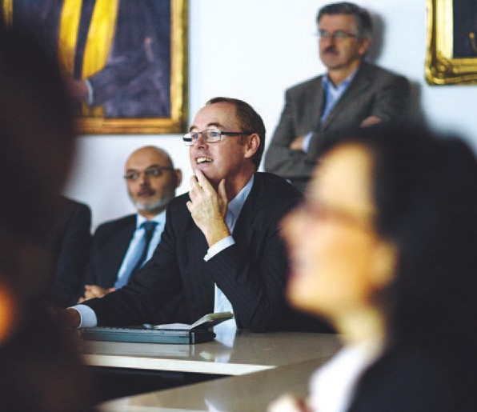Dr Alex Harper

“It was very gratifying to have some formal recognition from the hospital. It has been rewarding to mentor some outstanding people in the field, particularly through our retinal fellowship program, helping attract and retain
some outstanding talent.”
– Dr Alex Harper

Each year, the Eye and Ear awards the Dr J Aubrey Bowen Medal to
a medical staff member who has shown outstanding leadership and patient care. In 2013, the medal was awarded to Dr Alex Harper, head of the hospital’s Medical Retina Clinic.

Among his many contributions, Dr Harper runs a weekly Retinal Angiography Meeting for eye specialists and registrars to discuss patient cases presenting at the Eye and Ear. The meetings not only help improve patient care but provide a valuable teaching and professional development forum for staff.

Meeting of
minds

It’s 8am on Wednesday morning and more than 30 ophthalmologists and registrars have gathered for a meeting at the Eye and Ear.

Over the next hour, they will look at a range of complex and rare patient cases coming through
the hospital to discuss diagnosis, management and treatment options.

This meeting of minds, known as the Retinal Angiography Meeting, has been a weekly ritual at the Eye and Ear since 1988, when it was instigated by the then head of the hospital’s Medical Retina Clinic, Dr Wilson Heriot.

Dr Alex Harper took over as head of the clinic in
1996 and has been instrumental in continuing the meetings, providing an important forum for eye specialists to discuss conditions affecting the retina such as macular degeneration and diabetes-related eye disease.

“The meetings are attended by pretty much most of the retinal consultants, the retinal fellows and retinal registrars in the training program at the Eye and Ear,” Dr Harper says.

“I show patient cases and we question the
registrars about management and then discussions are held about how to best manage the cases that are shown.

“It is an important part of the continuing professional development of all the staff.
It allows staff to remain at the cutting edge of research and is a very valuable teaching resource for the registrars.”

Dr Nathan Kerr, who is Chief Resident and a fifth- year ophthalmology trainee at the Eye and Ear, attends the meetings each Wednesday.
“The format of the meeting involves analysis of various angiographic and imaging case studies of patients, with discussion of diagnosis and management,” Dr Kerr says.

“It provides an opportunity to draw upon the collective knowledge of different clinicians in the hospital and gauge different opinions.”

Dr Kerr says the meetings attract ophthalmologists from outside the hospital and are essential to the training of future eye doctors.

“The teaching that occurs at these meetings is unparalleled.
We are very fortunate to have such dedicated clinicians as Dr Harper, willing to give up their time to train young ophthalmologists.
It provides valuable real-world context for managing retinal diseases and helps ensure we maintain the highest level of care for our patients.”

The Eye and Ear’s Medical Retina Clinic sees more than 8,000 patients each year. Dr Harper says much has changed in the management and
treatment of eye disease since the first meeting was held in 1988.

“It has evolved over time from looking at images of the retina on 35mm film done on slide projectors
to now having digital imaging. We also have new treatments, particularly through injections that
can deliver medications directly to the eye, which allows us to treat conditions that were 10 years ago deemed untreatable.”

Our teaching
& research

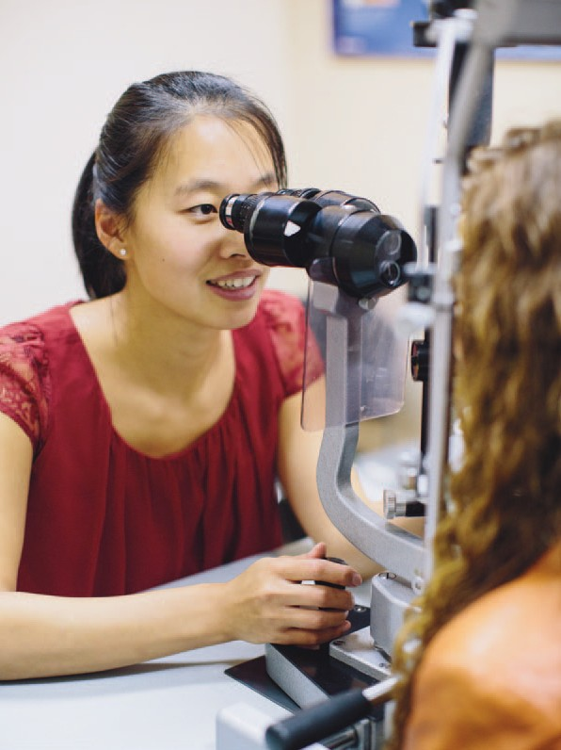

Dr Zoe Gao
Junior doctors training to be ophthalmologists in Australia and New Zealand must pass a gruelling final clinical exam to
gain their specialist qualifications. The Eye and Ear hosted the exam in 2014, bringing together 33 candidates from around Australia and New Zealand.

Facilitated by Eye and Ear doctor and chief examiner Peter Meagher, the exam is the culmination of more than a decade of study for future
eye doctors. In 2014, Zoe Gao took out the top honours, receiving the Gold Medal for her outstanding performance.

Striving for
success

After 13 years of rigorous study, there was no better reward for registrar Zoe Gao than passing her final exam to become an accredited ophthalmologist.

What she didn’t expect was to pick up the Gold Medal, which is awarded to the best performing candidate in the Royal Australian and New Zealand College of Ophthalmologists Fellowship Exams.

“I was really surprised because I was just hoping to pass. It certainly is very rewarding to know all the hard work went towards something like this,”
Dr Gao says.

Dr Gao, a fourth year ophthalmology registrar at the Eye and Ear, spent more than a year preparing for the exam, which involved both written and clinical components.

During the two-day clinical exam, candidates assessed 18 patients for a variety of eye diseases such as cataracts, macular degeneration and diabetes-related eye disease.

“It’s a marathon; you have nine minutes to examine each patient. Every station is manned by an examiner who quizzes you about what the problem is and how you’re going to treat it. It’s meant to ensure that you’re safe, that you’re not going to do anything sight-threatening or life-threatening,”
Dr Gao says.

One of the patients who volunteered for the exam was Bridgette Fahey-Goldsmith, who suffers from a rare eye condition known as Fuchs Heterochromic Iridocyclitis, which had caused a cataract to form over her left eye.
“I couldn’t see out of my left eye,” Bridgette says. “I had hand movements vision, which means you
can’t detect objects but if someone waves a hand
in front of you, you can see movement.”

Bridgette, who has since had an operation at the Eye and Ear to remove the cataract, says taking part in the exam was a rewarding experience.
“These students are the doctors of the future. They are the people that are going to be helping patients with eye conditions
and it’s nice to be involved.
I felt really confident with the students coming through.”

Dr Gao says the Eye and Ear has provided an invaluable training ground for her and is one of the most sought after hospitals among eye registrars seeking placements.

“We’re extremely lucky here because the Eye and Ear is one of the best teaching hospitals in ophthalmology in the entire country. We have amazing teaching and, without it,
I couldn’t be where I am.”

Dr Gao is planning to spend time in Alice Springs and Fiji in 2015 to gain experience in Indigenous health and international development before returning to her home town of Hobart as a generalist eye doctor.

For now, she is enjoying taking a breather from studying: “It’s really tough, but once you get through it, there’s an amazing rainbow shining on you. You can go back to having a life again and seeing your friends and family.”

Our teaching
& research

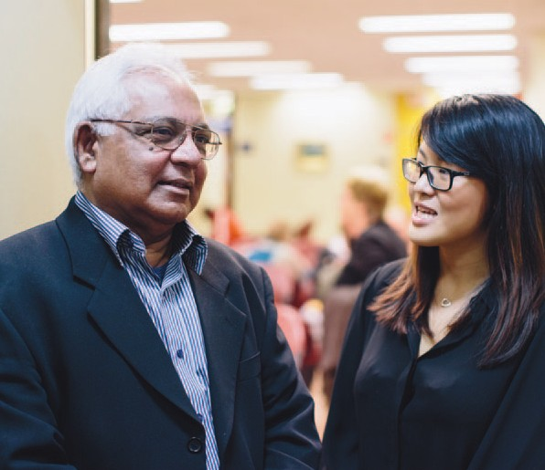Charles Braganca

“We’re very proud of what we’ve achieved for our patients and we’ve had interest from other hospitals looking at our model
to see if they can do something similar.” – Angela Stathopoulos, Director of Pharmacy

Eye patients requiring intravitreal injections at the Eye and Ear previously had to go to the pharmacy to collect their injections. Now pharmacists
come to patients, helping speed up hospital visits and allowing doctors to see more patients.

The Point of Care Dispensing trial was run at four eye clinics over 11 months in 2013, involving thousands of patients. The trial’s success has seen the service become business as usual at the hospital’s intravitreal eye clinics, with plans to expand it to other clinics in the future.

Thinking outside
the box

When Charles Braganca was referred to the Eye and Ear following a blood leak behind his left eye two years ago, doctors recommended intravitreal injections to help improve his vision.

The injections deliver medicines straight to the
eye and proved highly effective in treating Charles’ condition. However, visiting the hospital for the injections was often a lengthy process, involving assessments and medical imaging by staff in
the eye clinic, followed by a trip to the hospital’s pharmacy to pick up the injection and back again to the clinic for the injection to be administered.

Thanks to a trial undertaken in 2013, the trip to the pharmacy is no longer needed, with a pharmacist now positioned at intravitreal injecting clinics to process prescriptions.

“I think this is definitely a much better system,” Charles says. “Now it’s so much easier because they do it on the spot and you don’t have to go anywhere, they just call you when they’re ready.”

Eye and Ear Director of Pharmacy Angela Stathopoulos, who led the Point of Care Dispensing trial, says the service has reduced appointment times for patients and increased the number of patients doctors are able to see.

“It avoids the step of patients having to actually leave the clinical area and come to pharmacy and then go back up to the clinical area,” Angela says.

She says this was particularly difficult and time- consuming for elderly patients and those who had received eye drops before picking up their prescription.

“Unless they had someone with them, it could be quite a journey to come down to us to collect the prescription, so our focus was to make it easier for the patient.”
As part of the 11 month trial, pharmacists were positioned at four intravitreal injecting clinics at the hospital, processing prescriptions for 260 patients each month. Pharmacists also added value by reviewing the patients’ history to ensure the treatment was compliant, and assisted with
prescription maintenance by providing medication information to patients and clinic staff. Following the success of the trial, pharmacists have now permanently been positioned at these clinics.

“It shows that pharmacy is not just a box where you provide the service from, but a service you can take to the patient to
make it better for the patient and everyone involved,” Angela says.

“The feedback has been really positive with many patients saying it has significantly increased convenience. We’ve also had really good comments from the doctors because it’s allowed a better throughput of patients.”

Angela says the trial was the first of its kind for a public hospital outpatient eye clinic in Australia and hopes to expand the service to other areas of the hospital in the future.

“We’re very proud of what we’ve achieved for our patients and we’ve had interest from other hospitals looking at our model to see if they can do something similar.”

32 Eye and Ear Annual Review 2013–14

Our Research Partners

Bionic Vision Australia
HEARing CRC
The Bionics Institute
The Centre for Eye Research Australia
The University of Melbourne

Our memberships

The World Association of Eye Hospitals

Members: Tun Hussein On National Eye Hospital, Kuala Lumpur, Malaysia; The Department of Ophthalmology of the University Hospital Leuven, Belgium; Singapore National Eye Centre, Singapore; Moorfields Eye Hospital, London, UK; The Royal Victorian Eye and Ear Hospital, Melbourne,
Australia; Rutnin Eye Hospital, Bangkok, Thailand; St Eriks Eye Hospital, Stockholm, Sweden; The Rotterdam Eye Hospital, The Netherlands; The Royal Victoria Eye and Ear Hospital, Dublin, Ireland; Jakarta Eye Center, Jakarta, Indonesia; Tianjin Medical University Eye Centre, China; Sydney Eye
Hospital, Australia; Kim’s Eye Hospital, Seoul, South Korea; Aditya Jyot Eye Hospital, Maharashtra, India; St John Eye Hospital, Jerusalem, Israel; Kellogg Eye Center, Ann Arbor, USA.

The American Association of Eye and
Ear Centers of Excellence

Members: Bascom Palmer Eye Institute, Florida, USA; Emory Eye Centre, Georgia, USA; Massachusetts Eye and Ear Infirmary, Massachusetts, USA; Moorfields Eye Hospital, London, UK; New York
Eye and Ear Infirmary, New York, USA; Phillips Eye Institute, Minnesota, USA; Rotterdam Eye Hospital, The Netherlands; The Royal Victorian Eye and Ear Hospital, Melbourne, Australia; Rutnin Eye Hospital, Bangkok, Thailand; Show Chwan Health Care System, Taiwan; Singapore National Eye Centre, Singapore; St Eriks Eye Hospital, Stockholm, Sweden; Wills Eye Hospital, Pennsylvania, USA; Wilmer Eye Institute, Maryland, USA.
Disclaimer

While every effort has been made to ensure the accuracy of this document, The Royal Victorian Eye and Ear Hospital makes no warranties in relation
to the information contained herein. The Royal Victorian Eye and Ear Hospital, its employees and agents disclaim liability for any loss or damage which may arise as a consequence of any person inappropriately relying on the information contained in this document.

Produced by Marketing and Communications, The Royal Victorian Eye and Ear Hospital

Photography by Leo Farrell and
The Royal Victorian Eye and Ear Hospital Designed by Viola Design Environmental Profile
Both the printer and the paper used to produce
this document have Forest Stewardship Council® (FSC®) and ISO 14001 environmental certification. FSC® is a Chain of Custody (COC) process. IS0
14001 is the international standard of Environmental
Management Systems (EMS) designed to ensure the continuous measurement and reduction of environmental impacts. This publication is printed using vegetable based soy inks.

The Royal Victorian Eye and Ear Hospital

32 Gisborne Street East Melbourne Victoria 3002 Australia

T +61 3 9929 8666

F + 61 3 9663 7203

E info@eyeandear.org.au www.eyeandear.org.au

