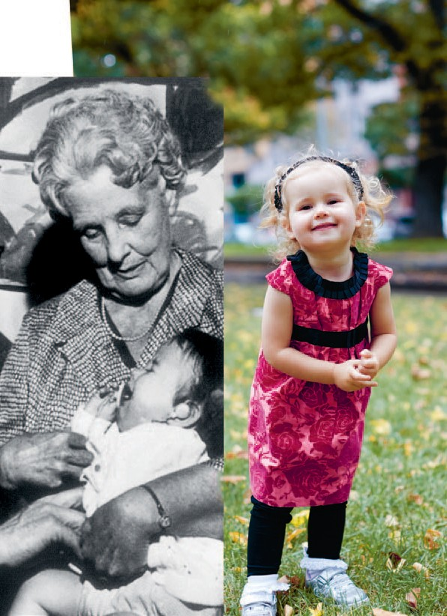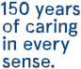

Our Stories
Our History

Annual Review 2012–13

Contents

Welcome to our hospital 3

Our people 4

Our Senior Medical Staff 5

Carmel — The next generation 6

Gerard — Paving the way 8

Lisa, Amy, Richard, Andrew, Matthew, Rebecca, Kaye — A different perspective 10

Valerie & Jascie — A tradition of patient support 12

Sue — Honouring patient-centred care 16

Lucy — Unsparing in her efforts 18

Mike — Working behind the scenes 20

Our patients 22

Graham & Graeme — Breaking the sound barrier 23

Lily — Hearing clearly 26

Leah — A brighter outlook 28

Janet & Paul — A familial approach 30

Dianne, Maurice & Murray — A vision for the future 32

Our teaching & research 34

Kerryn — Supporting innovation 36

Bill — A legacy of professional standards 38

Daniel & Alice — Valuing Voice 40

Jean — A foundation for hearing research 42

Joanne — Seeing the light 44

John — Reinvigorating education 46

2 Eye & Ear Annual Review 2012–13

2 Eye & Ear Annual Review 2012-2013

150 years of caring in every sense

Celebrating
150 years of caring in every sense

our stories
our history

Welcome to
our hospital

Since 1863, the Royal Victorian Eye and Ear Hospital has provided specialist health care to generations
of Victorians. This year, we take the opportunity to reflect on our achievements in clinical care, teaching and research over the past 12 months and throughout our history — and how our past successes are still benefitting our patients today.

A proud history of research and teaching

Since our inception, the Eye and Ear has been
at the centre of world-leading eye, ear, nose and throat care, research and teaching. We have long embraced the important connection between improving patient outcomes through ground- breaking research and educating the next generation of health professionals. As early as 1882 the hospital began admitting medical students for clinical instruction and since then we have maintained competitive and unrivalled training programs, providing students with unique learning opportunities in real-life clinical settings.

Our founder Dr Andrew Sexton Gray formed our first partnership in 1870; recognising the Eye and Ear is made stronger by linking with organisations that share our passion for innovation. Together with our partners, we continue to collaborate on new and exciting ways to improve the lives of our patients. We currently have 270 active research projects, in conjunction with our partners, the Centre for Eye Research Australia (CERA), the University of Melbourne, Bionics Institute,
Bionic Vision Australia and HEARing CRC.

A tradition of dedication

The Eye and Ear has consistently attracted the best and brightest, with some of the greatest medical and scientific minds of our past and present working, teaching and learning here at the hospital. From just
a handful of staff in our early days, we have grown into a multi-disciplinary team of anaesthetists, eye and ear surgeons, nurses, emergency and specialist medical staff, allied health professionals and support staff. Today, we are accredited by the relevant colleges, including The Royal Australian and New Zealand College of Ophthalmologists (RANZCO),
The Royal Australasian College of Surgeons (RACS), The Royal Australian and New Zealand College of Anaesthetists (ANZCA) and the Royal Australasian College of Emergency Medicine (ACEM) — ensuring we continue to attract innovative and passionate professionals for the next 150 years.

Our patient-centred approach

Despite the many changes we have witnessed in medicine, science, clinical care and within Victoria as a community, our patient-centred approach
has remained constant. Dr Gray first opened the Eye and Ear Infirmary in 1863, available to all who needed care. Now, in 2013 we care for hundreds
of thousands of Victorians, helping to improve their quality of life. We were excited this year to receive the news the State Government will fully fund a comprehensive hospital redevelopment, helping
us provide the best possible patient care well into the future.

Ann Clark
Chief Executive Officer

4 Eye & Ear Annual Review 2012–13

We attract the best and brightest to the Eye and Ear

our people

Our Senior
Medical Staff

Directors Assoc. Professor Robert Briggs Clinical Director,
Otolaryngology and
Head, Otology
Dr Caroline Clarke Executive Director, Ambulatory and Medical Services, Chief Medical Officer
Assoc. Professor Michael Coote Clinical Director,
Ophthalmology Services
Dr Peter Read
Director of Anaesthesia
Heads of Clinic Assoc. Professor Anne Brooks
Head, General Eye Clinic 3
Dr William Campbell Head, Vitreoretinal Unit Ms Anne Cass
Head, Head & Neck Dr Carmel Crock Director, Emergency Department
Dr Mark Daniell
Head, Cornea
Dr Catherine Green
Head, Glaucoma
Dr Alex Harper
Head, Medical Retina
Dr Lionel Kowal Head, Ocular Motility Dr Gary Leber
Head, General Eye Clinic 5
Mr David Marty Head, Rhinology Dr John McKenzie
Head, Ocular Oncology
Dr Alan McNab
Head, Orbital Plastic and
Lacrimal Clinic
Dr Peter Meagher
Head, General Eye Clinic 1
Dr Mark Paine
Head, Neuro-Ophthalmology and Vestibular
Ms Elizabeth Rose
Head, Paediatric ENT
Dr Joseph San Laureano
Head, General Eye Clinic 4
Dr Richard Stawell
Head, Ocular Immunology
Dr Christine Tangas
Head, General Eye Clinic 2
Ophthalmologists
Dr Penelope Allen
Dr Alex Amini
Dr Brian Ang
Dr Maged Atalla
Dr Alicia Wai Pheng Au
Dr Renuka Bathija Dr Jacqueline Beltz Dr Robert Buttery Dr Roland Bunting Dr Susan Carden
Dr Dermot Cassidy Dr Christopher Chan Dr Elsie Chan
Dr Thomas Chia
Dr Daniel Chiu
Dr Au Chun Ch’ng
Dr Li Ping Chow
Dr J Ben Clark
Dr Suzanne Cochrane Dr Benjamin Connell Dr Joan Cosgrove
Professor Jonathan Crowston
Dr Rodger Davies Dr Fio De Vincentis Dr Joanne Dondey Dr Rohan Essex
Dr David Fabinyi Dr Xavier Fagan Dr Lisa Farber
Dr Kevin Foo
Dr Justin Friebel Dr Fiona Fullarton Dr Trevor Gin
Dr Padmini Gnanaharan Professor Robyn Guymer Dr Thomas Hardy
Dr Oded Hauptman
Dr. Farokh Irani
Dr Jwu Jin Khong Dr Kavita Khurana Dr Mark Lazarus Dr Lyndell Lim
Dr Troy Lim Joon
Dr Cecilia Ling
Dr Lance Liu
Dr Michael Loughnan Dr Damien Louis Professor David Mackey Dr John Manolopoulos Dr Nicolaos Mantzioros Dr Wendy Marshman
Dr Mark McCombe
Dr Lorraine Ong
Dr Terrence Ong
Dr Pathmanathan Pathmaraj
Dr Alexander Poon Assoc. Professor Salmaan al-Qureshi Dr Robert Ramsay
Dr Edward Roufail
Dr Jonathan Ruddle
Dr Nisha Sachdev
Dr Julian Sack
Dr Sukhpal Singh Sandhu
Dr Marc Sarossy
Dr Khami Satchithananthan
Dr Michael Shiu Dr Grant Snibson Dr Helene Steiner Dr Mark Steiner Dr Tony Stubbs
Dr Charles Su
Dr Laurence Sullivan
Dr John Sutton
Dr Tu Anh Tran
Dr Robyn Troutbeck Professor Rasik Vajpayee Dr Anton Van Heerden
Dr Faye Walker Dr Mark Walland Dr Diane Webster Dr Kristen Wells Dr Harry Wenas Dr Mark Whiting
Dr Sanjeewa Wickremasinghe
Dr Elaine Wong Professor Tien Wong Dr Jonathan Yeoh
Dr Ehud Zamir
Otolaryngologists
Ms Vasuki Anpalahan
Mr Simon Braham
Mr Christopher Brown
Ms June Choo
Mr Benjamin Cook Mr Markus Dahm Mr Michael Dobson Mr Simon Ellul
Mr Mark Guirguis
Mr David James
Mr Richard Kennedy
Mr Randal Leung
Mr Philip Michael
Professor Stephen O’Leary
Mr Halil Ozdemir Mr Theo Sdralis Mr Craig Semple
Mr Michael Tykocinski
Mr Robert Webb
Dr Benjamin Wei
Mr Sarin Wongprasartsuk
Anaesthetists
Dr Matthew Acheson
Dr Peter Ashton Dr Glenn Bakyew Dr Jacob Boon
Dr Michael Boykett Dr Andrew Braun Dr Linda Cass
Dr Junkeat Chan
Dr Anne Chenoweth Dr Stephen Chester Dr Elizabeth Coates Dr Gavin Doolan
Dr Duncan Forbes
Dr Natalie Anne Gattuso
Dr Alexander Gershenzon
Dr Gaylene Heard
Dr Sean Hearn
Dr William Hurley Dr Simon Jones Dr Jennifer King
Dr Sarah Kondogiannis
Dr James Koziol Dr Joshua Lau Dr Ei Leen Lee Dr Ana Licina
Dr Lisa Lin
Dr John Lioufas
Dr James Mitchell Dr Craig Morgan Dr Al Motavalli
Dr Michelle Natividad
Dr Igor Oleinikov
Dr Irene Palgan
Dr Tuong Dien Phan
Dr Dayalan Ramasamy Dr John Riseborough Dr Mhousci Scanlan
Dr Peter Seal
Dr Caroline Sharpe
Dr Peter Snider Dr Mark Suss Dr Alan Tse
Dr Andrew Tymms Dr Andrew Walpole Dr Crispin Wan
Dr Margaret Watson
Dr William Watson Dr Anthony White Dr Daniel Wong
Dr Andrew Wyss
Physicians
Dr Julian Bosco
Dr Timothy Godfrey Dr Balasubramanian Krishnamurthy
Dr Neil Shuey
Dr David Szmulewicz
Dr Anneke Van Der Walt
Medical
Administration
Dr Susan Sdrinis
GP Liaison Dr Lina Nido Emeritus
Consultants
Dist. Professor Graeme
Clark, AC
Dr Julian Heinze
Assoc. Professor Hector
Maclean
Assoc. Professor Justin
O’Day, AM
Professor Hugh Taylor, AC Dr John Thomson

Our people

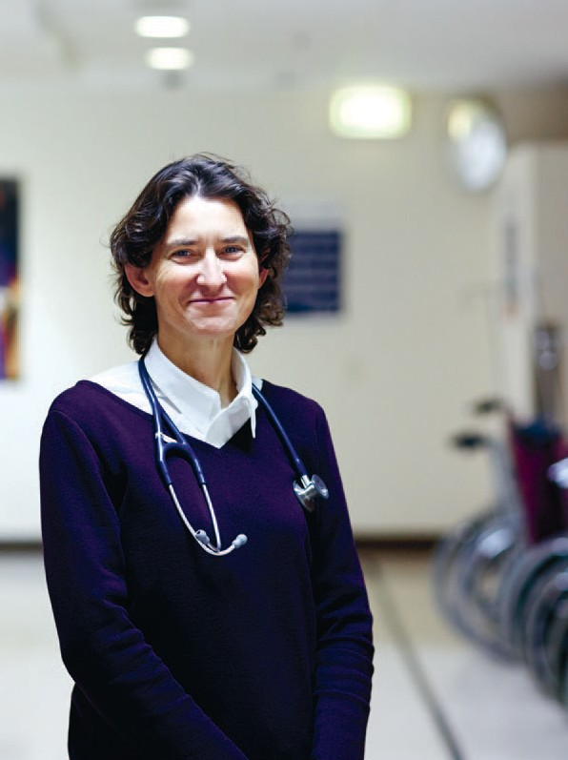

Iliquate prereptatur, comnihi tibeaque si omnieniet ut verferendi ist enis si aut
resto quosseque nus aditaes maximenis mint ommos
dollor solutasped quae platem. Nequatur?

Carmel
Niece of the late Professor Gerard Crock, who was appointed as the first professor of ophthalmology in Australia, Dr Carmel Crock is Director of the Royal Victorian
Eye and Ear Hospital Emergency Department, where around 45,000 patients are treated every year.

The department is accredited for the training of general emergency physicians as well
as trainee ophthalmologists and otolaryngologists. Each year, over
100 medical students are taught essential eye and ENT skills in the department.

The next
generation

When patients in the Royal Victorian Eye and Ear Hospital’s Emergency Department notice Dr Carmel Crock’s name badge, they often ask if she is related to the ophthalmologist who used to treat them, Professor Gerard Crock.

The answer is yes: her father, Henry and Gerard were identical twins who both studied medicine at the University of Melbourne. While Carmel’s father practiced as an orthopaedic surgeon, her uncle was an ophthalmologist, who was appointed as the first professor of ophthalmology in Australia in 1963,
and worked at the Eye and Ear until his retirement in 1986.

Carmel says: “I didn’t work with Uncle Gerard because he had already retired when I qualified, but I did talk to him about my job. He and my dad were an
inspiration to me because of their amazing work ethic, love for their work, and their high standards.”

And that’s what Carmel brings to her role as Director of the Emergency Department, high standards.

She wants every patient to receive the best possible care, as quickly as possible. To achieve that,
Carmel makes sure that all staff members use every opportunity to learn from each other, feel supported and enjoy working in the department.

“Eye and ear problems aren’t life threatening but they’re sense threatening. It’s very scary to suddenly lose vision or your hearing, or for your child to be in pain. We do everything we can to put patients at ease, and provide effective, timely treatment,” she says.
Many eye and ENT emergencies present to general hospital emergency departments, and when Carmel was training as an emergency physician, she
sought extra experience by working in the Eye and
Ear Emergency Department for six months.

“I loved working at the Eye and Ear so much I stayed,” she says.

When Carmel, who has been with the Eye and
Ear for four years, took up the position as Director of the Emergency Department she set up six- month training placements for general emergency physicians. Added to this, she now ensures there is a range of experience among the doctors on duty, so that trainee ophthalmologists, otolaryngologists and emergency registrars work very closely with experienced consultants.

“We’ve introduced a culture where trainees have to ask for a second opinion from the senior consultant. This means there are multiple learning opportunities for trainees and a much lower margin for error,” she says.

Every Wednesday morning Carmel finds out how her improvements are working for patients. She says: “I meet with the Consumer Liaison Officer every week and personally call every patient who has made a complaint.”

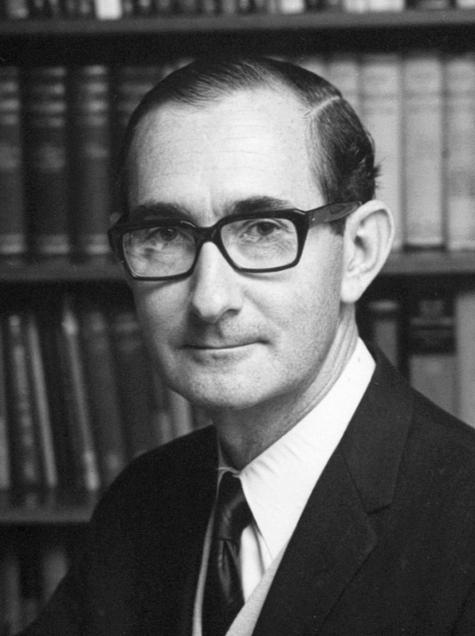Our people

Our history

Gerard

Paving the way

At the age of 34, Gerard Crock was appointed Australia’s first professor of ophthalmology, when the University of Melbourne established the Department of Ophthalmology at the Royal
Victorian Eye and Ear Hospital in 1963. During his tenure, he introduced microsurgical techniques to the specialty of ophthalmology, invented ophthalmic instruments used around the world and carried out pioneering research.

Gerard graduated from the University of Melbourne medical school in 1953 and for the next ten years he undertook specialist training in ophthalmology in
London and Baltimore. After his return to Melbourne to take up his professorial appointment, he specialised in retinal, corneal and glaucoma surgery.

At the same time Gerard was appointed Director of the Retina Unit at the Eye and Ear, a post he held until 1987. He established a registrar training program, and Melbourne soon became a leading centre for ophthalmology training in Australia.

The ophthalmoscope, an instrument used to examine the inside of the eye with a beam of light and a magnifying lens, was invented more than a decade before the Eye and Ear was founded. Over the years the ophthalmoscope gradually improved until 1965 when Gerard approached ophthalmic instrument designer, Don Schultz with a prototype of the world’s first spectacle-mounted, indirect ophthalmoscope.

Allowing surgeons to use an ophthalmoscope while keeping both hands free, the Schultz-Crock ophthalmoscope remained in production for the next 35 years and was sold around the world.

In 1972, Gerard and Don Schultz went on to develop an enhanced model of the ophthalmoscope, which incorporated Galilean telescopes to make retinal surgery easier.
Under the direction of Gerard, the Department of Ophthalmology carried out research into retinal angiography, an imaging technique used to detect damage to blood vessels at the back of the eye.
He was a pioneer in this field, especially in the areas of stereo-photography, fluorescein angiography, cinematography and retinal laser photocoagulation.

Gerard’s research also embraced the field of microsurgery. One of Australia’s pioneering vascular microsurgeons, Bernard O’Brien introduced
Gerard to the transplant properties of tendons in the leg that he went on to use in the treatment of complicated retinal detachment. And, in 1978, he and his team published a paper describing a new corneal cutting instrument they had developed over five years, which was used to transform the precision of corneal transplant surgery.

Despite running a busy ophthalmology practice and serving as Chairman of the Eye and Ear’s Senior Medical Staff from 1982–7, Gerard found time
to share his knowledge and skills with the wider community.

He worked with Fred Hollows’ Indigenous Eye Care Program in Aboriginal communities and was the founding member of Project Orbis, in which experts from Australia and the US delivered training programs in China.

Closer to home, Gerard supported the new Department of Optometry, headed by Professor Barry Cole. Together they established the Low Vision Clinic for the Association for the Blind in
1972, which is now known as Vision Australia.

In 1985, Gerard’s enormous contributions to ophthalmology were recognised when he was made an officer of the Order of Australia (AO).

Our people

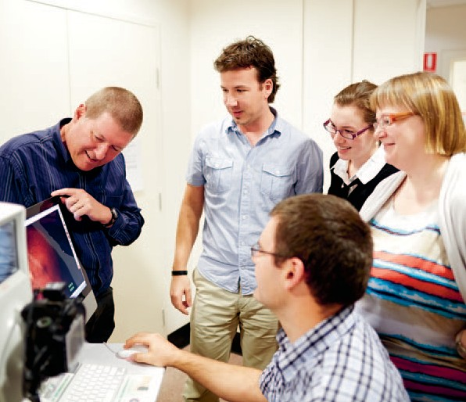

“It’s very interesting to be involved in the research programs because they add an extra dimension to
my work. The more challenging conditions extend my skills
and it’s good to know that my work might contribute to new treatments in the future.”
The Medical Photographic
Imaging Centre uses any one of
16 different machines to produce images assisting in the diagnosis and monitoring of eye disease. One machine takes 3D retinal scans and can compare previous
scans to current images of the eye.

Techniques such as ocular coherence tomography (OCT) produce images showing detailed retinal structure, particularly useful for monitoring
age-related macular degeneration. Retinal angiography uses dye injected into the bloodstream to illuminate blood vessels at the back of the eye, helping detect swelling
or bleeding associated with diseases like diabetic retinopathy.

A different
perspective

During the early 20th century, many attempts were made to produce a camera that could take pictures of the retina, at the back of the eye, to assist with diagnosis and monitoring of eye disease. By the middle of the century, retinal photography became fully developed and refined, and in 1953 the Royal Victorian Eye and Ear Hospital recruited a medical photographer from England, Thomas Cottier, to establish the hospital’s first clinical photography department. He started with a small studio and
one of the first of the new retinal cameras.

This new department within the hospital was representative of the development and progress of medical photography as a specialist field globally. In 1959, students in the U.S. carried out the first retinal angiogram, an imaging technique using dye injected into the bloodstream, to show damage to blood vessels at the back of the eye. And in 2004, a new machine was introduced, using a technique called ocular coherence tomography (OCT), which shows the structure of the retina in minute detail.

Today’s medical photographic imaging team at the Eye and Ear continue to see changes and improvements in the machines, techniques and reporting systems they use.

Manager of the Medical Photographic Imaging Centre (MEDPIC), Lisa Breayley says: “The retinal images we take help ophthalmologists diagnose and monitor the progress of a number of diseases. We are also responsible for taking before and after
photographs of patients undergoing some ENT and plastic surgery procedures.”

The team of five photographers and two clerks see around 1400 patients each month, a number that has tripled since 2006. Andrew Newton is the longest serving member of the department, starting in 1986. Alongside an increase in numbers, he has seen a major shift in the reporting system.
“The biggest change for me has been the transition from film to digital photography. Producing images for retinal angiograms used to take half a day for black and white images and a week for colour, on films that were placed in patient notes. Now we have software that uploads images
to the Imagenet system, and doctors can view them in clinic immediately,” he says.

The fact that there are now 16 different machines in the department means that the team needs to be highly skilled.

Lisa says: “There are about ten medical photographers in Australia who specialise in ophthalmic imaging, and more than half of them are at the Eye and Ear, which makes our department
the best place to be trained.”

Newest member, Amy Khong is very enthusiastic about her work in the department. She says: “It’s such a supportive environment. You can go to any member of the team to ask for help and it’s very busy so I get a lot of experience.”

Richard Smallwood is a Grade 2 photographer who is certified to carry out imaging for eye research undertaken at the hospital. He says: “I often work on multi-centre, international trials, using a very specific protocol so that all the imaging is carried out in exactly the same way for every patient on the trial.”

Our people

Our history

Volunteers have long played a critical role in the Royal Victorian Eye and Ear Hospital’s patient- centred approach to clinical care.
Valerie & Jascie

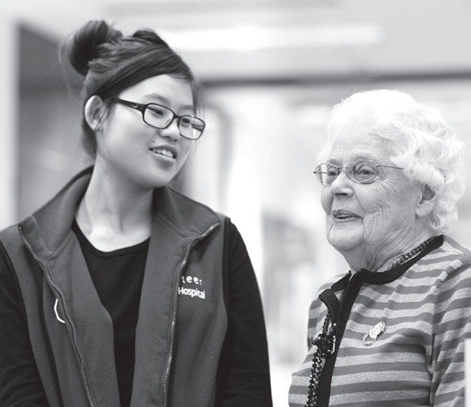
Those who choose to generously volunteer their time to the Eye and Ear do so because, not only do they wish to help others, but often the hospital resonates with them on a personal level. Once you begin to chat with one of our volunteers,
a complex connection with the hospital is often revealed.
Since 1922, the Eye and Ear has benefitted from the amazing contribution of generations of Victorians.

There are currently 30 active volunteers at the Eye and Ear, who fulfil a variety of roles within the hospital from our concierge service formed in 2008, roles within our emergency department, gift shop and fundraising.

A tradition of
patient support

Valerie Galagher — Auxiliary member since 1971

Valerie Galagher has a 40-year association with
the Eye and Ear, stemming back to the late 1960s, when her son Christopher was first treated for
a serious eye injury. Three years after Chris first presented to the Eye and Ear, Val began working with the hospital as part of the Auxiliary network of volunteers, who for nine decades have helped
support the hospital through fundraising initiatives.

“In 1968, my eight year-old son Chris received
a severe eye injury. He was playing a game at a church youth group when he received a direct blow with a short stick to his left eye. It resulted in a torn iris and a detached retina.”

“Suffering from traumatic glaucoma, he became a private patient of Dr William (Bill) Gillies, Head of the Glaucoma Unit and had all his treatments at the
Eye and Ear,” she says.

“After several operations and despite wonderful treatment from the Eye and Ear hospital and Dr Gillies, Chris lost the sight of his eye.”

“The care and support from the hospital was outstanding. Chris adjusted well and has been a capable, successful lawyer and one-eyed Collingwood supporter ever since,” she says.

In June 1971, Val became a foundation member
of the new Nunawading and District Auxiliary of the Eye and Ear. From the beginning the small Auxiliary was very active and over the years was able to raise significant funds for the hospital.

“I became president in 1974 until the Nunawading Auxiliary closed in 2007. All the Auxiliaries were very supportive and visited one another’s annual meetings and functions. We were a large family,
with great input from the hospital’s Committee of Management, the doctors, nurses and administrators.”

In the 1970s, the Committee of Management suggested the Council of Auxiliaries might shift their focus away from funding individual pieces of
equipment, which with rapid changes in technology soon became obsolete, towards pooling their resources to fund major developments.

“We were able to fund the upgrade of the operating theatre, a new staff tea room and the fit out of the second floor of the Smorgon Family Wing.”

Auxiliary fundraising also enabled a new day surgery facility, high dependency unit beds, upgraded
theatre lights and a lift system better suited to hearing and visually impaired patients. In 1969
Auxiliary members also purchased the Eye and Ear Opportunity Shop in Smith Street, Fitzroy, operating and staffing the store for the next 36 years.

“I really enjoyed all the years of close involvement with the hospital. I am sure we all appreciated the friendships and the satisfaction of supporting such a wonderful institution,” she says.

“The Royal Victorian Eye and Ear Hospital is still a place where wonderful miracles of healing and care happen and now a new generation of volunteers are
picking up the torch and involving themselves in the life of the hospital.”

“In doing so they will discover the joy of belonging
to the Eye and Ear family, that still serves the people of Victoria after 150 years.”

14 Eye & Ear Annual Review 2012–13

Jascie Hong — Concierge volunteer

Currently in her third year at the University of Melbourne, 20 year-old Bachelor of Science student Jascie Hong is a recent recruit to the concierge volunteer service, joining the Eye and Ear in February 2013 as part of a recent volunteer recruitment drive.

Jascie spent most of her childhood in Hong Kong, learning English from the age of 11 when she settled in Australia with her family. She plans to begin a Master of Audiology, a two-year course, next year.

“I want to be an audiologist because I come from an ESL (English as a Second Language) background and I know the difficulty of not being understood
and not being able to communicate with others. It would be really good if I could do something to help people who find themselves in a similar situation,” she says.

Jascie says those first few years in Australia were difficult for her, while she worked to catch up to her classmates. However, it has helped her realise the role of communication in all areas of life, from
working, making friends and just being able to feel a part of the community.

“You just don’t understand what people are trying
to say to you and you don’t have a good command of English. It can be really frustrating and it creates
a sort of barrier and that prevents you from talking to people as well.”

“I wanted to volunteer at the hospital because I wanted to be able to help others and also to see how the Eye and Ear works before I hopefully become an audiologist,” she says.

Audiology is the assessment and treatment of hearing-related problems. Audiologists at the Eye and Ear are allied health professionals who work with patients to assess, monitor and improve their hearing and balance issues through diagnostic testing and treatments.

Audiology also forms a critical role in the success of a Cochlear device following implantation, particularly for young recipients who have never been exposed to sound and must be taught how to process verbal language.

In addition to her work at the Eye and Ear, Jascie says she is keen to learn more about what life is like for people who are profoundly deaf. She obtained
a level one qualification in Auslan sign language in October last year and wishes to continue her studies in 2013.

“I would love to continue (with the course). It is an interesting language, the grammar and sentence structure is very different from spoken English.
I really felt like I should understand more about
Australian deaf culture,” she says.

Jascie has enjoyed her role as concierge, with longer serving staff and volunteers welcoming the Eye and Ear’s newest recruit.

“I remember during my interview one of the staff members came
up and introduced herself and gave me a lolly, which I though was really nice.”

“I have learnt a lot from the volunteers who have been here a long time and I admire their dedication.”

150 years of caring in every sense

The first volunteers at the Eye and Ear were often the wives of Committee of Management members, who would read to
patients, bring food to the hospital or take younger patients on trips
to the Fitzroy Gardens. The first official volunteers joined the hospital in 1922 as members of newly formed Auxiliaries. The first Auxiliary originated from Olinda and Sassafras in the Dandenong Ranges and eventually consisted of a large network of volunteers and fundraisers around the state.

As the decades progressed, the funding and patient support Auxiliaries provided proved increasingly important to the hospital. During the severe rationing periods of World War II and the
Great Depression, Auxiliaries helped supply patients with ‘luxuries’ such as fruit, eggs and poultry and since the 1960s have supplied a ‘Good Samaritan’ fund, to assist low- income patients in getting to and from the hospital.

To date, Auxiliary fundraising has provided millions of dollars to fund critical hospital resources and equipment for our patients.

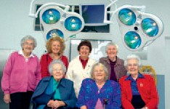Auxiliary members with new theatre lights, 2005

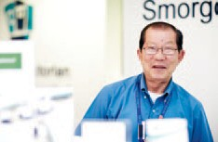
Concierge volunteer, Gim

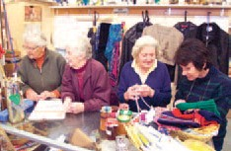

The Eye and Ear Opportunity Shop

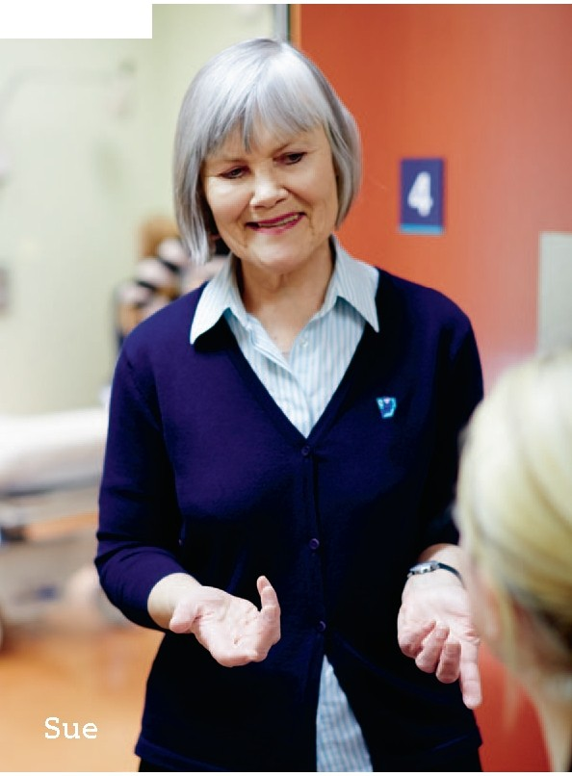Our people

Honouring
patient-centred care

Sue Le Roux has been a nurse for more than 40 years. When asked how nursing has changed since she first started and how she has maintained her enthusiasm for nursing over the years, she says:

“It’s a combination of being able to provide care that’s appropriate to the individual patient; the opportunity to use problem solving and organisation skills; as well as the camaraderie between team members,” she says.

After a career that has spanned senior positions in neurology, intensive care, community nursing, paediatrics and infectious diseases, Sue was appointed ENT Clinic Nurse at the Royal Victorian Eye and Ear Hospital four years ago.

“I hadn’t worked in ENT before but I find it fascinating. The work is varied and I love being part of the team,” she says.

As a recently appointed ENT Clinical Nurse Specialist, Sue’s next challenge is to be involved in setting up a nurse-led ear care clinic at the hospital. “This initiative is a very innovative and creative approach from the nursing staff to address the needs of our patients. Nursing care can make an important contribution to patient wellbeing, including facilitating patient access to hospital services.

“I’m going to be trained to carry out procedures such as post-mastoidectomy care and wax clearance, with the aim of opening the new clinic soon,” she says.

Sue was chosen as the recipient of the hospital’s
2012 Nursing Excellence Award, which she sees as a great honour as well as an acknowledgement of the contribution nurses make to healthcare at the Eye and Ear.
Over the last two years Sue has become involved with the hospital’s indigenous ear health outreach program. “I’ve been to Alice Springs four times
as part of the outreach team, visiting Aboriginal communities by 4WD with an ENT surgeon and an audiologist.

“Ear infections and resulting hearing impairment are a major problem for children and can have huge ramifications for their language, social and educational development, so it’s wonderful to
be able to help make a difference.”

The outreach program is also working closer to home, at the Victorian Aboriginal Health Service (VAHS) in Fitzroy. Once a month, Sue is part of the team who run an audiology and ENT clinic at the VAHS centre, with the aim of increasing the
number of Aboriginal Victorians accessing specialist healthcare services.

Sue is also a member of the Eye and Ear’s 150th anniversary committee, which has been organising celebrations to acknowledge the enormous contribution by staff, past and present, to eye and ear healthcare in Victoria. “I learned so much about the history of the hospital and enjoyed meeting members of the public and past staff members as a tour leader at the Community Street Party in April,” she says.

For Sue the word retirement doesn’t exist: “I plan to keep working because I enjoy it and feel that I’m making a contribution.”

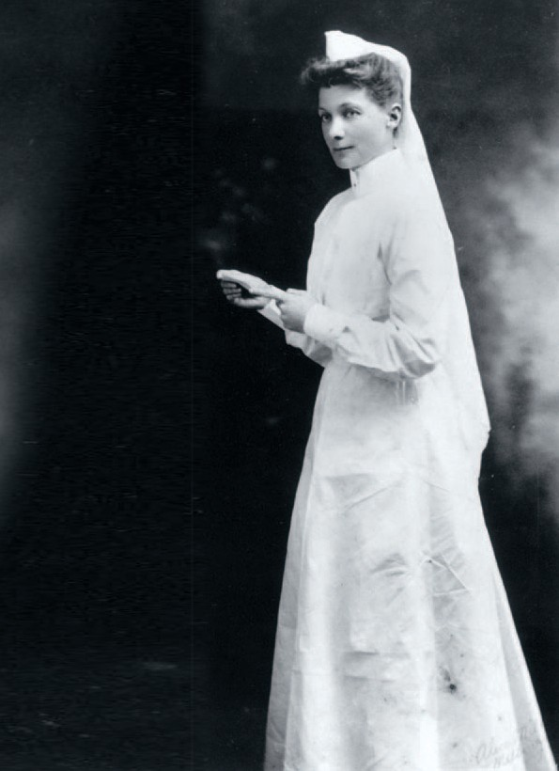Our people

Our history

Lucy

Unsparing in
her efforts

Lucy Jones assumed the role of Matron at the Victorian Eye and Ear Hospital long before it obtained the ‘Royal’ prefix in 1961 and not long after the turn
of the century, when the hospital was still in its early years and medicine too was in its infancy.

Trained as a nurse at the Melbourne Hospital,
Lucy graduated in 1902, working as Matron of the
Bairnsdale Hospital before commencing at the Eye and Ear in 1908. Lucy was one of the earliest nurses to be registered with the first Nurses’ Board on 8 December 1924.

Working during the first few decades of the 20th century, Lucy was all too familiar with the often harsh conditions that characterised healthcare
at the time. Patients usually required months to recover from surgery and in some cases stayed up to a year. Lucy was often confronted with the boredom and irritation of patients who unwittingly found themselves living at the hospital.

Conditions for nurses were not much better than those of the patients. Working 60 hour weeks with just one day off a year and living in cramped and uncomfortable conditions onsite it was an extremely demanding post. With few resources,
it was common for nurses to not only look after patients’ medical needs but also to act in domestic roles. Nurses undertook most of the cleaning duties and patients often needed to be physically carried between wards and theatres.

In 1914, to help ease the physical burden on the nursing staff, Lucy obtained funding for a trolley, which could be used to transport patients to and from theatre more comfortably. However, when the trolley wore out and there were no funds to replace it, patients were again transported in canvas slings attached to poles.

Yet, although she worked in difficult times, patients and staff alike respected Lucy as a caring and thoughtful leader who helped pioneer the Eye and Ear’s patient-centred approach to clinical care. During her considerable tenure with the hospital
she consistently fought for the rights of patients and
staff and worked hard to improve conditions at the hospital. To help keep young patients occupied, Lucy equipped a children’s play area and pushed for the purchase of Dodgshun House to use as nurses’ living quarters.

Renowned otolaryngologist, Dr Jean Littlejohn worked alongside Lucy during her early years at the Eye and Ear. She later said, “Matron Jones was a disciplinarian but scrupulously fair in all her administration of not only the nursing staff but, when necessary, the resident medical staff.

“She was immaculate in her dress of starched white uniform and high goffered cap; an example to everyone of dignity, bearing and behaviour.”

A respected member not only of Eye and Ear staff but of the medical community, the Minister for Health asked Lucy if she would coordinate nursing arrangements across multiple Melbourne hospitals during the influenza epidemic of 1918.

Following her resignation in late 1939, the Committee of Management noted its disappointment, Secretary John Millar said in The Argus, 24 October 1939: “during Matron Jones’ 31 years of service to the hospital, staff had increased from 13 to 70, inpatients from 869 to 2,082 and outpatients from 6,400 to
25,000.”

The Committee said in a separate statement Lucy had been, “unsparing in her efforts for the relief
of the sick poor and their return to health and strength. Her long association with the hospital has been marked by high efficiency and zeal and by the loyalty and goodwill of the staff.”

In the late 1960s, the Eye and Ear officially renamed its lecture theatre the Lucy Jones Hall in honour of her decades of dedicated service to the hospital.

150 years of caring

Our people

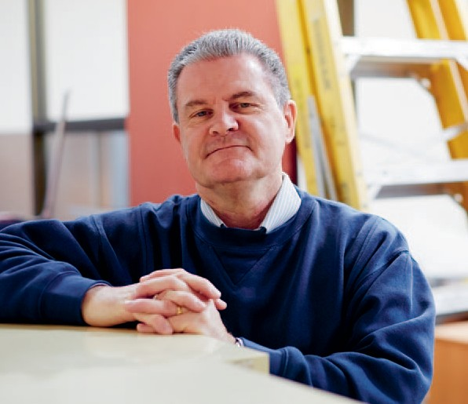Mike

“The main focus of all of us in the redevelopment team is to deliver better patient outcomes, reflected in patient comments that come back to the hospital.”

When a piece of hospital equipment has come to the end of its useful life, Mike assesses whether it should be disposed of, or whether it could be donated
to a country in need.

Over the past five years, items such as beds and large pieces of ophthalmic equipment have been donated to hospitals and cataract programs around the world. This includes the Marsh Foundation (Indonesia distribution), the Vietnam Vision Project and The John Fawcett Foundation (Indonesia). Donations are also made to Eyes for Africa, which carries out cataract
programs in Ethiopia.

Working behind
the scenes

As a visitor to the Royal Victorian Eye and Ear Hospital, you are not likely to meet Mike Anderson but for seven years he has been integral to the operation of the hospital. Initially employed as a Coordinator in the Supply Department, Mike has also worked in the Engineering Department and as a Health and Safety representative.

Following the State Government’s announcement in November 2012 that it would fully fund a $165 million comprehensive hospital redevelopment, Mike’s role has shifted toward ensuring a smooth transition to improved patient and staff facilities. Already assisting in smaller refurbishment projects prior to the announcement, Mike is now busy ensuring the foundation is set for widespread works to begin in the coming years, during this intense planning period.

The redevelopment, scheduled for completion
in 2017, will be carried out in stages to allow for normal functioning of the hospital’s services and minimal disruption to patients and staff. However, this entails moving staff, departments and wards to other areas to make way for the building works, and the hospital needed the right person to coordinate this ‘decanting’ process. Mike was asked to help with the logistics due to his detailed knowledge of
all areas of the hospital and excellent relationship with staff at all levels.

He says: “So far I have decanted staff to a refurbished hospital building on Victoria Parade and a number of hospital staff has been relocated within the main building. My next job is to move further hospital functions to different areas as demolition works commence.”

Following the first decanting experience, Mike has found that moving equipment is easy, but keeping everyone happy is more challenging. He tries to ease the transition with good communication, backed up by a satisfying experience for everyone.
As departments move from their locations, Mike says the aim is to keep patients and staff fully informed so they are aware of the changes and how this may affect them.

He says: “The redevelopment team plan a relocation and prepare the staff who will be affected.

“I try to convey that it’s best to treat the move as a change of scenery, as well as the perfect opportunity to archive paperwork and de-clutter. Most moves are completed efficiently with very little time lost, and clinical areas are moved at times that avoid impact on patients.”

Mike says that the decanting process will happen continuously over the next five years. As each section is completed, the relevant department will move back, and the next department will be moved out. One difficult part of the role is the moving of very expensive medical equipment, which apart
from being large and heavy, can be easily damaged.

“The main focus of all of us in the redevelopment team is to deliver better patient outcomes, reflected in patient comments that come back to the hospital.

“Unfortunately, there will be disruption and noise but the end result will provide a much better service for our patients,” he says.

150 years of caring

22 Eye & Ear Annual Review 2012–13

Working together to provide the best possible care

our patients

Our patients

Our history

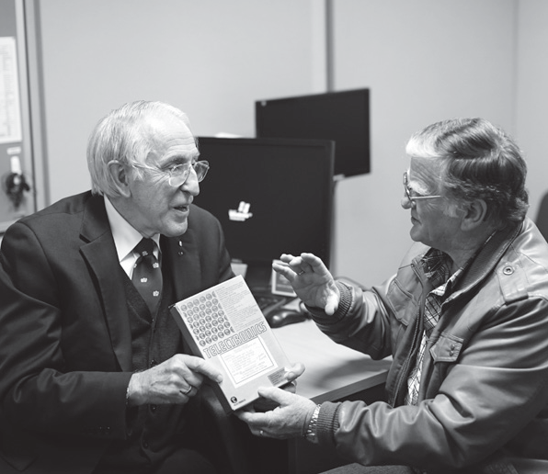Graham &
Graeme

Their hard work means that today, approximately a quarter of all Australia’s Cochlear implants are conducted at the Eye and Ear, as
a dedicated team of surgeons, audiologists, speech therapists and support staff continue the proud tradition started 35 years ago.

Since the first successful implantation of a prototype bionic ear at the Royal Victorian Eye and Ear Hospital in 1978, approximately
300,000 patients world-wide have been given the gift of sound.

This world-leading research became a reality due to the innovation and persistence of Professor Graeme Clark and his team and through
the courage and dedication of patients like Graham Carrick, who chose to take part in those first few critical trials.

24 Eye & Ear Annual Review 2012–13

Breaking the
sound barrier

Professor Graeme Clark

Professor Graeme Clark understood from a young age what it means to be severely-to-profoundly deaf, and the social isolation deaf and hearing impaired people often experience.

“My father had a severe hearing problem and as a young person I knew how difficult this was for him, within the family and at work…he often wouldn’t enter a conversation at all.”

“(It was always) my desire to help people who were deaf because of my father.”

While working as an ENT surgeon at various hospitals across Melbourne in 1965, Graeme happened to read an American journal article during a lunch break, about a surgeon who had carried out the implantation of wires into a deaf person’s inner ear.

Graeme consequently left Melbourne to undertake a PhD in auditory brain physiology at the University of Sydney; exploring whether auditory stimulation could restore hearing.

“I was always really research orientated from a young age, I really had this very strong passion — it was an addiction — to do research.

“I wanted to [explore electronic stimulation of the inner ear] carefully, scientifically, not just operate on a patient without the basic understanding. It was a little bit slower that way but I felt it was the right way.

“I gambled my whole future on this question,”
he says.

Graeme, armed with encouraging results from his PhD was awarded the first chair of otolaryngology at Melbourne University in 1970 and designed the new University department at the Eye and Ear, opened by the premier Sir Henry Bolte in 1973.

“The development of the bionic ear was fundamentally tied to having all facilities in the same place. It really couldn’t have been done as efficiently without the relationship between the Eye and Ear and the University of Melbourne and the research going on in the second floor.

“We were producing the most complex package
of electronics ever put in a patient and that had all sorts of ramifications. We were also doing things to help patients, who were not just guinea pigs, so it was important that the patient be able to come just upstairs to our research establishment.

“After the surgery was getting more routine I could be in my office and also see what was happening with the surgery at any time so it was a very good arrangement,” he says.

Graeme says the development of the bionic ear has in many ways informed the current bionic eye project, however the push for bionic vision requires a different connection to the brain.

“We were fortunate with the Cochlear implant in that for hearing and speech we could create useful speech understanding with just 22 electrodes from timing information and the judicious use of more sites of stimulation.”

“Vision however depends upon different spots of stimulation, which involves lots and lots of little dots to give a high quality picture — perhaps up to as many as 500,000. That makes it a very different set of challenges for those researching the bionic eye to what we faced with the ear.”

“We should not give up; we should keep the research going. Ninety-nine per cent of the scientific community said (the bionic ear) would not work but that is often the story with these things. There is a
a good team of relevant scientists working on the bionic eye, and they should therefore push forward the boundaries of this important project for it to become a clinical reality.”

Graham Carrick

A fun trip to the local tip with dad and pop became a rush to the hospital for four year-old Graham Carrick, when he badly burnt his legs and required strong doses of pain medication. While his legs eventually healed, the medication he had received had permanently damaged the fine hairs in his inner ear that help register sound, leaving Graham with significant hearing loss.

“I was about seven or eight years old when my parents enrolled me in the Glendonald School for the Deaf and my brother started taking me to speech therapy so I could learn to talk and learn lip reading.”

A workplace incident at the age of 21 impacted his remaining hearing and Graham was then diagnosed as profoundly deaf. His time with the Glendonald School fortunately enabled him to continue communicating with those around him.

“I was profoundly deaf when I met my wife Kathy
at 27 and she found it almost unbelievable, I could understand what people said, I spoke well and
most people I met never know I was deaf,” he says.

“Then we started to have a family and I missed out on hearing my kids’ voices as babies. When my daughter was 18 months old she realised I was deaf and would pull my chin around so I was facing
her when she spoke so I could hear what she said.”

An infection in his ear lead Graham to a specialist
in Collins Street, who mention Professor Clark was currently looking for a profoundly deaf patient with the ability to read lips.

“That was the start of this fantastic journey. There were six of us involved in the clinical trial for the Cochlear implant. I can recall getting my first

speech processor; it was something like a cigar box — a gold box.

“My very first switch on was an important one, as there was a lot riding on its success. For ten minutes I didn’t hear anything, everyone in the room was just looking at the ground. Somehow,
suddenly, I heard a ‘ding, dong’ sound and I looked at Professor Clark and said ‘I heard a dong’.

“I just broke down. This was the first time I had heard a sound in 17 years. I never thought I would be able to hear again and I did,” he says.

Graham worked closely with audiologists at the Eye and Ear, to ensure the implant was registering sounds at the correct pitch.

“From that day on there was a bit of back and forth to the hospital doing tests. The audiologists who worked with us were fantastic people. They had to work hard and have a lot of patience, we worked together to work out sounds and it wasn’t easy.
“We were learning from each other, really.” After almost five years working closely with the
audiologists to tune the device, Graham experienced
the breakthrough the team had been waiting for and taught himself to stop relying on lip reading.

“I can remember the day I first heard my daughter’s voices very well. That was an exciting thing to happen, when you haven’t heard your daughters for
13 years. I never heard them when they were babies.

“When I see how the implant brightens the world up for the little children who have it, I feel so proud that I’ve done it and so worthwhile. To see these children get their hearing back and be able to communicate in the hearing world — I can’t express it properly how it makes me feel.”

Our patients

Lily
Lily received bilateral cochlear implants when she was ten months old. At two years old, her speech is at the same level as her hearing peers. She attends the Eye and Ear every three months for
‘mapping’, which is a continuous process of adjusting the implant to match her hearing development.

The first successful paediatric implantation was conducted at the hospital in 1986 on 10 year old Scott Smith. In 2007, the
first simultaneous dual cochlear implant operation in Victoria was successfully performed on
20-month-old Hayley Walsh at the
Eye and Ear.

Hearing
clearly

Following a newborn screening test, Sandra King found out that her baby girl, Lily could hear nothing at all. While it was devastating news for Sandra
and her husband, she wasn’t aware that Lily would benefit from cochlear implants, invented by Royal Victorian Eye and Ear Hospital specialist, Professor Graeme Clarke AO in 1978.

“When we were told our newborn baby was profoundly deaf, we thought it was the worst thing in the world. But, we didn’t realise then how good her life could be,” she says.

“Before Lily was born, I was oblivious to the fact that cochlear implants even existed, let alone the fact that they can transform the lives of people who are profoundly deaf.”

Before Lily’s cochlear implant operation, she had
a series of hearing tests at the Eye and Ear to find out if she had any residual hearing. The cochlear implant can damage residual hearing, which is important to preserve for the times when the implant receiver has to be removed, such as at night. The tests showed that Lily had no residual hearing, and that it was safe to go ahead with a bilateral cochlear implant.

Sandra says: “If babies don’t hear sounds, they can’t learn to make sounds and their language development is delayed. Lily had two cochlear implants put in during one operation when she was ten months old, so she has missed out on as little as possible.”

Now aged two, Lily is very used to the two sound processors on either side of her head, but more importantly her speech is at the same level as her hearing peers.
Sandra learnt from the Eye and Ear speech pathologist how to help Lily make sense of the world by showing or explaining to her where all new noises were coming from. And, everyone in the family makes sure Lily can see their face when they’re speaking so she connects the sound with facial movements and copies them.

Sandra said: “The wonderful thing about the service at the Eye and Ear is that we see the same speech pathologist, Denise Courtney every time we come, so Lily has a wonderful relationship with her.

“And all the staff in the Cochlear Implant Clinic are so incredibly warm and welcoming, including the receptionists, the audiologists and Lily’s surgeon, Dr Briggs.”

Sandra says that all their hard work has paid off because Lily now attends childcare for a few hours each week so she can learn to communicate in a noisier environment, and she loves it.

“The plan is for her to go to kindergarten and then onto the same school as her older sister. I’ve been told that the teachers can wear a microphone connected wirelessly to Lily’s receiver, so she won’t miss anything,” she says.

Sandra says that she and her husband will be forever indebted to the staff at Eye and Ear and she has since volunteered to join the hospital’s Consumer Register.

“We want to do everything we can to help the hospital because everyone here has gone out of their way to help us. We are so incredibly lucky to have their care and support.” Sandra concludes.

Our patients

Our history

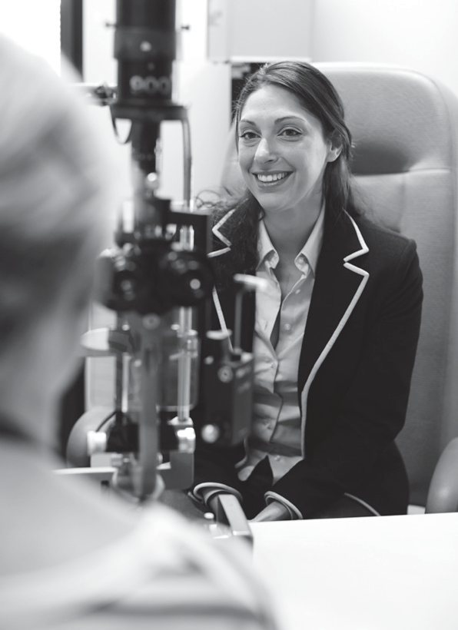

Leah
Fuchs’ heterochromic uveitis (FHU), sometimes known as Fuchs’ heterochromic iridocyclitis is a chronic, relatively mild form of uveitis.

FHU usually affects only one eye but in about 15 per cent of patients both eyes are impacted. A change in the colour of one eye compared to the other is one possible symptom and the disease is commonly associated with the development
of a cataract and/or glaucoma. Similar to other uveitic conditions, researchers are still looking into the causes and treatment of FHU and research is ongoing.

A brighter
outlook

Diagnosed with a serious eye condition in 1990,
14 year-old Leah Graeve faced the possibility of losing the sight in her left eye. Two years later, as her eyesight began to deteriorate; she was
referred to the Royal Victorian Eye and Ear Hospital for treatment under legendary ophthalmologist Professor Gerard Crock.

“I was diagnosed with Fuchs Heterechromic Uveitis (FHU). The condition started with the initial symptoms coming on extremely suddenly, with
a flash of tunnel vision that lasted only about 20 seconds. Following that episode, my vision was still generally ok, but with an opaque film coming across the eye when I moved my eyes from side to side.

“I was under the care of an ophthalmologist for a couple of years whilst the condition was ‘behaving’. Once I started experiencing flare-ups and was not responding to treatment I was referred to Professor Gerard Crock at the Eye and Ear for further investigation,” she says.

Now 16, Leah was increasingly concerned at the prospect of losing the sight in her eye.

“Since I had been diagnosed at 14, I was always worried about the possibility of losing my vision. Professor Crock explained the condition to me and also what
I could expect over time. He explained that there were options for surgery, which had very good success rates.

“Once I knew that I would have options when my vision became increasingly poor, I felt more at ease.

Leah’s condition was monitored closely at the Eye and Ear for almost 13 years until it was determined that surgery would be the best long-term solution. Leah underwent a vitrectomy in 2005 at age 29,
during which the vitreous gel is removed from the middle of the eye, making it easier to access the retina and macula for repair or treatment.

“I finally underwent a vitrectomy more than 10 years after my initial consultation with Professor Crock. I can honestly say that the short time I was under
the care of Professor Crock at the Eye and Ear absolutely changed my outlook on the condition and allowed me to stop focusing on the possibility of losing my vision entirely,” she says.

In the years leading up to her surgery, FHU had begun to severely impact on Leah’s quality of life and her ability to live independently.

“Before surgery, I was unable to read a book, found it very exhausting working all day and had stopped driving for a while. Within a couple of weeks of surgery, I was back to reading, driving and working full time. I guess you could say I made a full recovery!”

Leah went on to study journalism/communications at Monash University and later a Bachelor of Law at Monash University and was admitted to practice in the Supreme Court in August 2009.

Now, 23 years after she was first diagnosed, Leah says, “When I see vision impaired people I am reminded of how lucky I am to have a condition that was able to be treated. I am forever grateful to all the people who have put their time and intellect into the research and treatment of eye conditions.”

Our patients

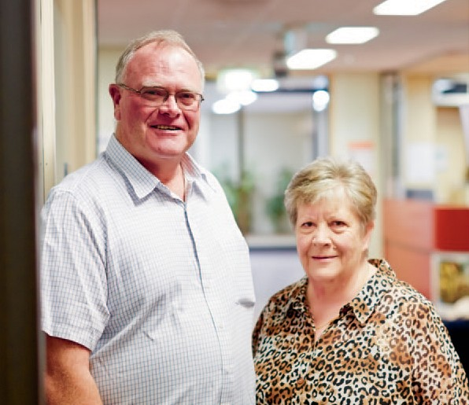Janet & Paul

“If I can’t help myself then maybe I can help my son or maybe even my grandchildren, who might develop it and we don’t really know yet. I don’t mind what I do, so long as I can help somebody.” says Janet.

CANVAS, or Cerebellar Ataxia with Neuropathy and Vestibular Areflexia Syndrome, is a medical condition affecting three key parts of a person’s balance system: the cerebellum (impacting coordination and balance) the vestibular system
(the part of the inner ear keeping us balanced) and peripheral sensation (impacting the ability of your arms and legs to feel things, such as the floor beneath your feet).

At the Eye and Ear, general dizziness and balance problems are among
the most common presentations to our emergency department at 2000 patients annually. The hospital’s specialty outpatient clinics see an additional 3000 patients per annum.

A familial
approach

Like much of our general health and wellbeing, we take for granted our sense of balance — which helps us to complete activities as simple as walking and standing upright. For sufferers of balance disorders, those vulnerable to lingering and extreme dizziness, this impacts their ability to work, care for
loved ones and complete average day-to-day tasks.

Janet, now 68 always thought the symptoms she experienced for close to two decades were just something she had to endure.

“I’ve been falling for around 18 or 19 years now. I can’t do a lot by myself, I’m always frightened I’ll fall. There are a lot of things I can’t do. I sleep with
the light on because I’m always frightened I’m going to fall but I didn’t think it was a balance disorder. Doctors in the past were unable to diagnose me
and the most common diagnosis was epilepsy. I always thought if there was something wrong with me that it was my arthritis.

“It’s concerning as I get older because if I break something at my age now I probably wouldn’t be able to come back from it. I’ve had a lot of broken legs,” says Janet.

Life has also been difficult for Janet’s brother Paul, who first experienced what he now knows to be CANVAS symptoms four years ago.

“I am unable to carry out many every day duties and need regular assistance from my wife. Balance is a big problem, when trying to step over things I have to hang on to something. I often drop things as I can’t feel them in my hand, have trouble climbing stairs and I need assistance to walk at night or in dimly lit areas,” says Paul.

Along with eight other families, Paul, Janet and her son David are helping Eye and Ear neurologist and neuro-otologist, Dr David Szmulewicz search for the gene that may be responsible for CANVAS.

“Locating the gene responsible, with help from the Murdoch Institute’s Accelerated Gene Identification Program means we can create a diagnostic blood
test, which as you can imagine is an enormous boon for patients and treating doctors,”
says David.

“If we understand how this condition is passed on from one generation to another, we can improve management and empower our patients. It is an
extremely emotional issue that also has lifelong ramifications for everyone involved.

“Patients like Janet and Paul have been invaluable to this process,” says David.

Paul hopes the research will create a better life for sufferers. “I am participating so that we can better understand this condition and hopefully find a cure for future generations. Hopefully the research that is carried out now can help find out which gene is responsible in causing this condition and they can do something to prevent future generations from (experiencing) CANVAS.”

Janet and Paul have also agreed to donate their temporal bones to the Australian Temporal Bone Bank (a new joint initiative between the University of Melbourne and the Eye and Ear) to help further balance disorder research. Temporal bones house
the balance mechanism that is impacted by balance disorders.

“Worldwide there are no temporal bone banks that specialise in balance research or any temporal bone banks at all in the Asia Pacific region. The idea for establishing a temporal bone bank came from the fact that we are seeing all of these patients with fascinating balance conditions and we know how insightful temporal bone pathology can be,” says David.

Our patients

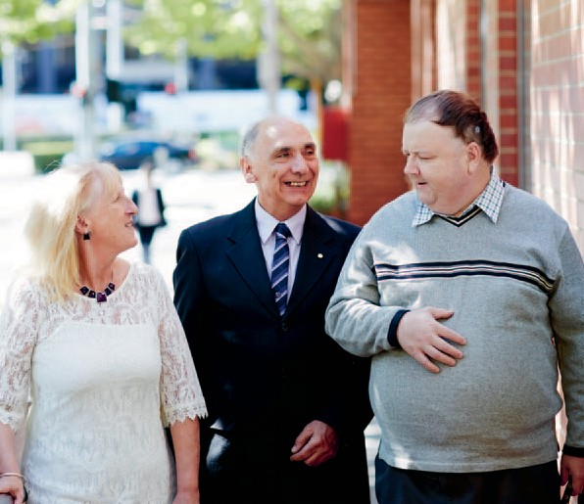Dianne, Maurice

The inc wit
and Murray

“I was very honoured to be chosen out of a few hundred people, [I felt] excited, nervous, exhilarated. I wanted to help my fellow blind person and the
research — without research we don’t go anywhere and without trial participants, the research doesn’t go anywhere.”

early prototype bionic eye orporates a retinal implant
h 24 electrodes. A small lead wire extends from the back of the eye to a connector behind the ear. An external system is connected to this unit in the laboratory, allowing researchers to stimulate
the implant in a controlled manner in order to study visual sensations (called ‘phosphenes’) that are evoked by electrical stimulation.

Patient feedback allows researchers to develop a more sophisticated vision processor and stimulation techniques so that clearer images can be built using flashes of light.

A vision for
the future

After living for decades with the effects of retinitis pigmentosa, Dianne Ashworth, Murray Rowland and Maurice Skehan are now helping researchers as they design, build and test a bionic eye prototype.

Dianne received the world’s first 24-electrode pre- bionic eye in July 2012, with Murray and Maurice also receiving the device later that year. All three underwent surgery at the Royal Victorian Eye and Ear Hospital with specialist eye surgeon Dr Penny Allen, as part of ground-breaking research with
our partners the Centre for Eye Research Australia (CERA), Bionic Vision Australia (BVA) and the Bionics Institute.

The Eye and Ear and CERA surgical team, which also included ENT surgeon Dr Robert Briggs, worked together with engineers and clinicians
to ensure the device met the challenges of implantation into the suprachoroidal space at the back of the eye. The device, made of the same materials as the Cochlear implant, has enabled Dianne, Murray and Maurice to experience a degree of vision for the first time in decades.

Dianne now in her early 50s says, “I have retinitis pigmentosa that was diagnosed in 1984, at
that stage I was 24 or 25 and my vision just got narrower and narrower and I have been completely blind since my early 30s.

“The trial was amazing. I tried
to go in not thinking about what to expect. I went in with a really open, clear mind and I was very calm on that day because of
that. When I did see something I thought that’s something in my eyes that’s being controlled and it was absolutely amazing.
“I was really happy for the researchers that day as well, because of all the work they had done and to get a result I knew they must be over the moon,” Dianne says.

Sixty-three year-old Maurice was also born with RP and had only 10 per cent vision from birth, which gradually deteriorated until he experienced a major drop 18 years ago.

“A couple of years ago I could see across the
road and make out the depth of colour, now I can’t see that. I’ve lost all crispness and definition from the light.

“I remember Professor [Gerard] Crock saying to me,
‘You’ll see before you die’ and I said ‘Yeah I reckon
I’ll walk on the moon too!’ that was 20 years ago.

“I’m very honoured to be selected for a position [in the study]. I wasn’t necessarily looking to improve my own vision but to help develop the technology. Anything that comes out for me is a bonus, but I entered into this knowing that there may not be any bonus at all; I wanted to help get it moving,” Maurice says.

Like Dianne and Maurice, 50 year-old Murray was diagnosed with RP at a young age and has spent most of his life without vision.

“I was first diagnosed in 1979, at the age of 17. I continued to umpire football after I was first diagnosed for seven weeks after and I live life the best I can.

“But also I don’t know the outcome (of the trial) and that excites me. I’ve experienced flashes of light
and circles of light; I’ve seen a back to front L and the letter J, a back to front banana. Every week
is an adventure and if you’ve had a bad week at work Fridays are the highlight, when I come for my check-up,” Murray says.

34 Eye & Ear Annual Review 2012–13

Improving patient outcomes through innovative research and teaching

our teaching
& research

Dedicated to research
and teaching excellence

As a world leader of eye, ear, nose and throat research and a specialist tertiary teaching
hospital, the Royal Victorian Eye and Ear Hospital is dedicated
to improving patient outcomes through pioneering research and innovative teaching.

Our research partners, the Centre for Eye Research Australia (CERA) and the University of Melbourne are housed on site and have access to the latest clinical resources and world class clinicians and doctors.
This means that we can collaborate with our partners and translate research into clinical care more quickly and have a direct impact on our patients.

Each year, the Eye and Ear approves approximately
80 new research projects, ranging from large clinical trials to small retrospective record reviews. Collaborating with our research partners, CERA, the University of Melbourne, the Bionics Institute,
Bionic Vision Australia, HEARing CRC and Monash University these projects translate into meaningful eye, ear, nose and throat health care outcomes.

The Eye and Ear, together with our research partners, is committed to conducting our research honestly and accurately and at the highest professional standards. We are responsible for the governance of research undertaken at the hospital, to ensure accountability for the scientific quality, ethical acceptability and safety of our research.
This ensures that all research conforms to national standards, including the National Statement on Ethical Conduct in Human Research (2007), the Australian Code for the Responsible Conduct
of Research (2007) and the Victorian Managed
Insurance Authority Guidelines.
The hospital Research Committee has oversight of strategic and operational issues, relating to the conduct of research. It makes recommendations in relation to the allocation of hospital and philanthropic funds for research and receives reports regarding research projects funded in this
way. The Committee is made up of a representative membership, including hospital Executives and Professors of the key University of Melbourne Departments based on the campus.

The Human Research Ethics Committee and the Animal Ethics Committee consider and approve new applications for research projects and manage the existing projects. The hospital also allocates research grants, such as the Wagstaff Fellowship, the Churches Bequest and other annual research grants and philanthropic donations.

We couple our ground-breaking research with dedication to training the next generation of Eye, Ear, Nose and Throat specialists and to ongoing mentoring and development of our junior staff. Through providing innovative and engaging pathways for learning to students and junior clinicians, we ensure our patients continue to benefit from the best available care well into the future.

The Eye and Ear has a long history as a teaching hospital, with the John Colvin Saturday Morning Ophthalmology Lecture Series and the Brian Pyman Otolaryngology Lecture Series long running initiatives at the hospital. The John Colvin series, renowned for its unusual teaching techniques, has been available to students since 1961.

We are proud of the important role we play in advancing eye, ear, nose and throat research and teaching, which together continue to improve the quality of health care we provide to our patients.

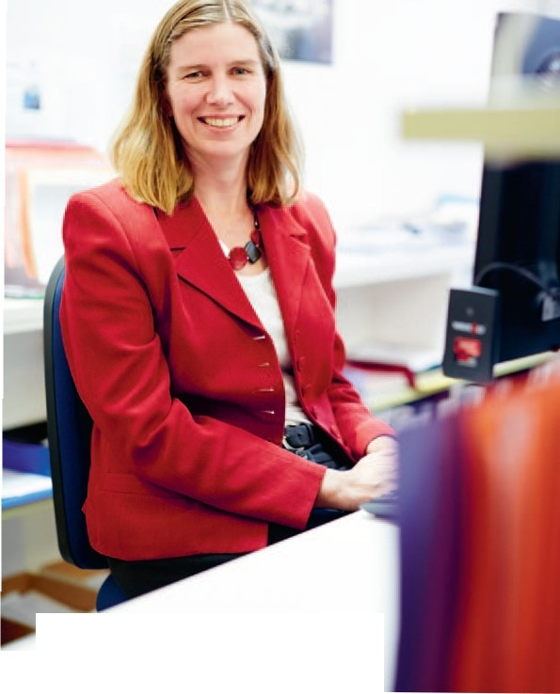
Our teaching
&. research

Kerryn

Supporting
innovation

For nearly two decades, Kerryn Baker has helped almost every major research proposal submitted at the Royal Victorian Eye and Ear Hospital to become a viable project.

As Administrative Officer to the Research and Ethics Committees and the Research Committee, Kerryn acts as liaison between these bodies
and researchers, to ensure Eye and Ear patients continue to benefit from world-leading research.

“I’ve been at the Eye and Ear for 17 years, in many different roles, but research has been the one constant. I have seen a huge number of project applications cross my desk throughout the years.”

There are currently more than 270 active research projects at the Eye and Ear, conducted together with various research partners. At the planning stages, all of these projects had to meet with a set of strict ethical standards and codes to be allowed
to move onto the active research phase. This meant undergoing a rigorous process to gain approval
from the various ethical committees.

“My role is really the start of the process for researchers who need ethical approval. This means interacting with researchers and getting those applications in to be approved by the various committees, because they can’t start the project until ethical clearance has been granted,” Kerryn says.

“There are a wide variety of members on the various committees that we have on board and I really
enjoy that interaction.” Many of these members are volunteers who give their time to read the paperwork and attend the meetings

Part of Kerryn’s role involves building ongoing relationships with, not only internal hospital departments but also the Eye and Ear’s key research partners.

“I interact with the University of Melbourne Departments of Ophthalmology and Otolaryngology, the Centre for Eye Research Australia, the Hearing CRC, Bionics Institute and quite a few hospital departments.
“It is really interesting to see the different projects that
are submitted and to see the outcomes from those projects. In particular, how research
outcomes end up changing daily clinical practice,” she says.

Kerryn has been involved in some of Australia’s most important research projects, including the push towards a fully functioning bionic eye.

“Seeing Bionic Vision Australia’s work on the bionic eye has been very interesting. The studies into macular degeneration and diabetic macular oedema, when you see all the different avenues the researchers are exploring to try and halt the disease and save sight is wonderful.”

Kerryn has also been involved in the allocating of hospital research funds to researchers to undertake these research projects. “Many of these projects would not get off the ground without the support of the hospital’s research grants”, she says.

Part of this funding also goes towards the support of Fellowships like the Wagstaff Fellowships, Peter Howson Deafness Fellowship, Zoran Georgievski Memorial Scholarship and the Churches Award.

At the hospital’s AGM last year, Kerryn received the Administrative Excellence Award and says: “I love my role. You need to be organised and able to work independently but also be able to communicate
with the researchers to ensure the research applications are complete, so approval can be granted and they can start on their journey.”

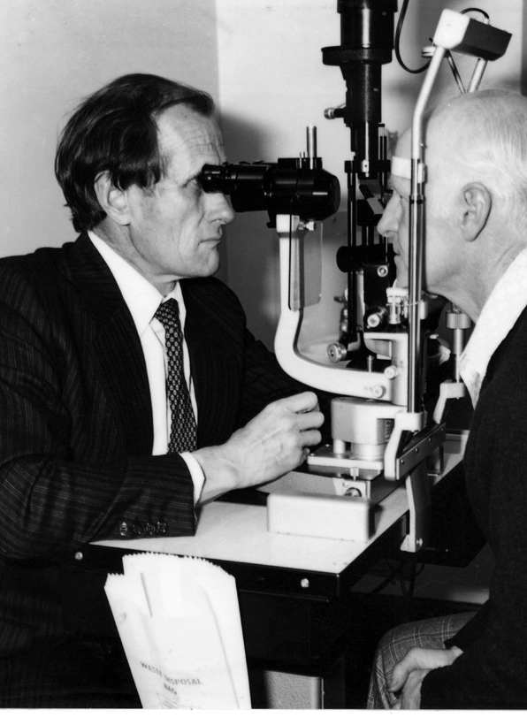Our teaching
& research

Our history

Bill

A legacy of professional
standards

Dr William (Bill) Gillies first arrived at the Royal Victorian Eye and Ear Hospital in 1952 as a young ophthalmology trainee. Over the next fifty years he was to become a renowned ophthalmologist and researcher, and through his teaching and board membership, he was also to have a lasting effect on the development of Australian ophthalmology.

When Bill moved from Queensland to Melbourne to take up the post of medical officer, he arrived at a time when the hospital was developing as a research facility and moving towards the current model of specialisation, with new, specialist units opening throughout the 1960s and 1970s.

By the mid-1960s, the Eye and Ear’s inpatient numbers had grown to 4000 per year, and 30,000 people were seen in the Outpatients Department annually. Ophthalmologist in charge of the Eye and Ear’s General Eye Clinic for 25 years, Bill became head of the hospital’s new, Glaucoma Investigation and Research Unit in 1972.

Bill held the position of Chief of Medical Staff
during his career, and was also Director of the ENT Research Institute from 1995, until its cessation
in 2005. A member of numerous key committees at the hospital; most notably, he served on the Management Committee and the Research and Ethics Committee.

A respected clinician, Bill had
a special interest in glaucoma, squint surgery and also pioneered iris angiography at the hospital; while his research was published in more than 100 peer-reviewed journal articles. For 33 years he also held weekly, teaching clinics for trainee ophthalmologists,
and over that period taught every ophthalmologist trained in Victoria.
Bill fought hard to ensure that ophthalmology remained a distinct profession with high standards of patient care. To this end, he founded the Melbourne Ophthalmic Alumni in 1991, to bring members of the profession together to share knowledge. Bill sat as a Council member on the Victorian State Branch of the Australian Medical Association, and was also active in developing the orthoptic profession in Australia.

He founded the Australia and New Zealand Squint Club, and also, in 1988, the Australia and New Zealand Glaucoma Interest Group (ANZGIG). The Glaucoma Interest Group established the Gillies Lecture in 2006 to recognise his contribution to
the study of glaucoma in Australia, and his role in establishing the group.

Through his friendship with Fred Hollows, Bill was a strong supporter of the National Trachoma and Eye Health Survey, which was one of the first studies
to focus on the health of indigenous Australians.
He led a team that was responsible for the surgical treatment of people affected by cataract and glaucoma in the Katherine region and chaired the RANZCO Trachoma Committee.

In 2003, Bill was awarded the Medal of the Order
of Australia for his contribution to ophthalmology in Australia. Past President of the Royal Australian and New Zealand College of Ophthalmology (RANZCO), Bill was also awarded the College Medal in 2006 for distinguished, meritorious and selfless service to the College, the community and medicine.

Our teaching
& research

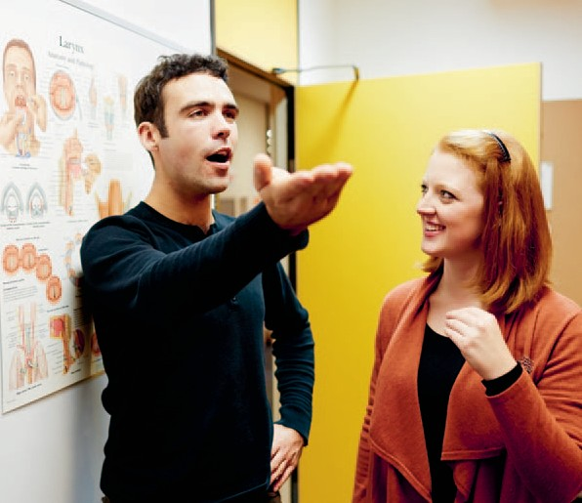Daniel & Alice

“You need to be confident to use your voice and you need to have a voice to be confident. Group therapy gave me that confidence back and I’m so glad I had the opportunity to take part.”

The need for early intervention for people with voice disorders means short-term group therapy programs may be more beneficial for patients than traditional, individual therapy. However, limited research has been carried out into the ‘boot camp’ model, which provides four days
of group therapy over four weeks.

The study is unique in Australia
for combining therapy with student teaching. Evaluation of programs conducted over the past year revealed group therapy could be
an effective treatment.

Valuing voice

Musician, Daniel Tucceri developed a rough, strained voice after evenings spent in loud, smoky venues and weekends umpiring football. He took part in
a joint research project between the University of Melbourne and the Royal Victorian Eye and Ear Hospital, researching the benefits of intensive group therapy for patients with voice disorders.

The study is unique in Australia because patient care has been integrated with student teaching, giving trainee speech pathologists clinical experience. There have been up to eight patients and four students taking part in each program, facilitated by speech pathologists from the Eye and Ear.

Over the course of four, full-day sessions, patients learnt how their voice is produced; how to modify their lifestyle to protect their voice; and how to use their voice efficiently, using special techniques. Daniel finds one technique, called ‘Yell Well’, particularly useful when he is umpiring.

He says: “I raise my arms to build power in my chest and as I draw my arms in, I engage the muscles in my back to help me shout. It works really well and it doesn’t hurt to talk after a game now.”

While most patients can be treated through weekly, individual sessions with a speech pathologist, the research is looking at whether intensive group therapy is more effective for some patients. Daniel feels that it was definitely effective for him.

“Learning techniques with a group you think, ‘if they can do it, I can do it’. And, if you don’t quite get the technique, the group gives you feedback and helps you get there. It makes you feel like you’ve achieved something and motivates you to keep going,” he says.

Student, Alice Tovey was thrilled to be given
the opportunity to work with patients with voice disorders. She says:
“We found it incredibly valuable. Working closely with our patients, and to be responsible for their voice assessments, planning
and the development of therapy materials was a real challenge but invaluable to our learning.

“The Eye and Ear speech pathologists were a wonderful support and resource and provided us with the guidance we needed to deliver a successful program.”

Students added significantly to their clinical education experience through working intensively with patients, receiving feedback via participant surveys and seeing patients’ voice improvements over a short period of time.

The Valuing Voice group therapy program included patients with voice disorders who may have been too stressed or busy to look after themselves and their voices. However, patients post-surgery or patients with neurological voice disorders were not included in the program. The study found adults tended to be more engaged when learning in a group and will put aside their fear of failure to try harder due to group encouragement.

Daniel sums up his experience: “You need to be confident to use your voice and you need to have a voice to be confident. Group therapy gave me that confidence back and I’m so glad I had the opportunity to take part.”

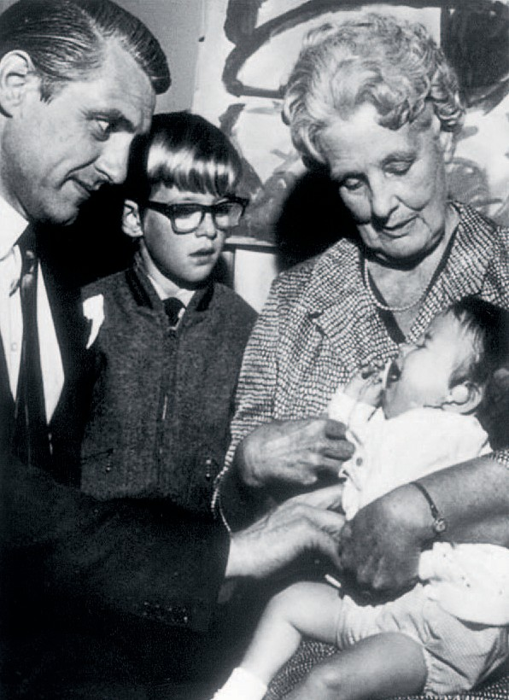Our teaching
& research

Our history

Jean

A foundation for
hearing research

Dr Jean Littlejohn was a pioneer in many ways during an otolaryngology career that spanned two world wars. She was the first woman to be appointed as Honorary Aural Surgeon to the Victorian Eye and Ear Hospital in 1929 and the
first doctor to obtain a Diploma of Otolaryngology from the University of Melbourne in 1933. Jean was also the first woman to be elected to the faculty of medicine at the University of Melbourne.

In 1922, one year before the Eye and Ear entered its 60th year, Jean was appointed to her first post of resident medical officer. The First World War had ended four years earlier, and a rapidly expanding population in Melbourne saw a large growth in patient numbers at the hospital.

Jean was drawn to the emerging specialisation of ear, nose and throat surgery, and was promoted to Assistant Surgeon in 1929. The University began offering Diplomas of Otolaryngology and Ophthalmology in 1930, to doctors wishing to
specialise in these areas. Prior to this, training was undertaken overseas or through on-site training under surgical staff.

Jean was the first doctor to obtain the Diploma of Otolaryngology
in 1933, and two years later she was also admitted as a fellow to the Royal Australasian College
of Surgeons.

The first hospital Auxiliaries were established in the 1920s, founded by women from Olinda, Sassafras and the Dandenong Ranges; and the funding they provided to the hospital became increasingly important. Jean and Matron Lucy Jones were instrumental in establishing new Auxiliaries around the state and liaising with them on behalf of the hospital.
During World War II, Jean was appointed as ENT surgeon to the armed forces, and in 1947 she was appointed Clinical Dean to the Eye and Ear, and elected to the faculty of medicine at the University of Melbourne. Very involved with the hospital, Jean served on the hospital’s management committee from 1946 to 1959.

Pioneering the use of hearing aids for babies,
Jean established the Infant Deafness Investigation
Clinic in 1948. As part of this move towards
a consolidation of the hospital’s research, the Deafness Investigation Clinic was renamed the Jean Littlejohn Deafness Investigation and Research Unit in 1957. Jean worked there as an otologist until
1974, researching the causes of infantile deafness, and the care of paediatric patients. She was awarded an OBE in 1962 and a CBE in 1972, in recognition of her work.

Professor Graeme Clark, creator of the bionic ear worked closely with Jean and says: “Jean was the first in Australia to develop procedures for
evaluating hearing loss in young children well before the school of audiology was developed.”

In 1972–73 Jean and Professor Taylor, head of the School of Audiology at Manchester University advised the State Government on establishing the first post- graduate training course in Audiology in Australia.

During her career, Jean saw the hospital, and the specialty of otolaryngology, change and develop. When she retired from the hospital in 1974, a
long awaited expansion of the hospital had come to fruition with the opening of the Peter Howson Wing. With this expansion, the hospital was able to accommodate 151 patients in a tall, modern building; very different to the Victorian building where Jean had given dedicated service for
more than half a century.

Our teaching
& research

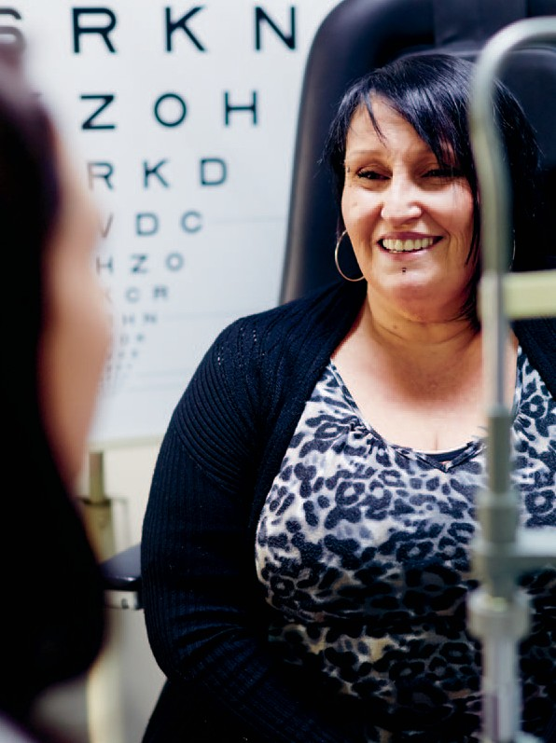

Joanne
Around one in seven Australians over the age of 50 has age-related macular degeneration (AMD).
The leading cause of blindness in Australia, AMD is not obvious in the early stages because vision is not affected until the disease is advanced and more difficult
to treat.

The Eye and Ear advocates regular eye checks for people over 50, so that the disease can be diagnosed in the early stages, before sufferers lose vision. It’s hoped that research
conducted at the Eye and Ear into a new, nano-second laser will result in a treatment that will stop the progression of AMD.

Seeing the
light

Researchers at the Royal Victorian Eye and
Ear Hospital in partnership with the Centre
for Eye Research Australia have conducted a groundbreaking, pilot study into a new, nano- second laser over the past two years, and promising results have led to the establishment of a large, multi-centre trial.

The nano-second laser beam has an intensity a thousand times lower than the laser currently used by ophthalmologists, which means it is potentially safer to use in the early stages of eye disease. The aim of the research is to develop a treatment that will stop the progression of age-related macular degeneration (AMD) before patients notice any vision loss at all.

Affecting older adults, AMD is the leading cause of blindness in Australia, resulting in the loss of central vision because it causes damage to the macular,
at the back of the eye. In advanced cases, patients are unable to read, drive or recognise faces.

Just ten years ago there was no treatment for AMD
but, thanks to research, one form of advanced AMD can now be treated with a series of injections into the eye, which slows the progression of vision loss. It is hoped that the new nano-second laser treatment could delay or remove the need for this costly and invasive treatment.

Joanne Hale took part in the two-year laser trial after she was diagnosed with early, age-related macular degeneration. Aged just 50, Joanne
is young to be diagnosed with the disease, so receiving treatment that could delay or stop its progression is very important to her.

She says: “I have a large family and I need to be there for my children and grandchildren, so receiving treatment and regular monitoring that might stop it getting worse is fantastic.”
After her laser treatment, Joanne was monitored after one month; then every three months for a year; and then every six months, until the trial ended.
This involved her undergoing a number of tests, including detailed photography of her macular.

Trial coordinator, Kate Brassington says that, in the early stages patients with AMD have good vision, and it’s hard for people like Joanne to detect any improvement in vision as a result of treatment. So, the researchers look very closely at the state of the retina and how it is working to assess effectiveness of the treatment.

She says: “One of the objectives of the trial was to evaluate the safety of the laser in the treatment of high risk, early AMD and after two years Joanne has maintained excellent vision, and not progressed to the advanced stages of AMD, which is a great result for her.”

Joanne feels that it’s important to take part in trials and she very much hopes the next stage of research will show that the laser treatment
is effective, not just for herself but for future generations.

She says: “It would be awesome to be involved in something that prevents the next generation suffering the effects of AMD.”

Kate agrees, saying: “Patients willing to give up their time to be involved in research are hopefully helping themselves, as well as future generations and indeed if we find the treatment works, saving society the huge costs associated with treatment and care.”

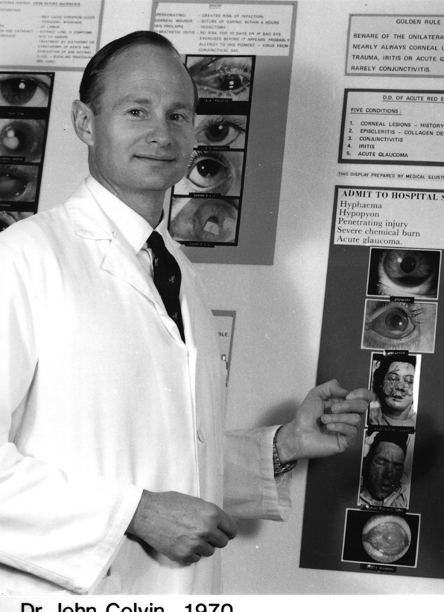Our teaching
& research

Our history

John

Reinvigorating
education

In 1961, charismatic ophthalmologist, Dr John Colvin started giving Saturday morning lectures at the Eye and Ear, and for 35 years he inspired generations of medical students to learn more about ophthalmology.

In the same year, a Royal Charter was obtained with permission from the Queen and the hospital’s name was changed to the Royal Victorian Eye and Ear Hospital. A new coat of arms was granted to the hospital, inscribed with the motto, ‘Teaching, Healing, Research’, the first of which was John’s passion.

Graduating from medicine in Queensland,
John spent five years in England training as an ophthalmologist, and, on his return to Australia in
1961, took up a post at the Eye and Ear. He was head of the General Eye Clinic for a number of years and also became Director of Medical Education.

John was also a qualified pilot and became a consultant ophthalmologist to the RAAF. He designed spectacles that allowed far-sighted pilots to read instruments and enable them to continue
to meet visual standards. John then went on to design spectacles with polycarbonate lenses that could withstand high gravitational forces, used by astronauts at the National Aeronautics and Space Administration (NASA).

A dedicated educator, John lectured to the Royal Australian College of General Practitioners; the College of Pharmacy; the Mobile Intensive Care Ambulance Service; as well as to dental and nursing students. For 25 years, John gave honorary service to the Royal Flying Doctor Service and his journal article, Effective Management of penetrating eye injuries in remote Australia became the basis of standard practice.

When John retired in 1995, the hospital had developed from an old, shabby building with no lift into a tall, modern structure with two wings. By this time, the Eye and Ear was renowned not only for its excellence in treatment and research, but also had
a reputation for excellent teaching, to which John had undoubtedly contributed.
It is estimated that during his career John gave 1,000 Saturday morning lectures to more than
12,000 medical students.

John’s lectures grew in notoriety due to his sense of showmanship when delivering lectures. He would herald each of his ‘35 Golden Rules of Eye
Care’ with a blast of a trumpet. These simple rules, designed to guide emergency doctors and GPs on how to deal with common eye problems, are still quoted today by senior doctors.

Royal Victorian Eye and Ear Hospital ophthalmologist, Dr Ehud Zamir, who now runs the lecture series named in John’s honour, says:

“Many colleagues fondly recall John’s lectures. His unorthodox lecturing techniques meant they were engaging, entertaining and very educational.”

Bringing together ophthalmic experts from all over Victoria, today’s John Colvin Saturday Morning Lecture Series is still extremely popular among university students because it adds greater depth
to the standard ophthalmology teaching provided in medicine courses.

Students attending a recent course were very enthusiastic, with one stating: “This series consistently provides the best lectures of my entire medical education — we are very lucky to have them, thank you.”

150 years of caring

48 Eye & Ear Annual Review 2012–13

Our Research Partners

Bionic Vision Australia
HEARing CRC
The Bionics Institute
The Centre for Eye Research Australia
The University of Melbourne

Our memberships

The World Association of Eye Hospitals

Members: Tun Hussein On National Eye Hospital, Kuala Lumpur, Malaysia; The Department of Ophthalmology of the University Hospital Leuven, Belgium; Singapore National Eye Centre, Singapore; Moorfields Eye Hospital, London, UK; The Royal Victorian Eye and Ear Hospital, Melbourne, Australia; Rutnin Eye Hospital, Bangkok, Thailand; St Eriks
Eye Hospital, Stockholm, Sweden; The Rotterdam Eye Hospital, The Netherlands; The Royal Victoria Eye and Ear Hospital, Dublin, Ireland; Jakarta Eye Center, Jakarta, Indonesia; Tianjin Medical University Eye Centre, China; Sydney Eye Hospital, Australia; Kim’s Eye Hospital, Seoul, South Korea; Aditya Jyot Eye Hospital, Maharashtra, India; Aravind Eye Care System, India; St John Eye Hospital, Jerusalem, Israel; Suriname Eye Centre, Suriname.

The American Association of Eye and
Ear Centers of Excellence

Members: Bascom Palmer Eye Institute, Florida, USA; Emory Eye Centre, Georgia, USA; Massachusetts
Eye and Ear Infirmary, Massachusetts, USA; Moorfields Eye Hospital, London, UK; New York Eye and Ear Infirmary, New York, USA; Phillips Eye Institute, Minnesota, USA; Rotterdam Eye Hospital, The Netherlands; The Royal Victorian Eye and Ear
Hospital, Melbourne, Australia; Rutnin Eye Hospital, Bangkok, Thailand; Show Chwan Health Care System, Taiwan; Singapore National Eye Centre,
Singapore; St Eriks Eye Hospital, Stockholm, Sweden; Wills Eye Hospital, Pennsylvania, USA; Wilmer Eye Institute, Maryland, USA.
Disclaimer

While every effort has been made to ensure the accuracy of this document, The Royal Victorian Eye and Ear Hospital makes no warranties in relation to the information contained herein. The Royal Victorian Eye and Ear Hospital, its employees and agents disclaim liability for any loss or damage which may arise as a consequence of any person inappropriately
relying on the information contained in this document.

Produced by Marketing and Communications, The Royal Victorian Eye and Ear Hospital

Photography by Leo Farrell

We have used a variety of historical images featuring members of staff and patients. We have wherever possible sought permission from relevant parties to use these images, we apologise in advance if there are any images used that cause offence.

Designed by Viola Design

Environmental Profile

Both the printer and the paper used to produce this document have Forest Stewardship Council® (FSC®) and ISO 14001 environmental certification. FSC® is
a Chain of Custody (COC) process. IS0 14001 is the international standard of Environmental Management Systems (EMS) designed to ensure the continuous measurement and reduction of environmental impacts. This publication is printed using vegetable based soy inks.

The Royal Victorian Eye and Ear Hospital

32 Gisborne Street East Melbourne
Victoria 3002 Australia

T +61 3 9929 8666

F + 61 3 9663 7203

E info@eyeandear.org.au www.eyeandear.org.au

