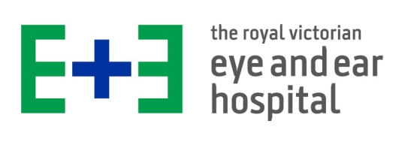

EYE EMERGENCY SEMINAR
Thursday 4th September 2025

via Microsoft Teams broadcast

0745 - 0800 | Join Teams broadcast
0800 – 0840  (40 min) | History and Examination Pearls in Diagnosing Eye Emergencies
0850 – 0930  (40 min) | Corneal Emergencies
0940 – 1020  (40 min) | Blunt and Penetrating Eye Trauma
1020 - 1040 | BREAK
1040 – 1120  (40 min) | Red Eye
1130 – 1155  (25 min) | Slit Lamp
1200 – 1240  (40 min) | Sudden Loss of Vision
1240 - 1245 | Questions/Closure

ENT EMERGENCY SEMINAR
Friday 5th September 2025

via Microsoft Teams broadcast

0745 - 0800 | Join Teams broadcast
0800 – 0830  (30 min) | ENT Examination
0835 – 0915  (40 min) | Paediatric ENT Emergencies
0920 – 0950  (30 min) | Epistaxis
0950 - 1010 | BREAK
1010 – 1040  (30 min) | Laryngeal Injury / Airway Emergency
1045 – 1125  (40 min) | Vertigo
1130 – 1200  (30 min) | Facio Maxillary Trauma
1205 – 1235  (30 min) | Otological emergencies
1235 - 1245 | Questions/Closure
1330 - 1530 | Fellowship Practice examination on  Eye and ENT emergencies (optional)

